Instructions for Running the All Transactions Interface

- Navigation for the All Trans within SHARE is General Ledger – General Reports – All Transactions Interface

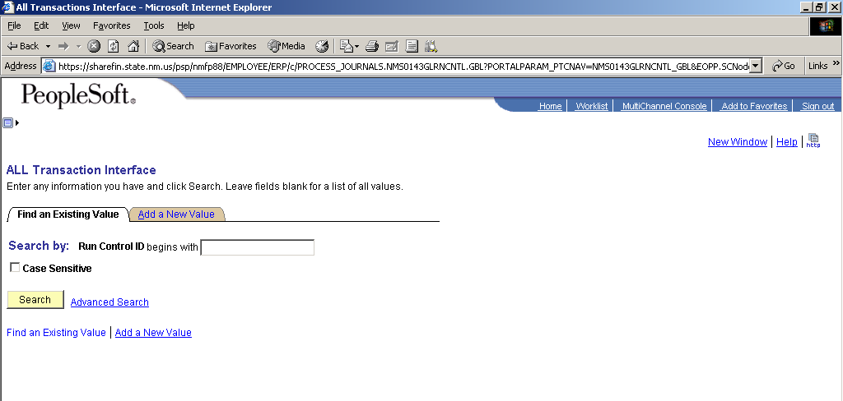

- Click on the Add a New Values tab

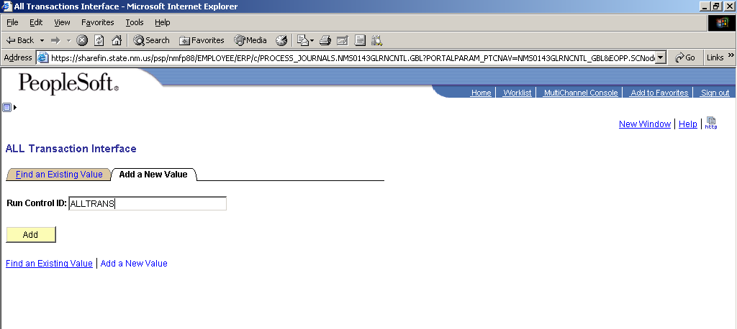

- Type a run control name such as ALLTRANS and then click the Add button.

Note: After the Interface has been ran once, next time the user can stay on the Find an Existing Value tab and use the prior run control.

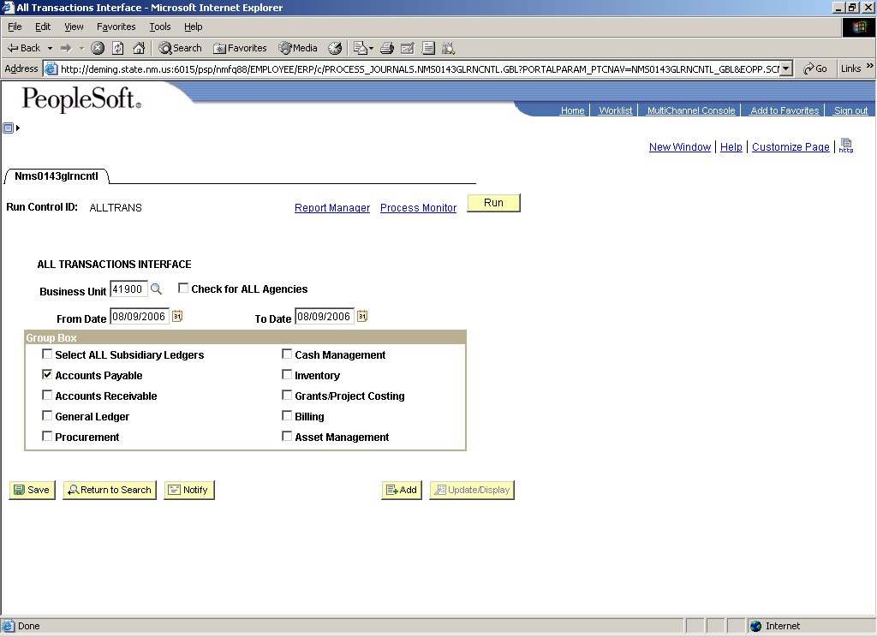

- The All Transactions Interface should come up after the Add button is pushed. This page is where the user selects the Interface output they want.
  - The user enters their Business Unit in the Business Unit field.
  - Enter the From and To Dates desired for the Interface. These dates reflect the dates transactions were actually posted to the ACTUALS Ledger within General Ledger except for Procurement. For Procurement the date represent ???????????
  - The Group Box allows the user to run the All Transactions Interface for a single module, multiple modules, or all modules. Each module will be in a separate file but all modules share the same file layout.

- Once the run control page is complete, click the Run button.

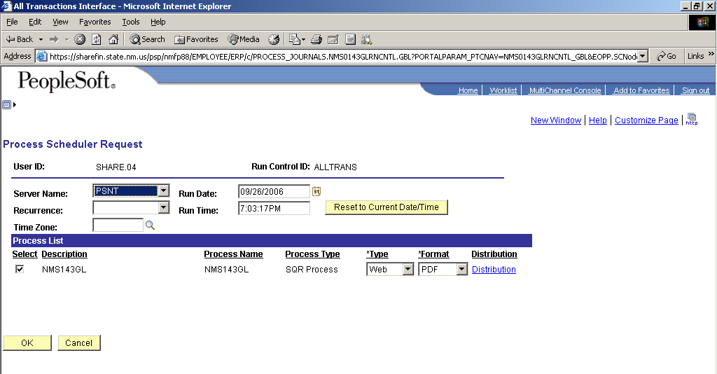

- The user must select to run the process from the PSNT server. The files will not be available if ran on the PSUNX server. After the server is selected, click the OK button to start the process running.

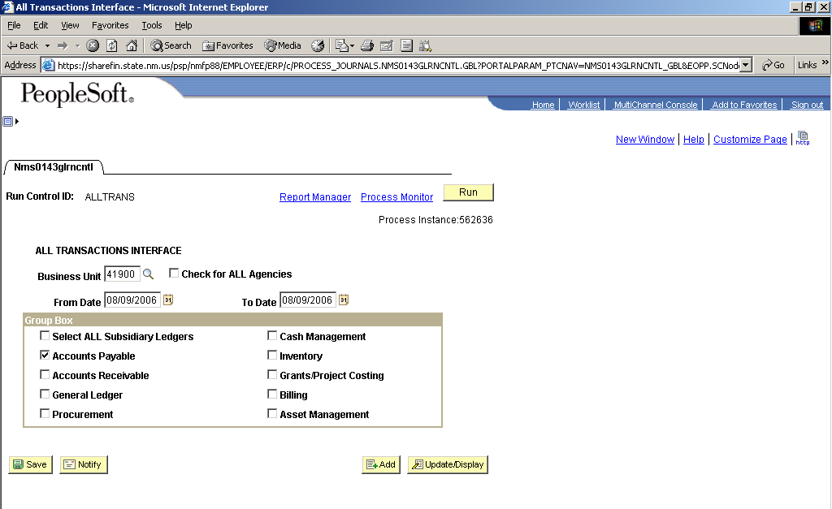

- The system should return the user to the run control page and assign the job a process instance number. Click the Process Monitor hyperlink to see the status of the process being ran.

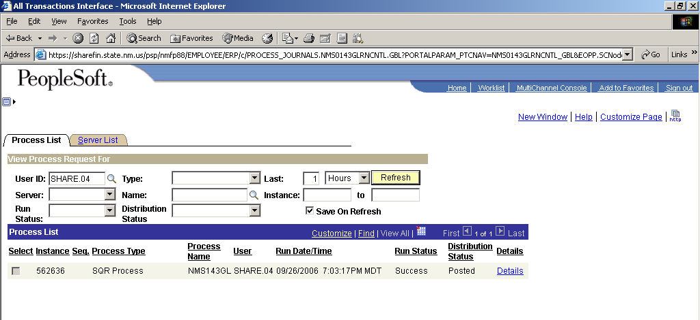

- Click the Refresh button every couple of minutes until the Distribution Status is “Posted“.
- Click the Details hyperlink.

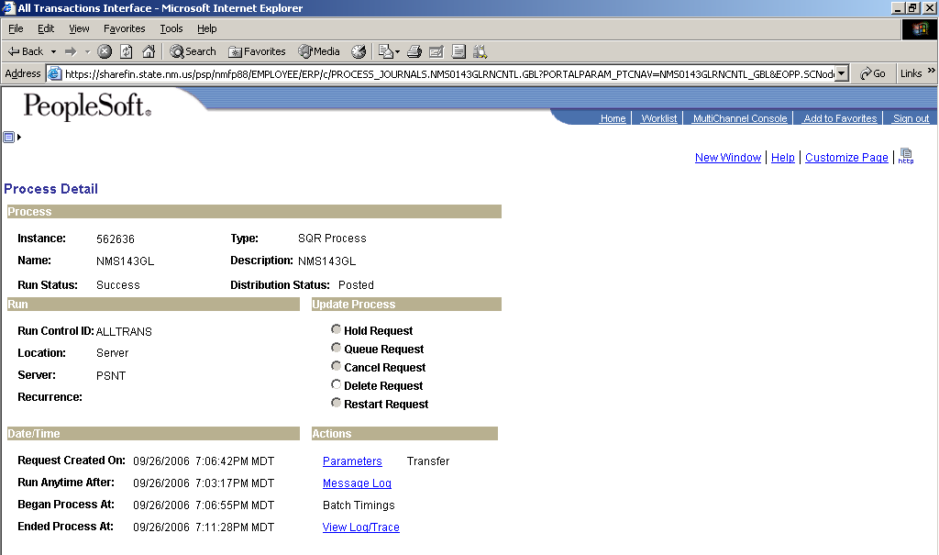

- Click the View Log/Trace hyperlink.

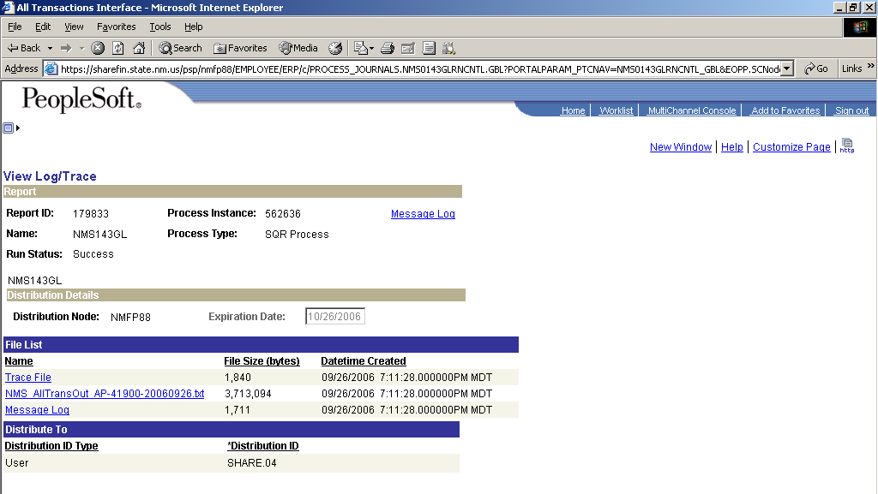

- The system creates a flat file named with the module, Business Unit and process instance number. Click the file hyperlink to open the file.

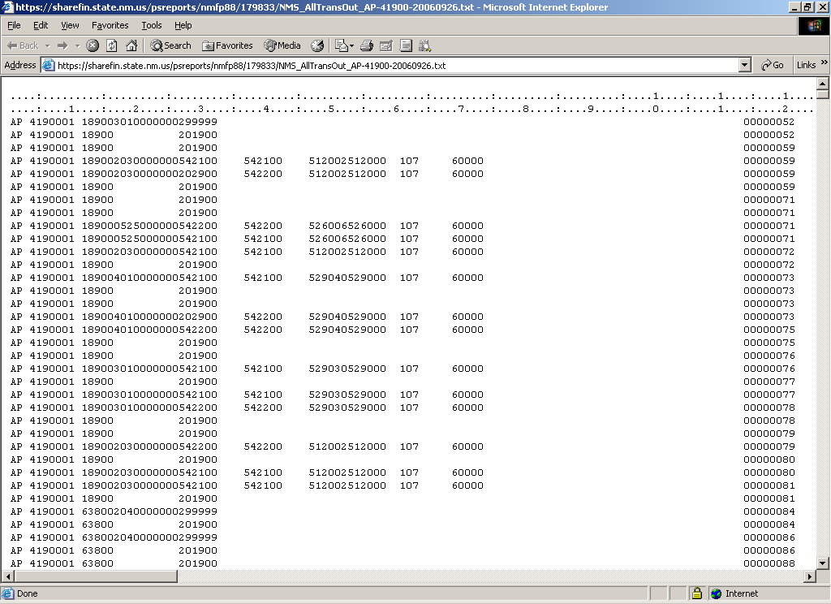

- The user must click File – Save As to save the file onto their computer.

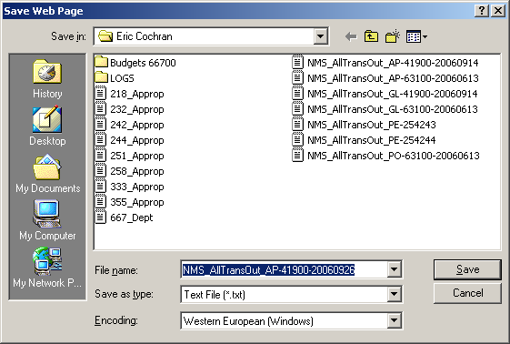

- Leave the default values and click Save. Now the file is available for use.

The file layout for the All Transaction Interface is on the SHARE website.

