State of New Mexico
User Training Guide

Budget Formulation and Management (BFM)



Contents
1. What is BFM? 1
2. BFM Terminology 1
3. The Budget Equation – How to Build Your Budget 1
3.1. Budget Forms 1
3.2. Budget Form Stages/Workflow 2
4. How to Access BFM 2
5. Logging In 3
5.2. Changing Password 5
6. Basic Navigation 5
6.1. Menu Navigation 5
6.2. Main Screen Description 6
6.3. Page Through Records 7
6.4. Quick Search 8
Example 1: Search by text 9
Example 2: Search by number 9
6.5. Advanced Search Filters 9
7. Budget Forms Overview 11
8. Base Budget E-4 12
Base Budget E-4 by Department ID, form 3300 12
Base Budget E-4 by PCode, form 4300 13
8.1. Budget Form List Page 13
8.2. Header Tab 14
8.3. Detail Tab 16
8.4. Excel Export/Import 20
8.5. Update Spreadsheet with Budget Values 22
8.6. Import Spreadsheet 24
8.7. Import Notes 27
Leading Zeros 27
Incomplete Files 27
8.8. Import Errors 27
Invalid chart of accounts entries 29
Blank rows at the end of the spreadsheet 29
Values in a column not part of the upload, such as in column W 29
8.9. In-Line Editing – Existing Budget Entries 29
8.10. Audit Trail 30
8.11. Add New Budget Entry 32
8.12. Delete Existing Budget Entry 35
8.13. Attachments Tab 35
Budget Header – Attachments tab 36
8.14. Submit Budget Form 36
8.15. Reports 38
9. Contracts E-5 38
9.1. Create New Contracts Form 38
9.2. Reports 43
10. Expansion Request 43
10.1. Create New Expansion Request 43
10.2. Header Tab 44
10.3. Position Tab 45
10.4. Position Tab Overview 45
10.5. New Position Wizard 47
10.6. Employee Changes 50
10.7. Detail or Request Tab 52
10.8. Explanation Tab 54
10.9. Analyst Comments Tab 55
10.10. Attachments Tab 55
10.11. Submit Expansion Request 56
10.12. Report 56
11. Revenue R-1, R-3, R-4, R-5 56
11.2. Report 60
12. Transfers R-2 60
12.2. Add New Transfers Form 61
12.3. Reports 65
13. Special, Supplemental & Deficiencies 65
13.2. Add New 65
13.3. Header Tab 66
13.4. Request (Details) Tab 67
13.5. Explanation Tab 69
13.6. Attachments Tab 70
13.7. Submit 70
14. Program Narrative 70
15. Fund Balance Projection 72
15.2. Header Tab 72
15.3. Detail Tab 73
15.4. Report 75
16. FTE Counts 75
16.1. Create New Form 76
16.2. Report 80
17. Vacancy Savings Application 81
18. Vacancy Rate Form 86
19. Performance Measures 90
19.1. Performance Measures 90
19.2. Performance Measures Quarterly 93
19.3. Performance Measure Change Request 96
20. Personnel Cost Forecasting (PCF) 100
20.1. Employee Allocation Updates 100
20.1. Invalid Employee Home Dept ID 104
20.2. Employee Home DeptID Updates 105
21. BFM Reporting 110
21.1. How to Access BFM Reports 110
21.2. Multiple Sessions 110
21.3. Logging In 111
22. Run Reports 111
22.1. Basic Navigation 111
22.2. Open a Report 112
22.3. Report Prompts 113
22.4. Report Icons 117
22.5. Report Navigation – Document Tabs 118
Navigation Map 118
Tab Strip 118
Paging 119
Zoom 119
22.6. Refresh a Report While Open 120
Refresh with Prompts 120
Refresh From User Prompt Input 120
22.7. Drill Through on Personnel Report 122
Linked Report 124
22.8. Limit Data Using Input Controls 125
22.9. Export a Report 127
Saving as Excel 128
Saving as PDF 129
22.10. Print a Report 130

What is BFM?
Budget Formulation and Management is the new software tool that will be used by the State to prepare budgets, track performance measures, and report on in-year budget-to-actuals. It includes a reporting solution that allows users access to any data that has been entered in BFM in any format.

BFM Terminology
Budget Form: A budget form is how users enter budget data into BFM. A budget form may display both historical and current budget data as well as require the user to enter data and text.

Form Instance: A form instance is the generic term for a particular budget form that users access to enter budget information. Each form instance has an ID, called a Form Instance ID, which is a unique numerical code that is assigned to each budget request. This ID is not generally referred to except for Decision Packages since agencies may submit multiple Decision Packages and each will have a unique Form Instance ID.

Stage: Stages are used in BFM to create workflow associated with forms. End users will enter data into a budget form at a particular stage. Some departments may have additional internal review that requires an additional stage for review and approval before it is submitted to the Budget Office.

Org/Organization: Org/Organization is a generic term referring to the organizational dimension which may consists of Agency, Budget Unit, Funds Center, or Program.

PCF: Personnel Cost Forecasting is the BFM tool that calculates the base personnel budget based on HR data and planning values loaded in the system.

Report: Reports are used to compile data in BFM in order to present budget information for decision-making and analysis or to summarize data for various uses.

The Budget Equation – How to Build Your Budget
BFM is designed to allow different components of the budget to be added together to create a budget request. Budget forms are used to get data into BFM; REPORTS are used to view the data.

Budget Forms
Following are the budget forms that will be used for budget preparation. Additional forms may be added as needed.
Form Type | Form Name
Program Narrative Form | Program Narrative (2500)
Fund Balance Form | Fund Balance Projection S-10 (2900)
Appropriation Forms | Base Budget E-4 by DeptID (3300)
 | Base Budget E-4 by PCode (4300)
 | Contracts E-5 (3800)
 | Expansion Request (3200)
 | Revenue R1, R3, R4, R5 (3400)
 | Transfers Form R2 (2800)
 | Special, Supplemental & Deficiencies (3500)
Performance Measure Forms | Performance Measures (4000)
 | Performance Measures Quarterly (4100)
 | Performance Measures Change Request (4400)
Position Related Forms | Employee Allocation Updates (7100)
 | Vacancy Rate Form (3900)

Budget Form Stages/Workflow
Budget forms advance through the budget process using a concept called Stages. Stages are unique to each budget form and the first three characters of a stage are the form to which they are assigned.

The chart below shows an example Stage workflow for a budget form.

Stage | Description
Stage 1 | Initial Entry
Stage 2 | Manager Review
Stage 3 | Agency Management Changes
Stage 4 | Submit to DFA

Users are assigned different roles to facilitate this workflow. For example, a “Requestor” will have EDIT access to ONLY stage 1 and can SUBMIT to stage 2, while the “Manager” will have access to EDIT stages 1 and 2 but can submit to stage 3. If security changes are required, contact the BFM Administrator.

Once you Submit your budget you will not have access any longer, but the approver has the authority to Submit the request backwards in the process, so contact the appropriate reviewer if you need to make changes post-submission (assuming the deadline has not passed).

How to Access BFM
BFM is accessed via internet browser. Chrome is the preferred browser and provides the best user experience. Chrome was used to create the screenshots in this user guide. Current versions of other major internet browsers are also supported.
- BFM Links: Your BFM Link is below. Save your link as a Favorite for easy access.
https://nm.bfm.cloud/bfmnm/default.aspx
- Reporting: Once you are logged into BFM, navigate to the Links dropdown menu, and click BFM Reporting, to access reports.
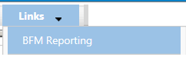
- User Identification (ID) / Password: Your BFM Administrator will send your User ID and Password. If you need your password reset, please contact your BFM Administrator.

- Timeout: Web-based applications have a built-in timeout function. A timeout function is required so users do not leave idle windows open for excessive amounts of time, impacting overall performances. The current timeout is set at 20 minutes. Be sure to save often as you work. If you are idle for more than 20 minutes, you will have to log back in and any work you did not save will be lost.

Logging In

Navigate to the BFM website.

Expand the Home menu at the top left of the screen and click on Login.

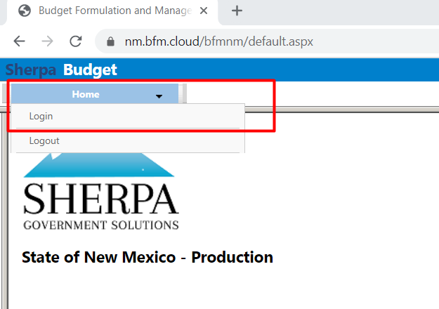

Enter your Userid and Password, then click Login.
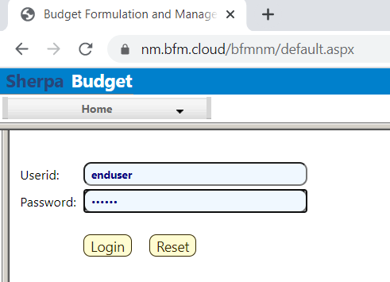

The first time you log in you may be required to change your password if you receive this dialog box:
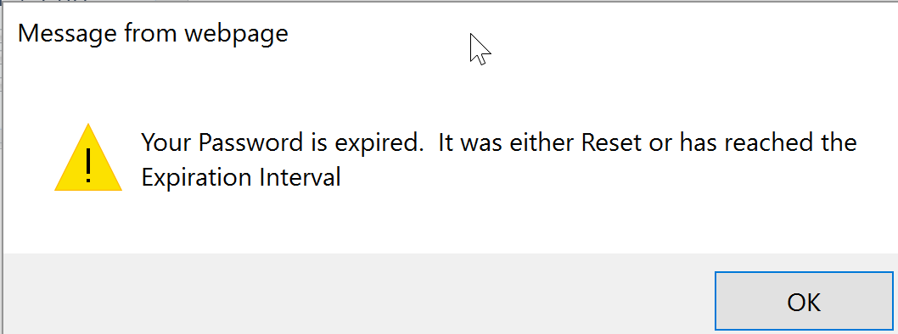

Click Ok.

Set your new password and click Update.
- Users often will set the password to match their computer login.
- Follow all State guidelines for proper password complexity.
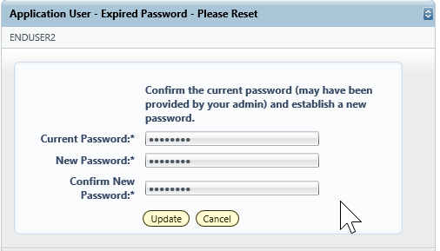

If successful, you will see the home screen and the top level menu items to which you have access. If your password needs to be reset, please contact your BFM Administrator to reset. If you believe you need additional access, contact your BFM Administrator.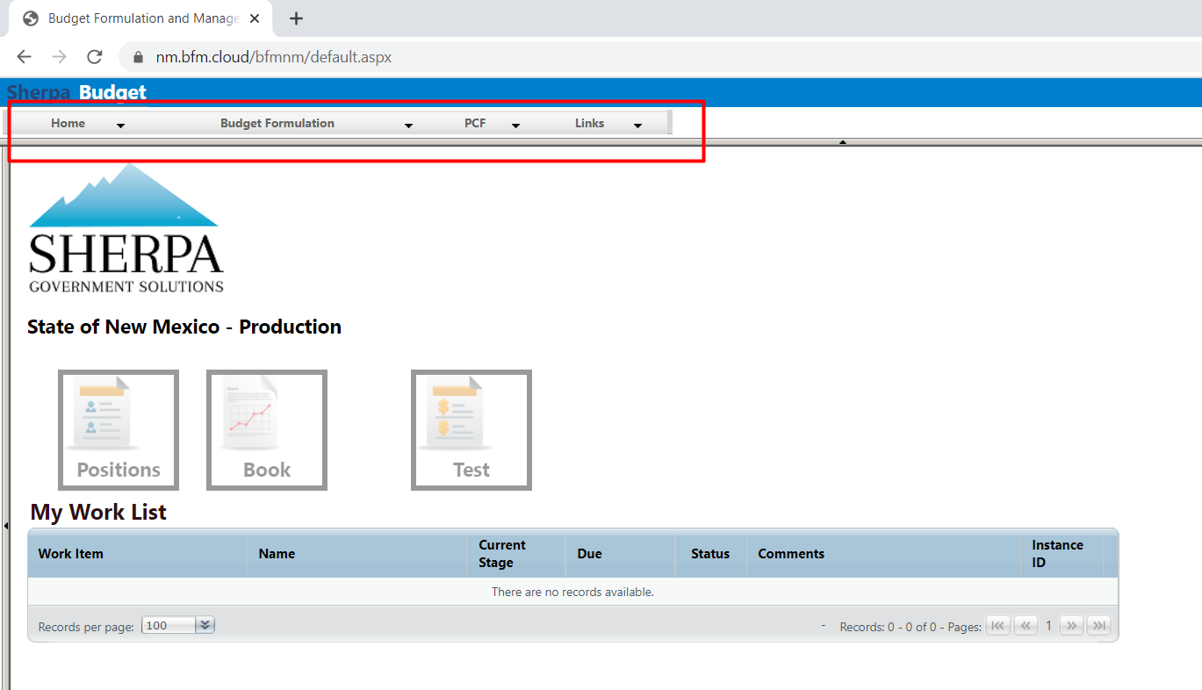

Changing Password

A user can change their password at any time. Expand the Home menu and click Update My Account to access the Update My Password screen.
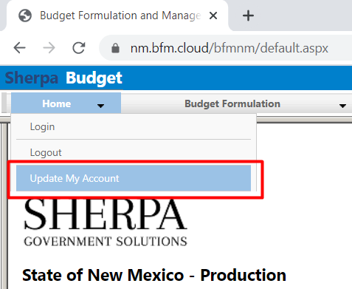

Enter the current password, and the desired new password into the correct fields. Follow all State guidelines for password complexity. Click Update.
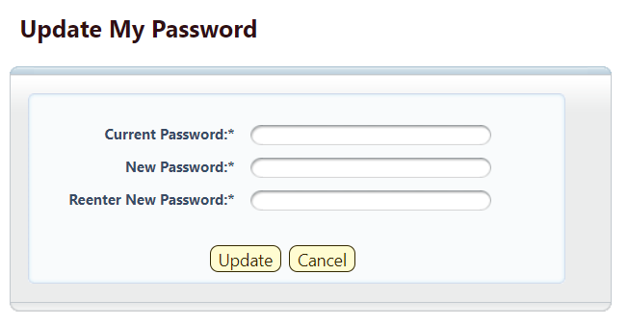
You will remain logged into your current session. Your new password will take effect the next time you logout of BFM.

Basic Navigation

Each user has different Security. The level of Security controls the menu items that appear in the application.

BFM relies mostly on the mouse for navigation. Some users prefer navigation using keyboard shortcuts, tabs/enter, and other shortcuts. At this time, only a few of the typical keyboard shortcuts work. We encourage users to use mouse point-and-click for the majority of the navigation.

Menu Navigation

Hover over any top-level menu item to see the menu options. For example, the Budget Formulation menu contains the Budget Forms available to the user.
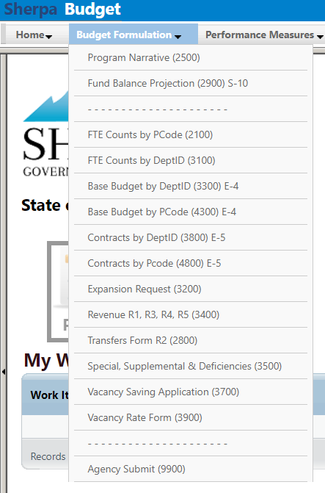

Click any menu item to open.

Main Screen Description
All main screens (also called a “List Page”) follow a similar format. The Screen or Form Title will appear on the top of the screen, followed by a search area, and finally a list of Records, with action options, below.
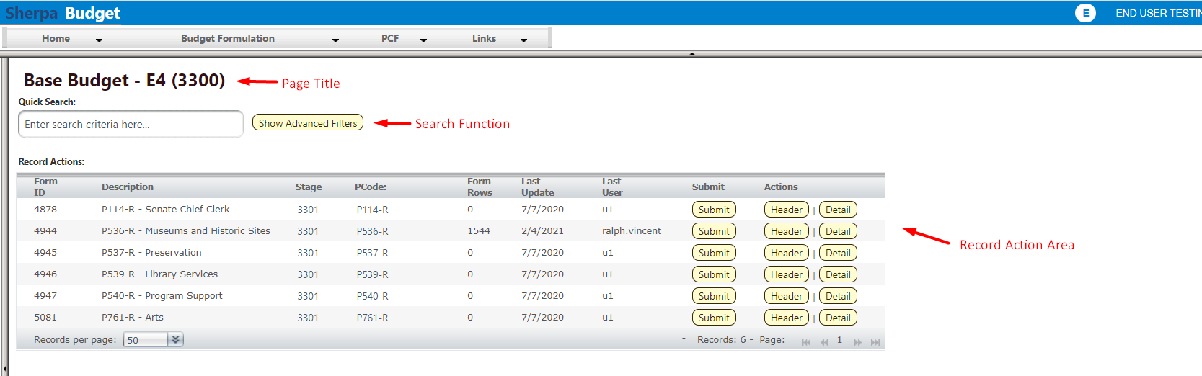
Records appear in a list in the Record Action area of the screen; each row in the table is an individual record. Record is a generic term that refers to a piece of data that will vary based on the screen content. On some screens, a record may be a distinct budget form instance; on other screens, a record may be a detailed budget entry or line item. In the example below, each record shown in the list is a Base Budget E4 form prepared for a separate P-Code.

In the bottom right corner of the Record Action list, the total number of records is displayed.
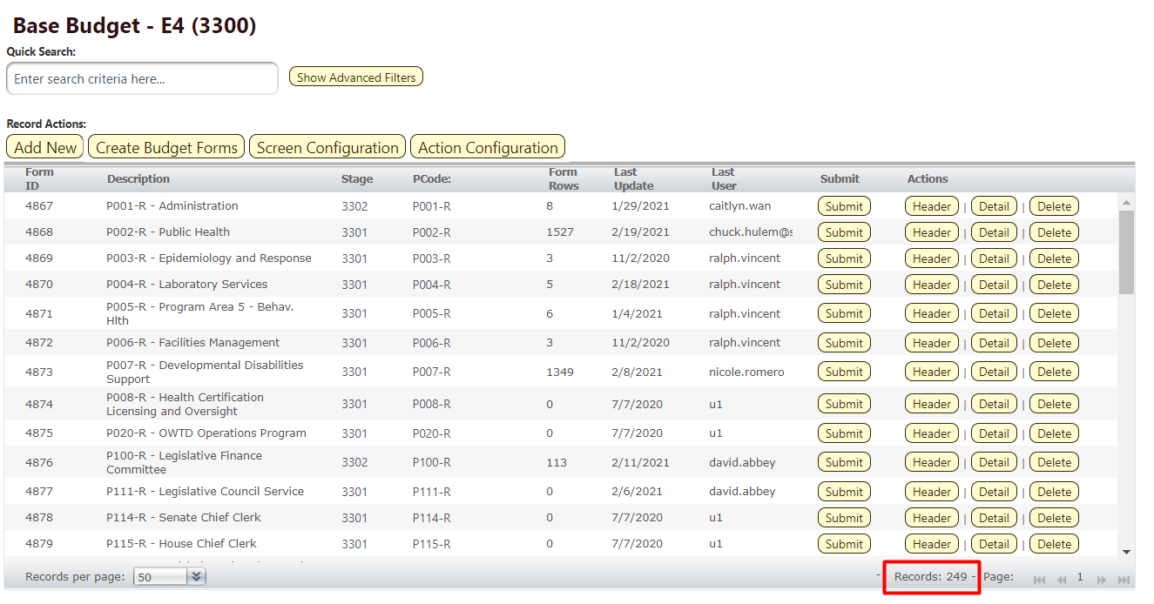

Page Through Records

Click on the on the double arrow (next page) to advance to the next page of records or double arrow with an end line (last page) to page through to the end of the available records.
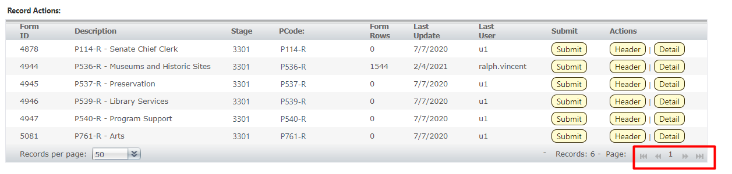

Records per page is displayed in the lower left-hand corner of the Record Action area. The default setting is 50 records. With this setting, up to 50 records will be displayed, depending on how many records are available.

To change the number of records displayed, click down arrows next to the Records per Page number and select the number of records to display.
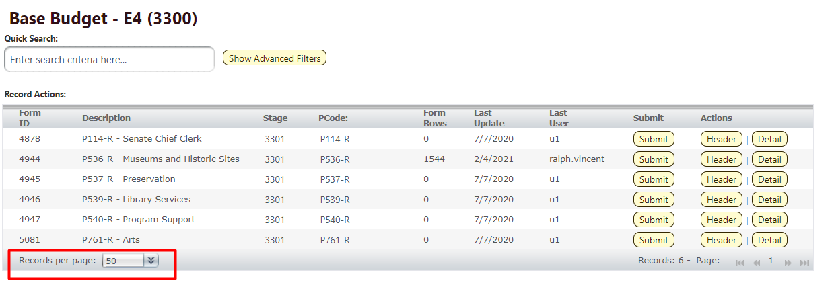

Quick Search
The Quick Search function allows users to narrow the list of records that appear in the Records Action area, instead of paging through records. Quick Search will search for text or numbers that appear in the Records Action non-data columns. For the example below, a user could search by Form ID, any text or number from the Description, Stage, or PCode. A user could even search by the last updated or last user who updated the form. Quick Search supports partial numbers or text. Quick Search does not search amount fields (dollars) or content in the record header or detail.
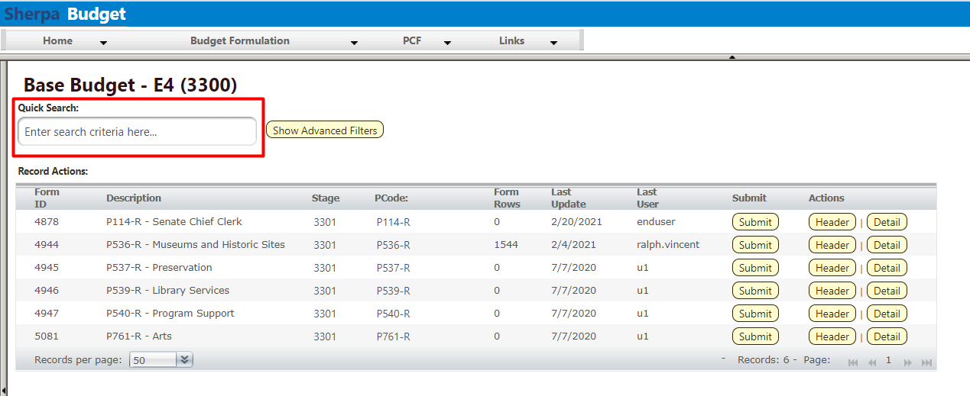

Type text or numbers in the Quick Search box. Once you stop typing for one second, you will see ‘Loading…’ in the table area below. The search will be applied to all non-data columns. All rows that contain the Quick Search text will be returned in the table. Do not press Enter or any other buttons to execute the search. Just wait.

Example 1: Search by text
Search: "Serv"
Result: All records that include the text “serv” including Preservation and Library Services.
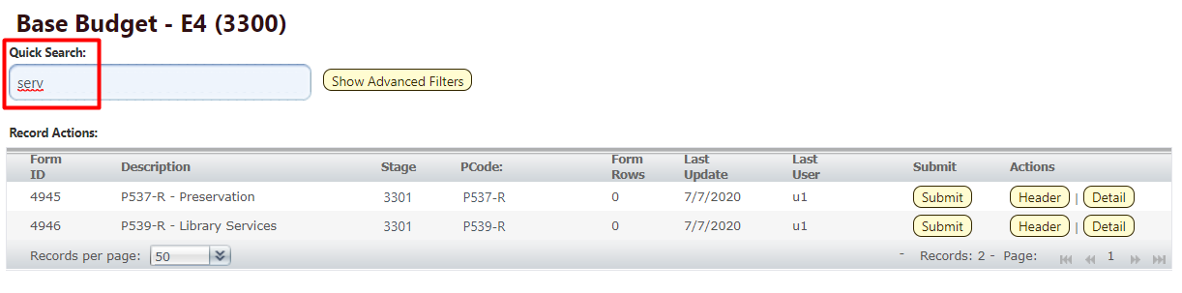

Example 2: Search by number
Search: "536"
Result: Record that contains 536.
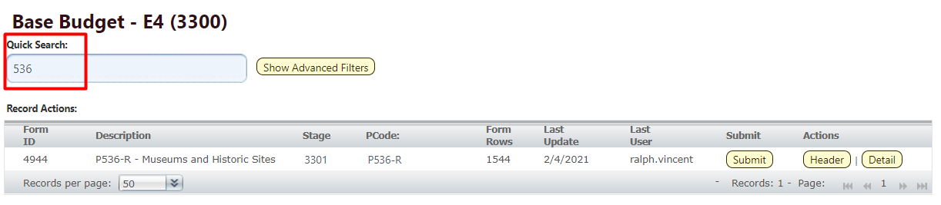

Advanced Search Filters
Most BFM screens will have a Show Advanced Filters option. This allows searching on every column in the Records Action list, or table.

Click Show Advanced Filters.
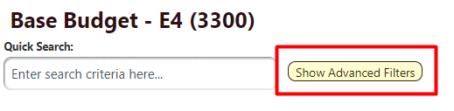

A filter appears at the bottom of the table for every column.
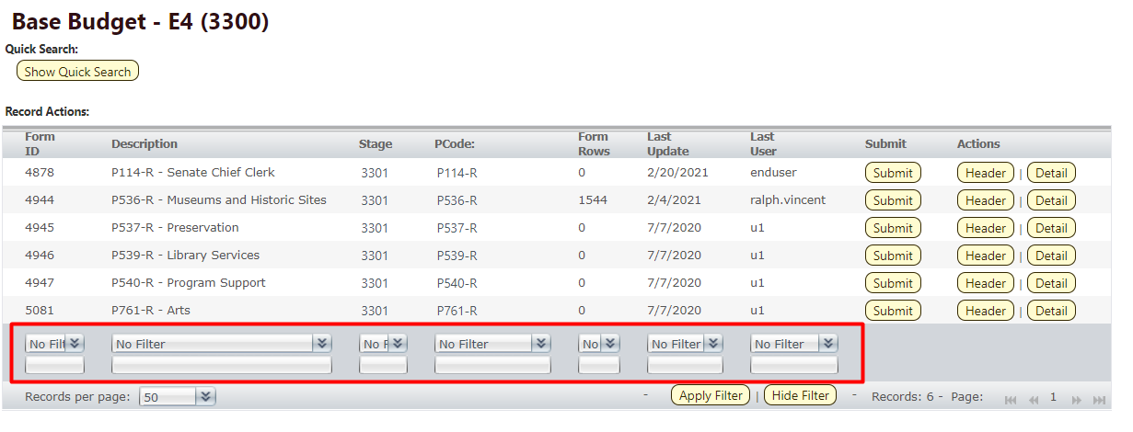

When searching text fields, the following options are available:
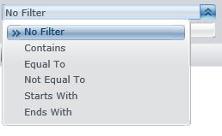

When searching check boxes, equal to is the only option. Equal to 1 means the box is checked and equal to 0 means the box is not checked.
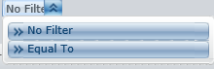

Click Apply Filter at the bottom when ready to search.
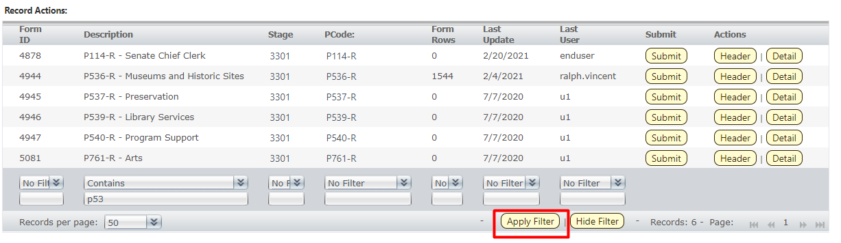

To remove the Advanced Filter and restore the Quick Search function, click Show Quick Search at the top of the screen.
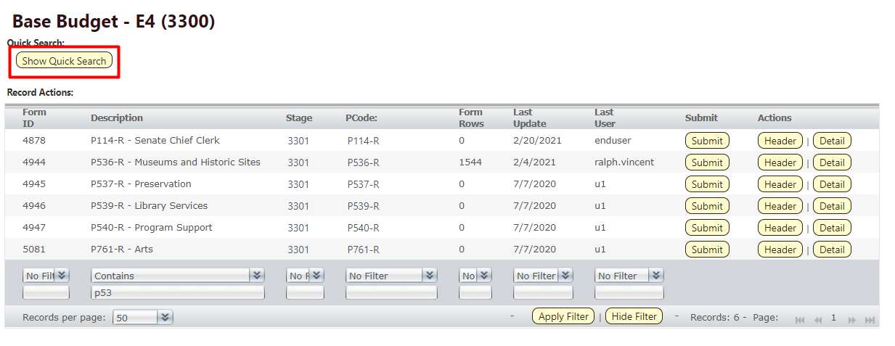

Budget Forms Overview
All budget forms have the same basic components, which are outlined in the table below. Depending on the information that needs to be provided by the Agencies during the budget process, the structure of each form may be slightly different. Forms may not use all elements, and in some cases some elements may be labeled differently for specific forms, as noted in the table. Detailed descriptions and click-by-click instructions for each form element are provided in subsequent sections of this document.

Form Element | Purpose | Detailed Description
Form List | Shows all budget forms available based on security profile; allows users to create new budget forms where appropriate | Section 8.1 Budget Form List Page
Header Tab | Contains general information about the form instance such as organizational unit (i.e., Agency, PCode, and/or Department ID) and form name | Section 8.2 Header Tab
Detail Tab | Contains detailed budget request including fund, account, amount, and justification text; labeled as Expenditures, Request, Revenues, or Transfers, and Measure(s) on corresponding forms | Section 8.3 Detail Tab
Export / Import | BFM feature that allows for budget form export to an Excel spreadsheet; users can enter data into the spreadsheet then import it back into the system to populate the form | Section 8.4 Excel Export/Import
Position Tab | Contains detailed position and employee data; allows system to project personnel costs; tab is only available to end users on the Expansion Request form | Section 10.3 Position Tab
Attachments Tab | Allows for files (PDF, Word, and Excel) to be uploaded as attachments on forms | Section 8.13 Attachments Tab
Narrative Tab(s) | Contains text fields to enter detailed narrative descriptions, also called Explanation Tab | Section 10.8 Explanation Tab

Base Budget E-4
BFM has two options for Base Budget E-4 forms: Base Budget by DeptID form 3300 and Base Budget by PCode form 4300. Agencies will select one form, either by DeptID 3300 or by PCode 4300, for each PCode to complete and submit for appropriations request.

Base Budget E-4 by Department ID, form 3300
The Base Budget by Department ID form will display data at the Department ID level, or level 4 in the hierarchy explained below. Data from SHARE that exists below level 4 will roll up to level 4 in the form.

Level | Name | Name / Format | Description
1 | All | ALL | Highest level of hierarchy, contains all Agencies
2 | Agency | 5 digit code  (50500)
3 | Roll Up | P+3 digit code-R  (P536-R) | Roll up level for all data level 4 and below
4 | PCode | P+3 digit code  (P536)
 | Department | 10 digit Department ID +  5 digit Agency ID  (3000000000-50500)
5 |  | 10 digit Department ID +  5 digit Agency ID  (3010000000-50500) | Rolls up to Department, level 4

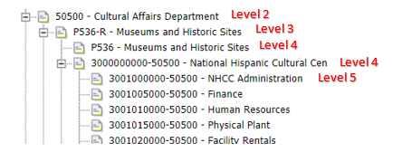

Base Budget E-4 by PCode, form 4300
The Base Budget by PCode will display data at the PCode Roll Up level 3.

Budget Form List Page
The follow sections provide detailed instructions for navigation and actions for the Base Budget form(s). The functions and features outlined in these sections will be available in other budget forms as well.

Select the appropriate Base Budget E-4 form (either Base Budget by Dept ID 3300 or Base Budget by PCode 4300) from the Budget Formulation menu. This user guide shows screenshots for the Base Budget by DeptID (3300) form, but the instructions apply to both forms.

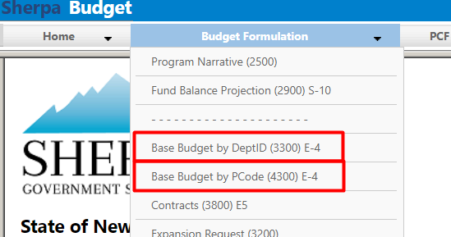

Select an available form from the main Budget form screen or "List Page." This page will return a form for each agency or program based on your security. If there are no agencies or programs assigned for your security role, this list will be blank. If you believe there is an error in the list of agencies or programs available in your list, then contact the BFM Administrator to update your security role.
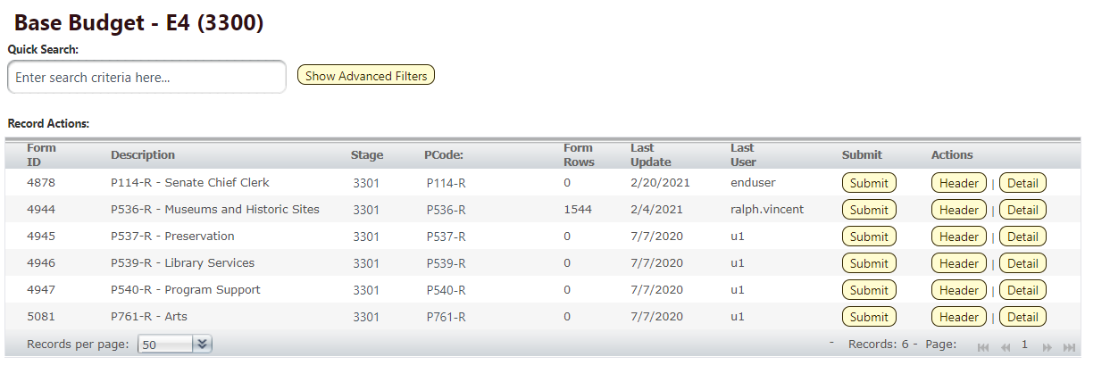

Most budget forms contain two Action options
- Header will open a tab that contains general and narrative data
- Detail will open a tab that contains budget data

To edit a form, users can click the Header or Detail buttons on the right side of the list.
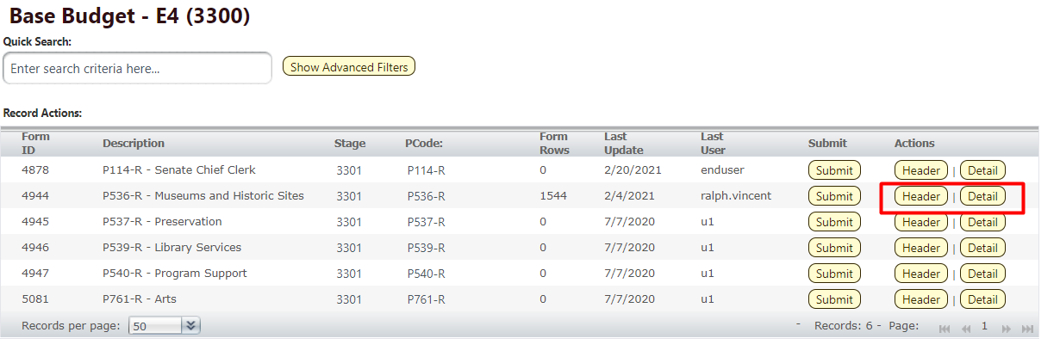

Header Tab
The Header tab contains general data for the form instance. From the Header tab, you can navigate to other form tabs including Expenditure (or Detail) and Attachments.

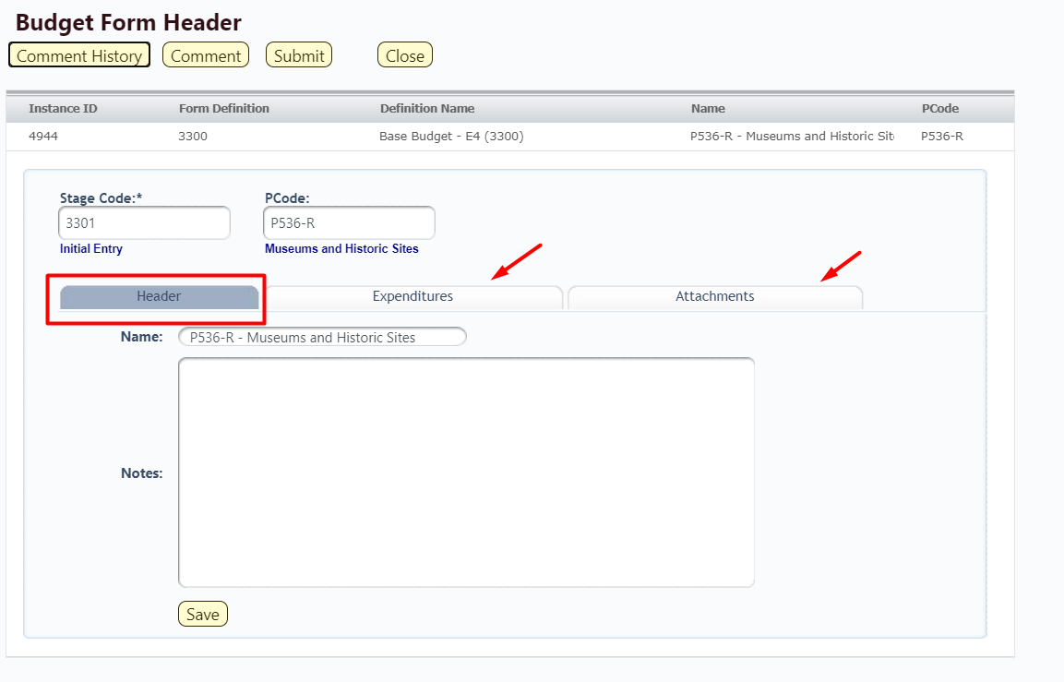

Tip: Depending on computer screen size and resolution, sometimes budget forms may not appear centered on your screen. If you need to reposition the budget form, move the cursor to the blue bar at the top of the screen. The cursor symbol will change to a cross; then click and drag the form to the desired position.
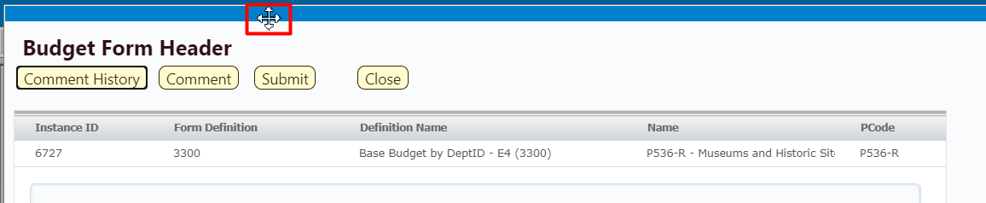

The Header tab data includes the PCode, Agency or Program Name, the Stage Code or workflow step, and a Notes field. To add Notes to the form, enter text into the field and click Save.

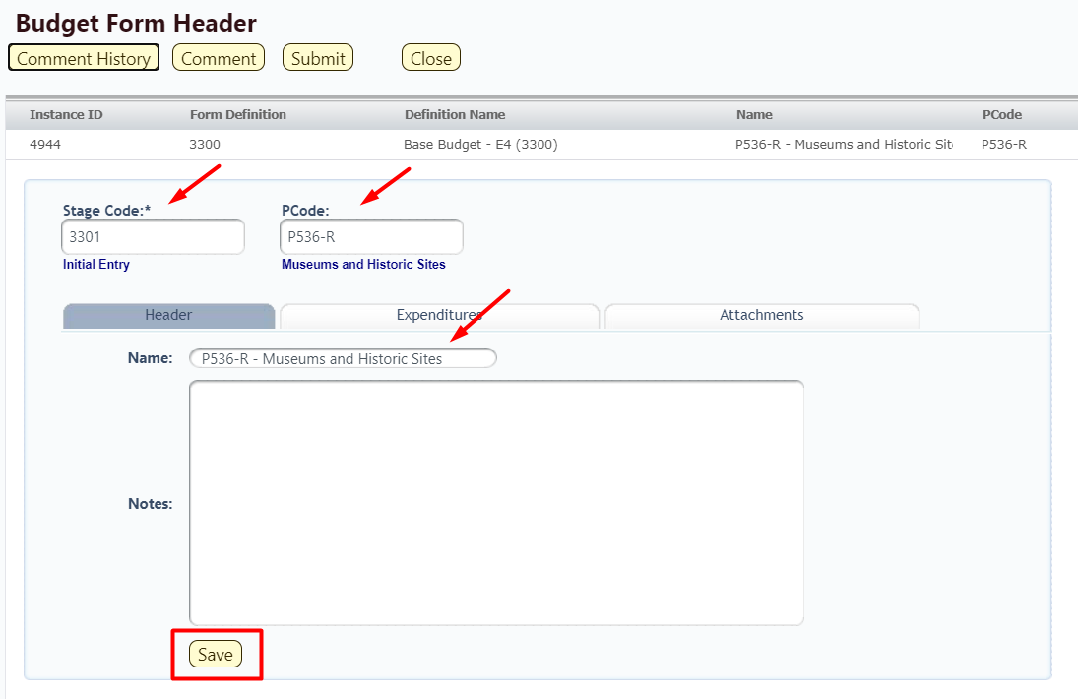

Comments
Click Comment History in the upper left corner to view any existing comments for the record.


The Budget Form Comments screen will display all comments for the record. These comments are view only and cannot be edited. Click Close to return to the Header tab.

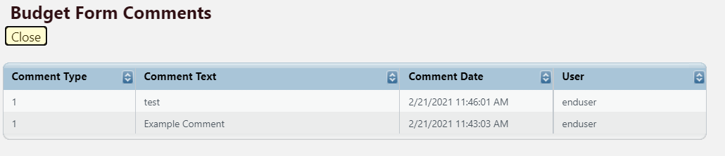

To add a comment to the form, from the Budget Form Header tab, click Comment.

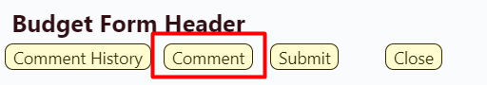

On the Budget Form Comments screen, select General the Comment Type* drop down. Enter comment text into the field. Click Add Comment to save. These comments will appear in the Comment History. Comments cannot be edited or deleted by end users.

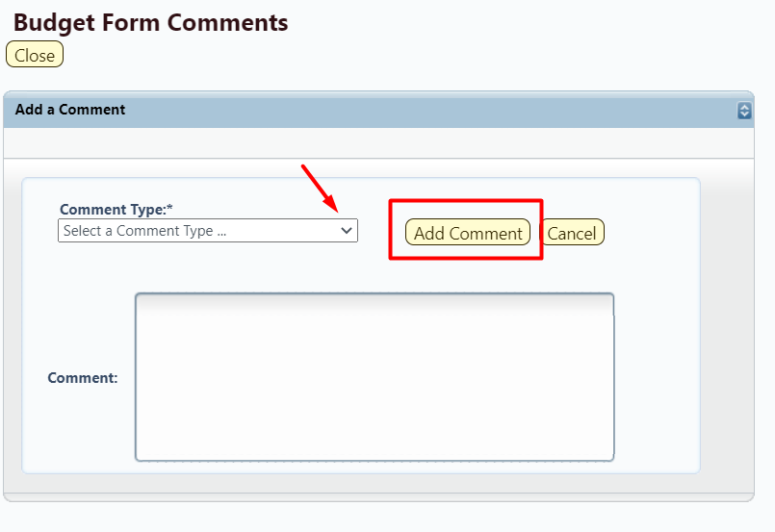

Click Submit will advance the form to the next step in the form workflow. This will be covered

Detail Tab
The Detail or Expenditures tab contains detailed budget request. Navigate to the Detail tab by clicking the Detail button on the budget form main screen.
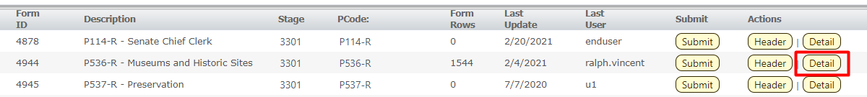

A user can also navigate to the budget data details by clicking the Expenditures tab from the Budget Form Header tab. Note: The system executes a query once you click the tab which may take a few seconds for the screen to open. There is no hourglass.

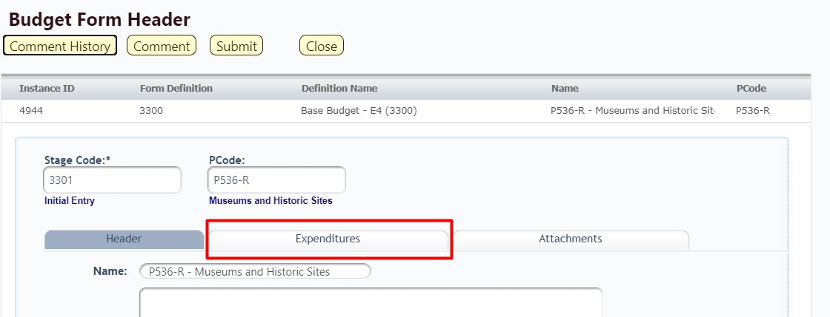

The budget form will load and the budget lines will be displayed.

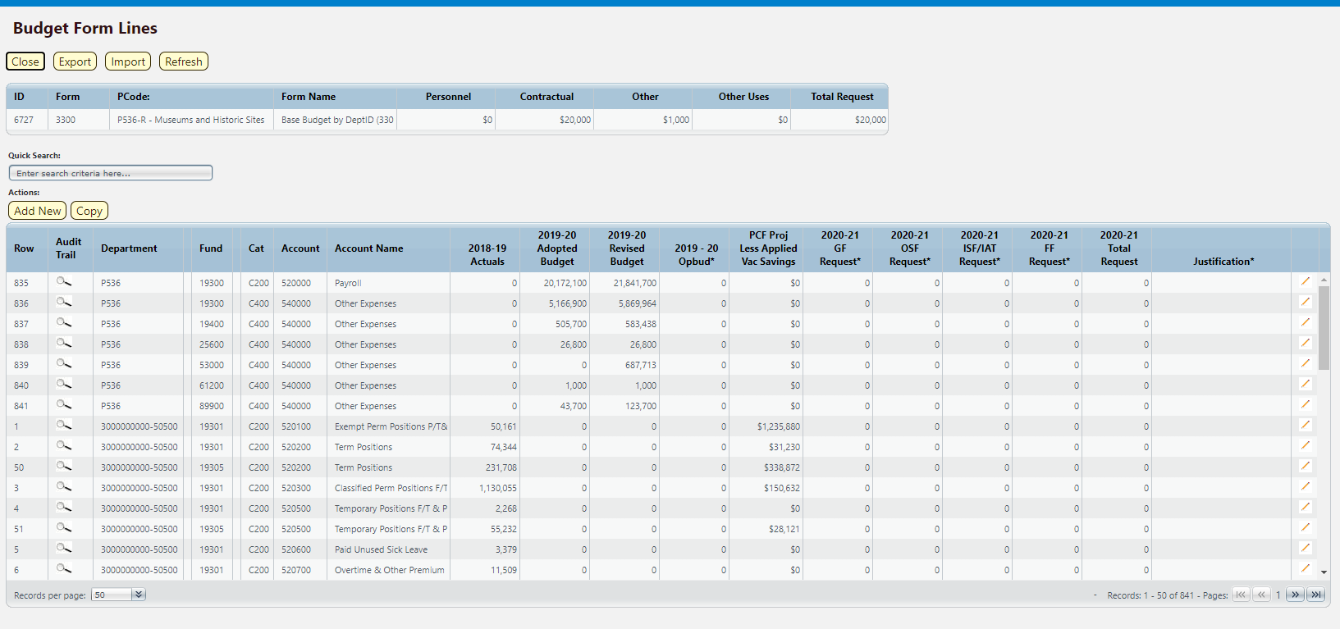

The top table shows a read-only summary of the budget request by Category. The columns are described below.
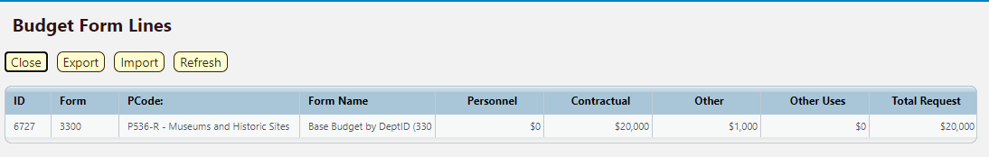

Screen: | Base Budget by Dept ID E4 3300 Budget Form Lines
Field (Column Name) | Description
ID | Read Only. Form Instance ID
Form | Read Only. Form number
PCode | Read Only. PCode and Program Name
Form Name | Read Only. Form Name
Personnel | Read Only. Total for C200 Personal Service & Employee Benefits
Contractual | Read Only. Total for C300 Contractual Services (from Contracts E5 3800 form)
Other | Read Only. Total for C400 Other
Other Uses | Read Only. Total for C500 Other Financing Uses
Total Request | Read Only. Total request amount

The second table contains the budget request data. Some columns contain read-only data; this data is either system data, imported from another source such as the financial system, or are calculated based on other values in the form. Columns with an asterisk (*) are data entry columns, where users enter the budget request data. The table below describes the columns for the Base Budget E4 by Department ID Form 3300.
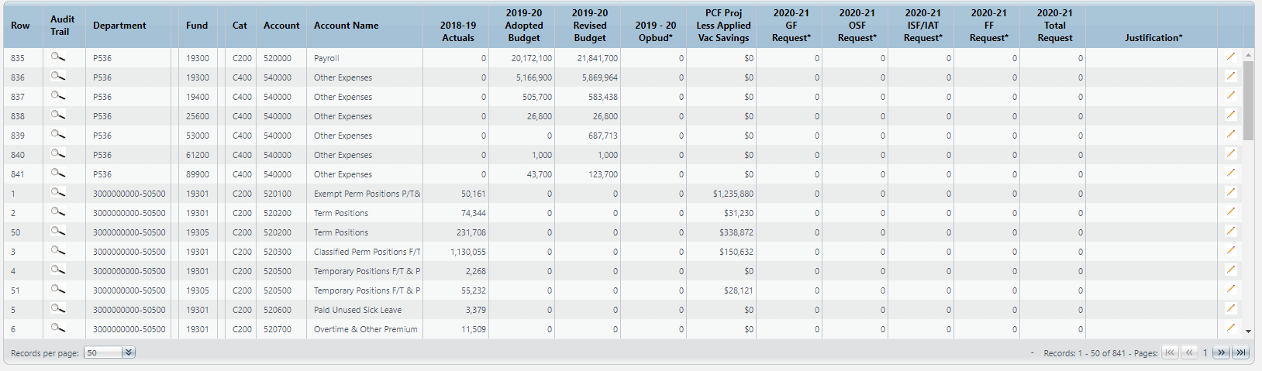

Screen: | Base Budget by Dept ID E4 3300 Budget Form Lines
Field (Column Name) | Description
Row | Read Only. Number indicating row count.
Audit Trail | Magnifying Glass button. Opens a window to display the audit trail records for the selected row.
Department | Read Only. Contains PCode Number.
Department Name | Read Only. This column is minimized, use double arrows to expand to see.
Fund | Read Only. Budget line for Fund
Fund Name | Read Only. This column is minimized, use double arrows to expand to see.
Cat | Read Only. Budget line for Category code
Account | Read Only. Budget line for Account
Account Name | Read Only. Budget line for Account Name
20XX-XX Actuals | Read Only. Budget line for previous year Actuals data from SHARE
20XX-XX Adopted Budget | Read Only. Budget line for current year Adopted Budget data from SHARE
20XX-XX Revised Budget | Read Only. Budget line for current year Revised Budget data from SHARE
20XX-XX OpBud* | Data Entry Column. Enter current year Operating Budget at the Dept ID / PCode level  Note: During the first year of using BFM, users must enter this amount. In future years, this will be pre-populated based on previous year’s form data.
PCF Proj Less Vac Savings | Read Only. Budget line for Personnel Cost Forecasting (PCF) amount less the Vacancy Savings calculated in Form 3700
20XX-XX GF Request* | Data Entry Column. Enter General Fund request
20XX-XX OSF Request* | Data Entry Column. Enter Other State Funds request
20XX-XX ISF/IAT Request* | Data Entry Column. Enter Internal Service Funds / Interagency Transfer request
20XX-XX FF Request* | Data Entry Column. Enter Federal Funds request
20XX-XX Total Request | Read Only. Sum of data entry requests columns.
Justification* | Entry Column. Enter text justification
Pencil (edit) Icon | Edit icon. When clicked, the Line Detail screen will display to allow budget request entries. Double-clicking a row performs the same action.

Chart of Account Dimension Names
To reduce clutter on the data entry screen, some columns will be minimized to hide Chart of Account dimension names. These columns can be expanded to reveal the Chart of Account dimension names if needed. In the screenshot below, the blank spaces in the budget grid can be pulled to the right to reveal the names of the dimensions.

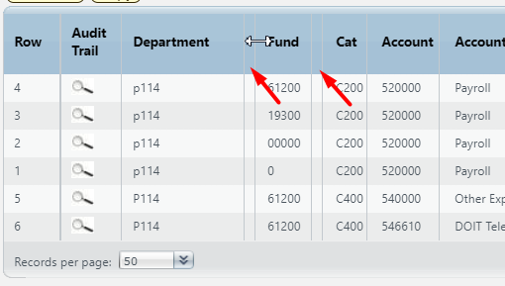

The screenshot below shows the Department Name and Fund Name columns expanded.

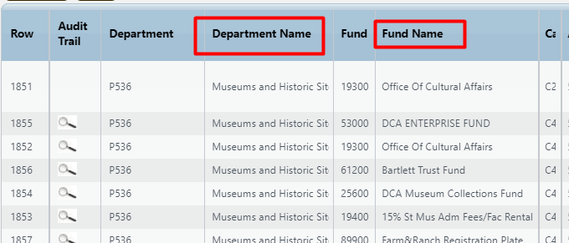

Excel Export/Import

BFM provides the ability for users to export and import budget forms via an Excel spreadsheet. This can streamline the budget data entry process, as formulas and other Excel tools can be leveraged to populate the budget form. In general, a user will export the budget form from BFM, make changes in Excel, and then import the spreadsheet back into BFM.

Important Note: The spreadsheet imported into BFM must follow the same format as the BFM export spreadsheet, that is the columns must match the same columns as on the BFM budget form. Below are the most reliable methodologies for creating an Import File:

- Click Export in the budget form, then make your entries directly into the pre-formatted spreadsheet and Import.
- Click Export in the budget form. Make entries in other spreadsheets. Copy the values into the Export template once you are ready to Import.
- Click Export in the budget form. Use formulas to link those cells to the more elaborate source spreadsheets and upload the properly formatted file when ready.

The instructions below show a click-by-click guide for how to export, update, and import the spreadsheet.

Go to Budget Formulation / Select the budget form.

Select the form instance you wish to update.

Click Detail (or navigate from the Header)

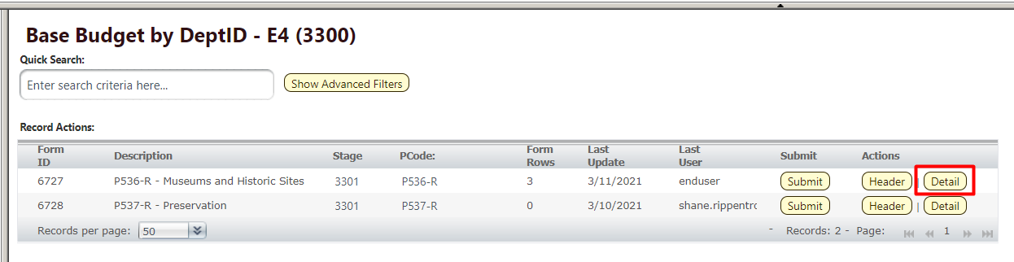

At the top of the page, click Export. If you do not see an Export button, that form may not allow for Imports.
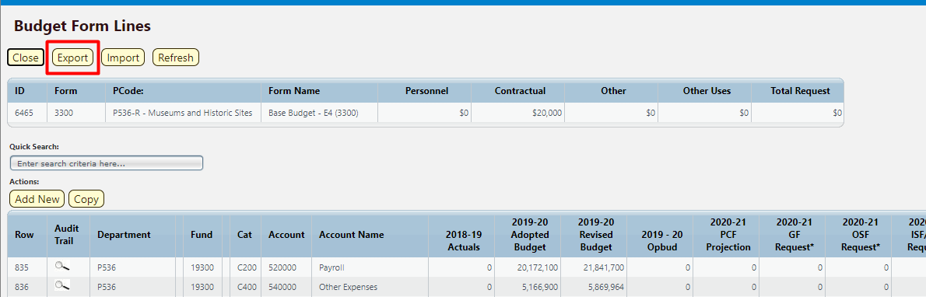

At this step, users may have different interactions depending on their settings for downloads. You may be prompted to Open or Save your file, or a default action has been selected in the past. The following example will follow choosing Open.

Click Open.

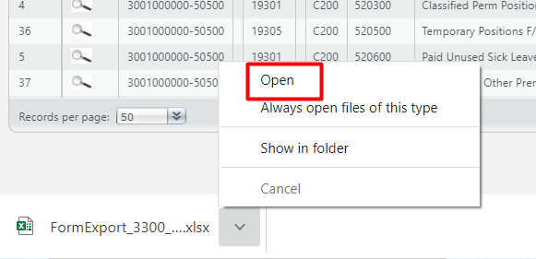

An Excel spreadsheet will open. There will be a yellow ‘Protected View’ ribbon at the top of the spreadsheet. Click the Enable Editing button.

Note: you can eliminate this Enable Editing button from coming back by going to Excel:
File/Options/Trust Center/Trust Center Settings/Protected View/uncheck everything.

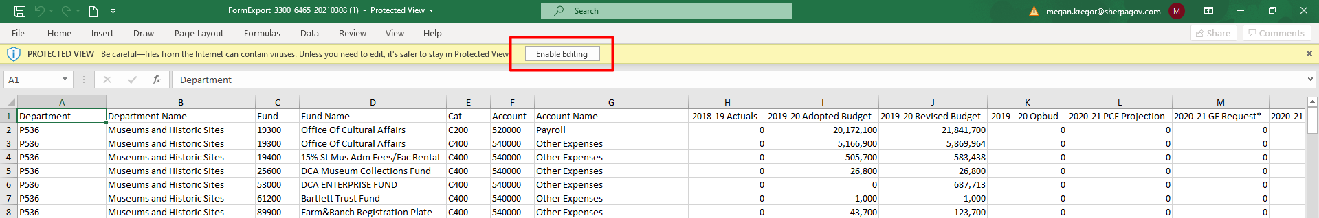

You will not be able to make changes in the spreadsheet unless you enable the spreadsheet to accept edits.

Next, it is best to Save As the spreadsheet. The original spreadsheet is saved as read only since it comes from the internet. Click File on the ribbon.

Then click Save As.

Choose a location to save the Excel worksheet where you can easily find it later. Keep the location simple since you will have to be able to find it again when you import. In the example below, a folder was created on the Desktop for BFM Exports.

Click in the ‘File name:’ text box and name the Excel worksheet. Note that depending on your version of Excel this window may appear differently.

Click in the ‘Save as type:’ menu and choose Excel Workbook (*.xlsx)

Click Save

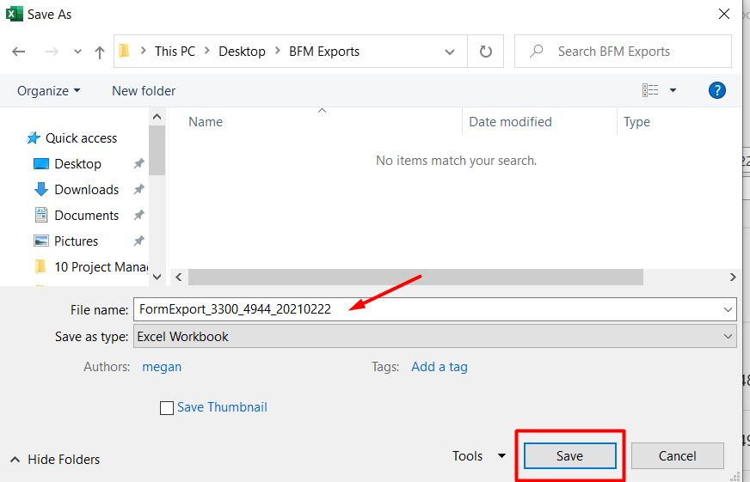

Update Spreadsheet with Budget Values
The spreadsheet is exported in plain text, with no formatting applied. The screenshot below shows the header row with text-wrapping so that all columns could fit in the screenshot for this document. When a user opens the spreadsheet, s/he can apply the same formatting for ease of use, if desired.

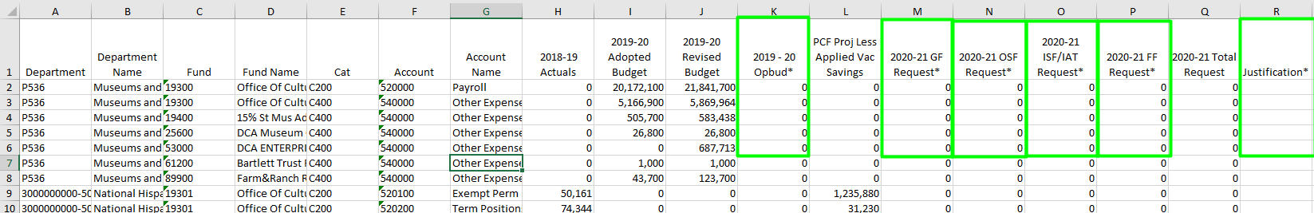

Get to know your spreadsheet.
- The spreadsheet above shows three rows of data. This is data that already exists on the form that was exported for this example. Depending on the state of your form, your spreadsheet may or may not have data.
- The columns of data consist of display columns and data entry columns, just like on the BFM form screen. Data entry columns are marked with an asterisk (*) next to the column heading and are outlined in green in the screenshot above. Data entered in these columns will be uploaded to the system during import.
- Display columns, such as the Actuals (column H) and the Adopted, Revised, and OpBud (columns I-K), are populated by data from other sources. These columns cannot be updated, just as on the BFM form screen, and if data is entered it will be ignored when imported.
- Columns with codes can be updated through the import. In the screenshot above, code columns include Department (column A), Fund (column C), and Account (column F). Name columns, such as Department Name (column B), Fund Name (column D) and Account Name (column G) exist to help users but will NOT be considered on Import. If you change text in a name column on an existing row, the change will be ignored on import.
- If you add a new row you do NOT have to include names in the name columns. When the spreadsheet is imported, the system will auto-populate the name fields based on the codes entered in the spreadsheet.
- If you change the text in an existing code column in the spreadsheet, BFM will import the change as a new row. The existing row will remain on the form, and a new row will be added with the new code and corresponding data added in the spreadsheet.
- If you create a duplicate of an existing budget line, only the single existing row will update as the system will aggregate the information during the import process.
- The number of columns and the order of columns cannot change. The BFM importer expects the exact file format that was exported. Do not add additional columns to the right or insert/delete columns (or if you do – put it back in this format prior to trying to import).

Make changes in your spreadsheet. Below are example changes:
- To change the request amounts in an existing row. Enter values into the data entry columns (M, N, O, P in the example). When the file is imported, BFM will load the new values.
- To delete data on the form, do not delete the row, instead zero out the data by entering a 0 in the cell. On import, the row will not be deleted, but the row will be zeroed out in the system.
- To add justification text, type in the columns that have text. If text exists on the export, type over the text in the cell. When the spreadsheet is imported, the previous text will be saved in the audit trail.
- To add a new row, insert a row in Excel. Populate the Chart of Accounts dimension codes, enter the requested amount in columns and text in Justification. Remember, you do not need to enter the Name columns (B, D, and G), as these will be auto populated by the system based on the codes entered.
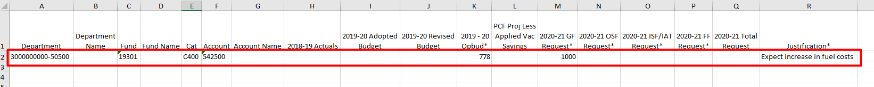

Save your spreadsheet.

Import Spreadsheet
Before importing, remember the number of columns and the order of columns must be the same as the spreadsheet exported from BFM. If you have made any change to the layout of the exported spreadsheet, reformat the spreadsheet to match the original layout before attempting to import.

Navigate to the correct budget form that you wish to import. From the Detail (Expenditure) tab on the budget form screen, click Import.

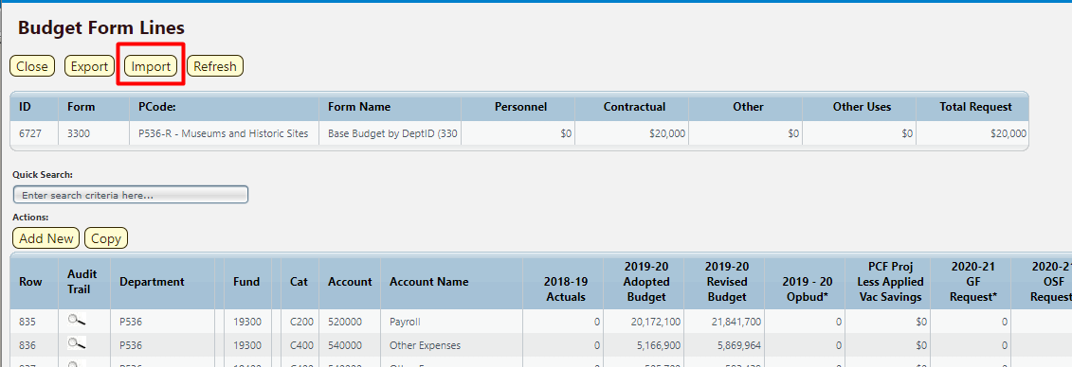

Click Browse and find your file.
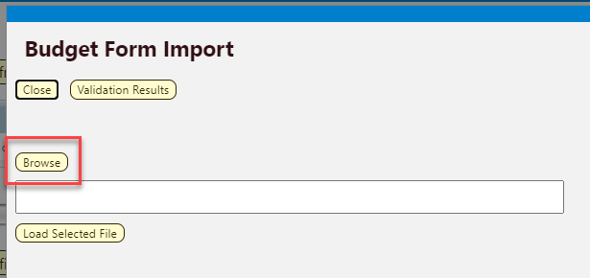

Hint: click on Date Modified heading and the file you just saved will go to the top. If a file is open, it will have a second entry with a ~ prefix; do not select that file. You do NOT have to close the file to upload it.
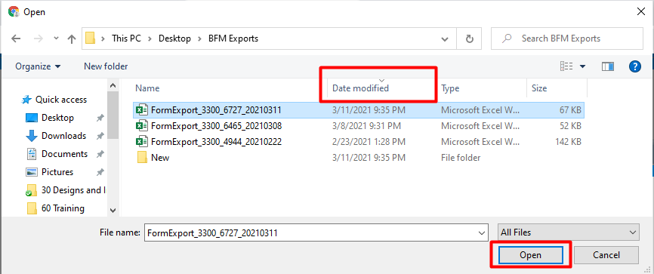

Click Load Selected File. If you see "fakepath" in the file name, this is just a browser security feature.
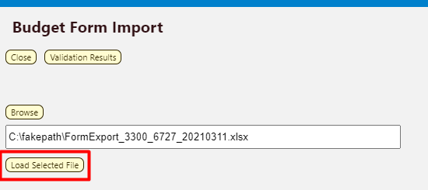

If the font returns in black it was successful. If there are errors the screen will have text returned in a red font. Review 8.7 Import Notes and 8.8 Import Errors for assistance in resolving errors.

Click Close in the upper left if you are successful.

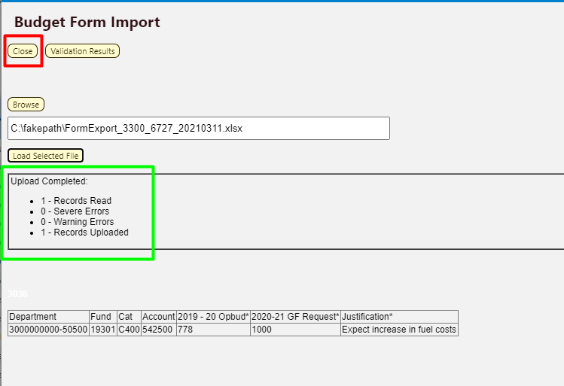

Once you close the upload screen, you will see a Loading… message. The results will load shortly. The screenshot below shows the new row added to the spreadsheet in the example above. Note how the system auto-populated the Account Name field based on the Account code entered.
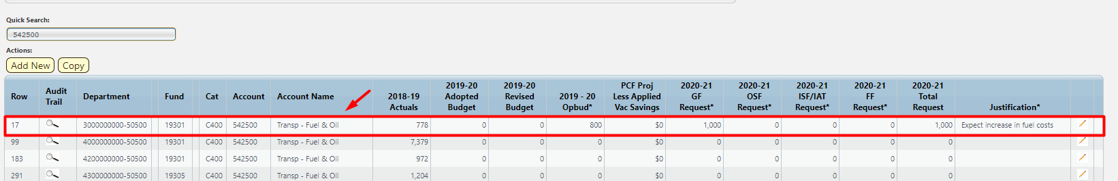

Import Notes

Leading Zeros
For some Line Sequence codes, leading zeros can be dropped by Excel. If your Line Sequence is 0002, the spreadsheet will show just 2 in many cases. This is ok. The import will add leading zeros back to the value so you can make your entries using just the 2 value.

Incomplete Files
You can load just one row or a series of rows and it will not harm existing rows. For example, you uploaded a 400 row spreadsheet three days ago, but someone may have made changes in BFM. You can Export/ Import or simply create an import file with the 3 rows that changed and import the smaller spreadsheet. It will apply the deltas to those new rows and leave all other rows remain untouched.

Import Errors
The below spreadsheet has invalid Department, Fund, and Account codes.

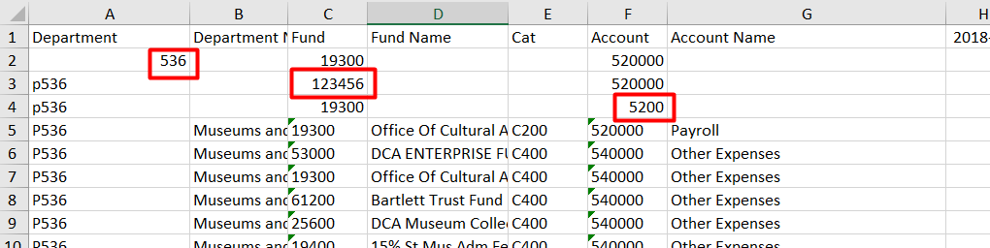

When you attempt to import a file that has any invalid codes or data, you will see an Upload Failed in red font with associated notes.

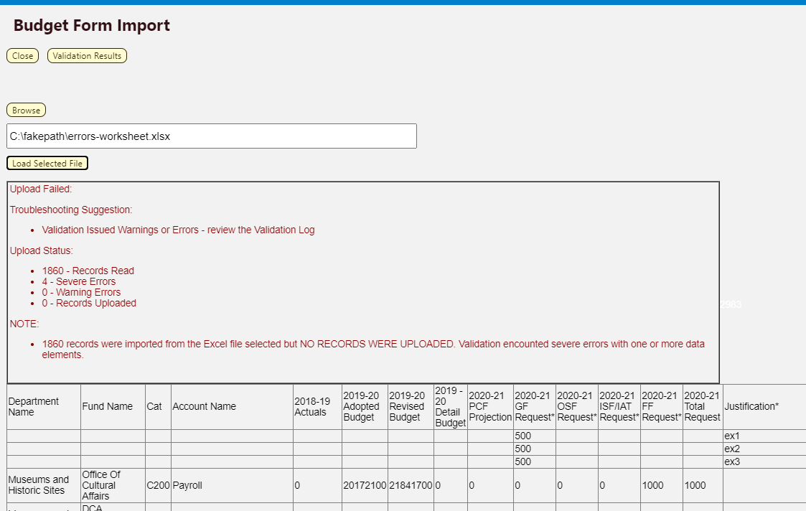

Click on Validation Results button in the upper left.
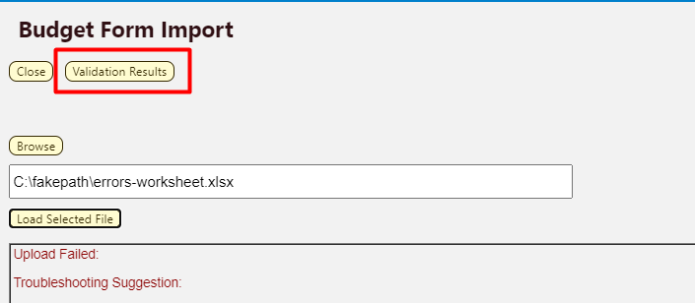

Review the upload validation message details. Note that you may have multiple errors on one row since it failed multiple validations. In this example, Row 1 had an invalid PCode (Organization) value; Row 2 had an invalid Fund code; and Row 3 had an invalid Account.

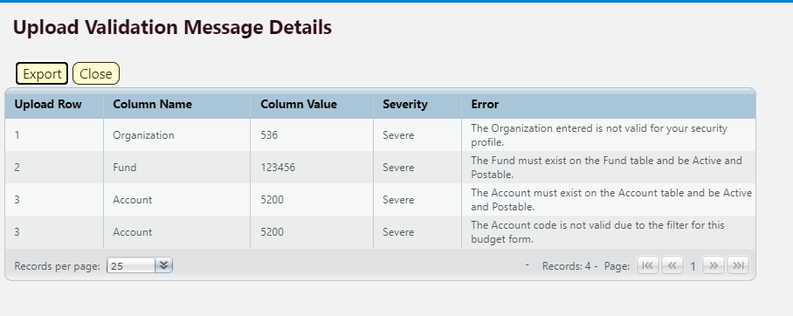

Return to the spreadsheet and make your corrections.

Invalid chart of accounts entries
Resolution: correct the entries or contact your BFM Administrator to have the chart of accounts added to BFM.

Blank rows at the end of the spreadsheet
Highlight the rows and choose Clear All. Clear all is in the Home ribbon in the upper right-hand corner, under the Clear option.
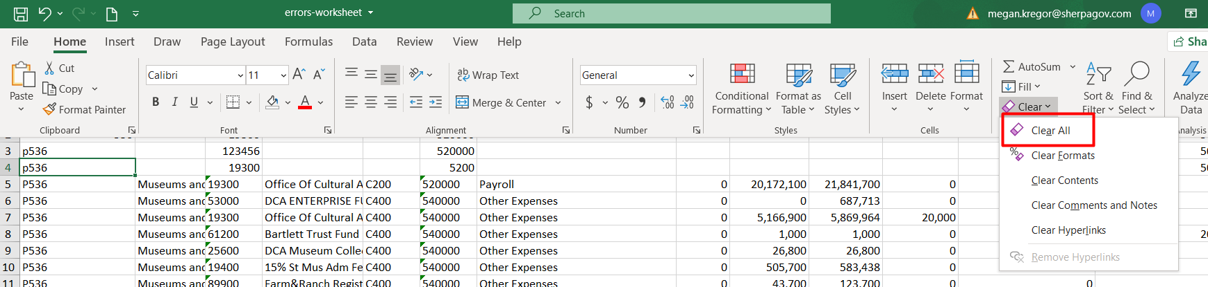

Values in a column not part of the upload, such as in column W
Highlight the cells and choose Clear All.

Re-import corrected file.

In-Line Editing – Existing Budget Entries
Budget request can be entered directly onto the screen, without using the Export/Import function described above.

Select a row to edit by either double clicking the row or clicking the Pencil icon on the right-hand side of the row.

Enter budget values or justification text into the text boxes that appear in the data entry columns, denoted with an asterisk (*). Click the blue X in the last column to cancel data entry.
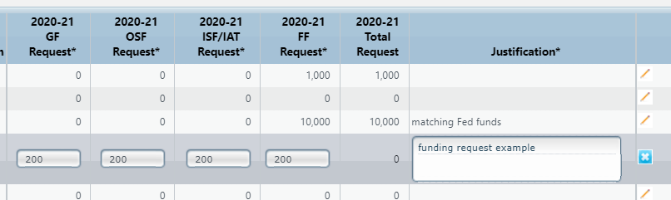

Click Save All in the bottom right-hand corner.

Note: Once data has been entered into the row, the entered text will be red until the data is saved.

Important: The entries on the visible screen must be saved before moving on to another page. If the Save All button is not clicked before the advance the page is clicked, the changes on this page will NOT be saved.

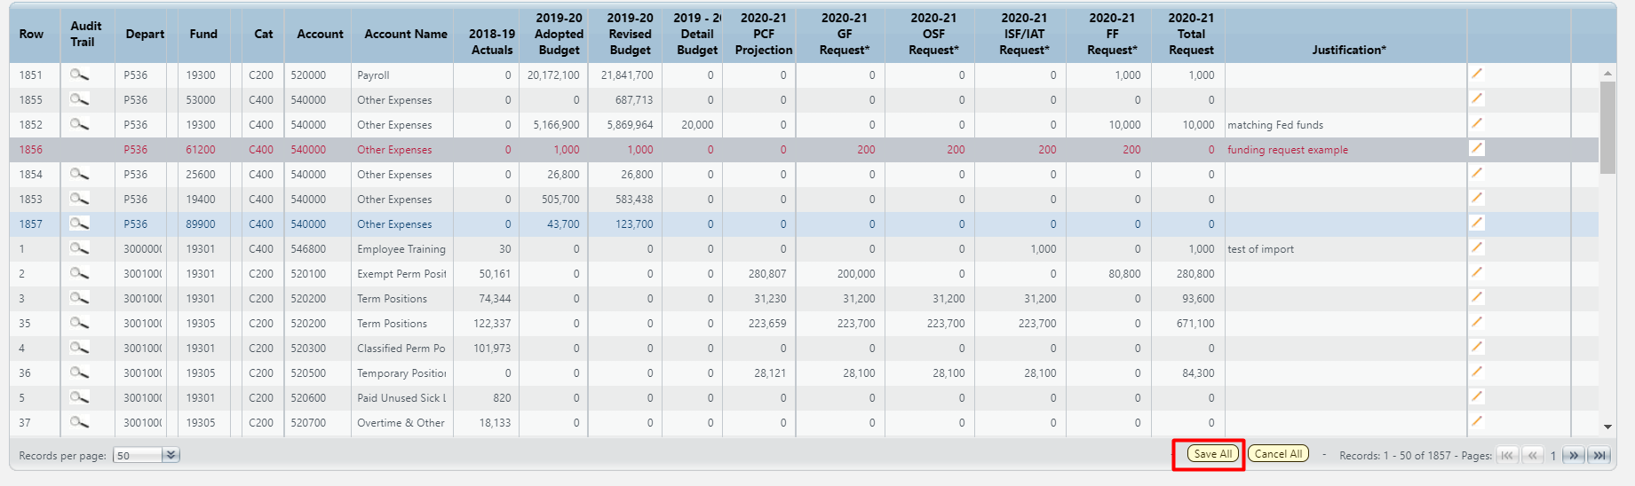

Once the data is saved, the Total Request column will be calculated by adding all request columns. Note: BFM will automatically perform natural rounding for all entered values to the nearest 100.

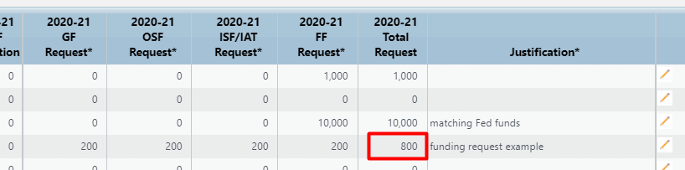

Audit Trail
Audit Trail stores the amount and text changes with the corresponding user and date timestamp.

Click on Magnifying Glass icon on a budget line.
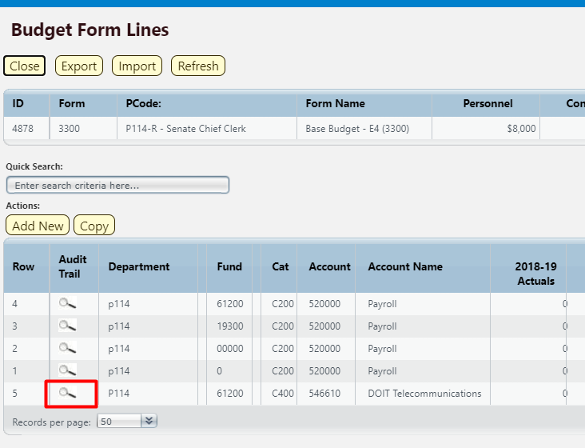
The Budget Form Expense Line History window opens with complete audit of all budget line changes.

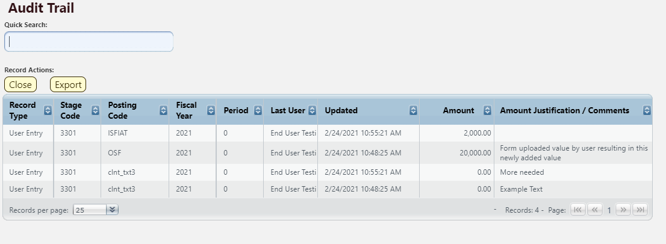
Below is a table with Audit Fields and Descriptions:
Budget Form Expense Line History | Budget Form/Magnifying Glass
Field | Description
Record Type | The source of the data.
Stage Code | The stage to where the amount by which you changed the data is posted.
Posting Code | The posting code used in SHARE. Most entries save to BUDGET; clnt_txt2, clnt_txt3 are the text entries.
Fiscal Year | The fiscal year.
Period | The fiscal period, it will generally be 0 to indicate we are not budgeting by month.
Last User | The user who saved the change.
Updated | The time and data stamp of the change.
Amount | The amount by which you changed the data is posted. The sum of these amounts should reflect what is seen on the Details page.
Amount Justification/ Comments | For Posting Codes = clnt_txt3, this displays line text. For all other entries, this displays the audit text.

Click Close button to return to list of budget lines.

Add New Budget Entry

From the Form Details (Expenditure) tab, click Add New.
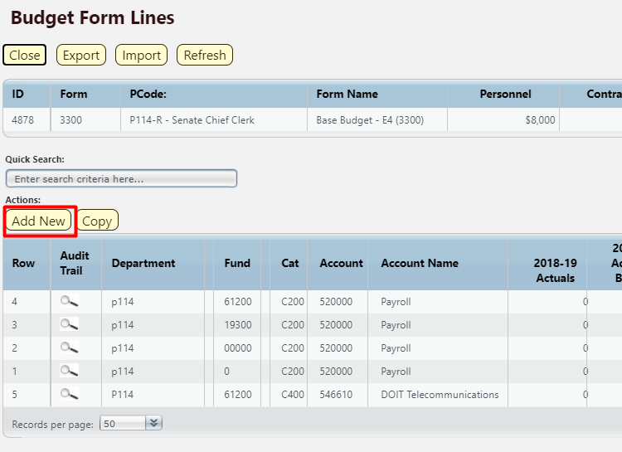

Click the magnifying glass to search for the codes to be added.
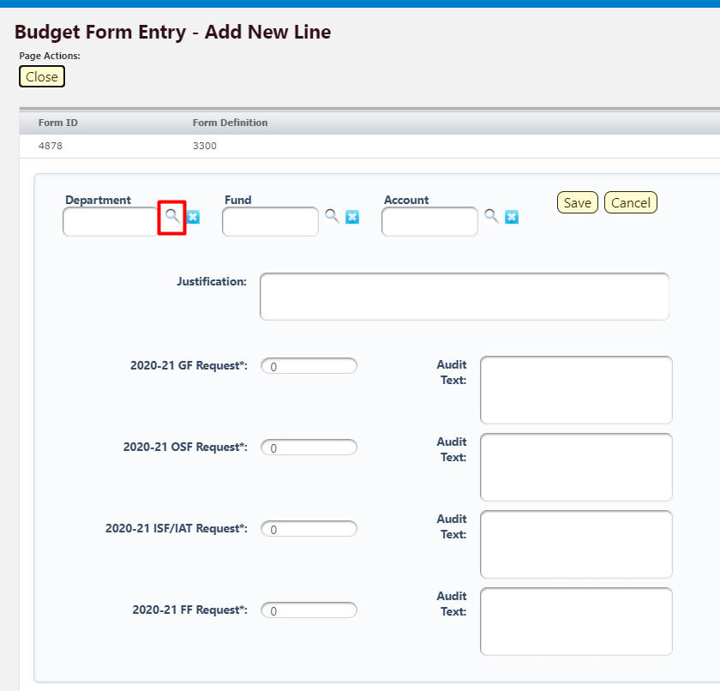

Click Select on any of the codes in the list. Note, you can also type in the code or name in the Quick Search, wait for one second, and then select from the filtered list.

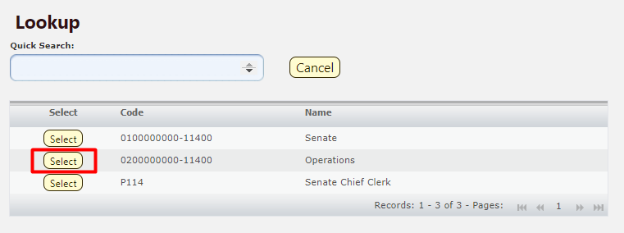

Repeat for all Chart of Account dimensions in the budget form.

Enter an amount in the request field(s). Note: BFM will automatically perform natural rounding for all entered values to the nearest 100.

Click Save.
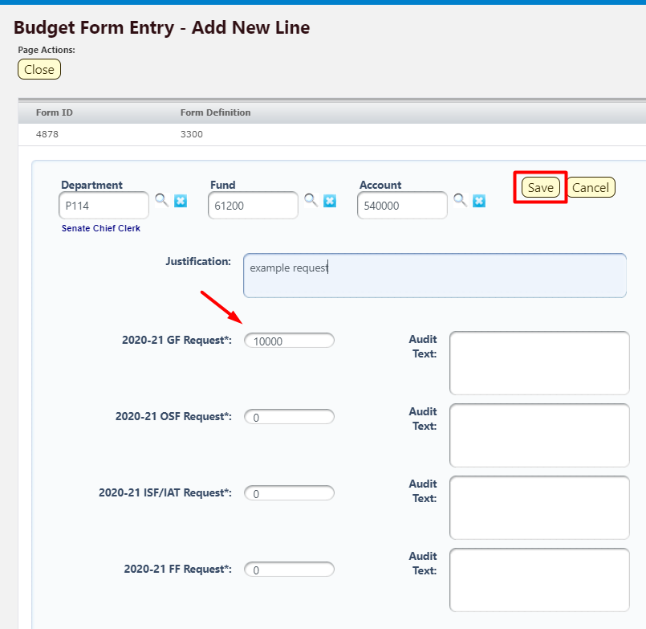

The new row will appear on your budget form.

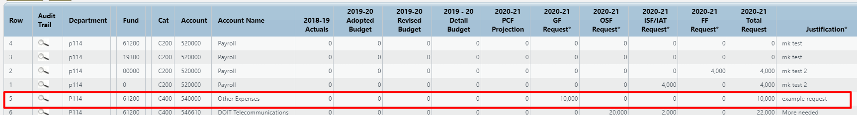

To closing a Budget Form instance, click Close to return to the “List Page”, the main screen for the budget form.
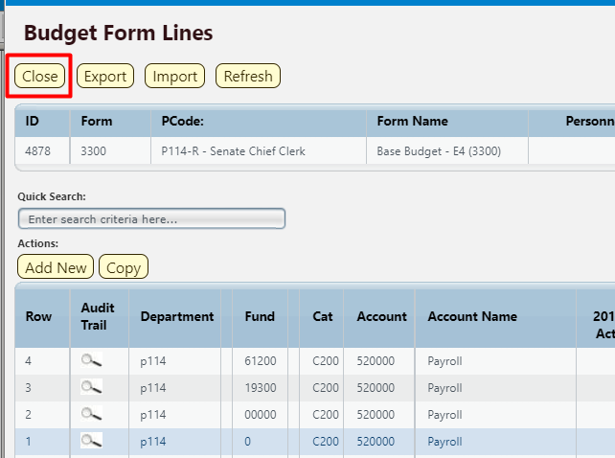

Delete Existing Budget Entry
In order for the audit trail to be easy to follow, deleting rows is currently not allowed. Just type a zero (0) in any field you wish to 'delete' to zero out the data and delete any text and Save All.

Double Click Row

Enter 0 to zero out the amount field.

Click Save All.

Alternatively, if a whole form needs to be zeroed out, Import/Export functionality can be used. A form can be exported, all rows set to 0, and then imported.

Attachments Tab
Attachments can be added to Budget Forms.

From the main budget form screen, or “List Page,” click Header.

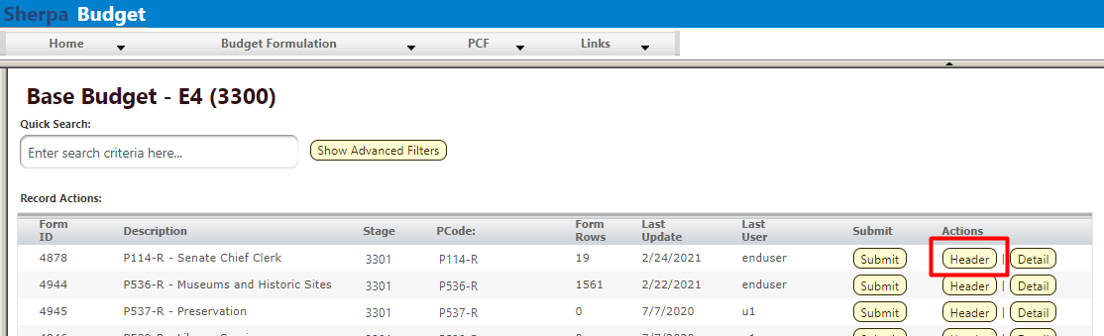

Once on the Header tab, locate the Attachments tab and click to open.
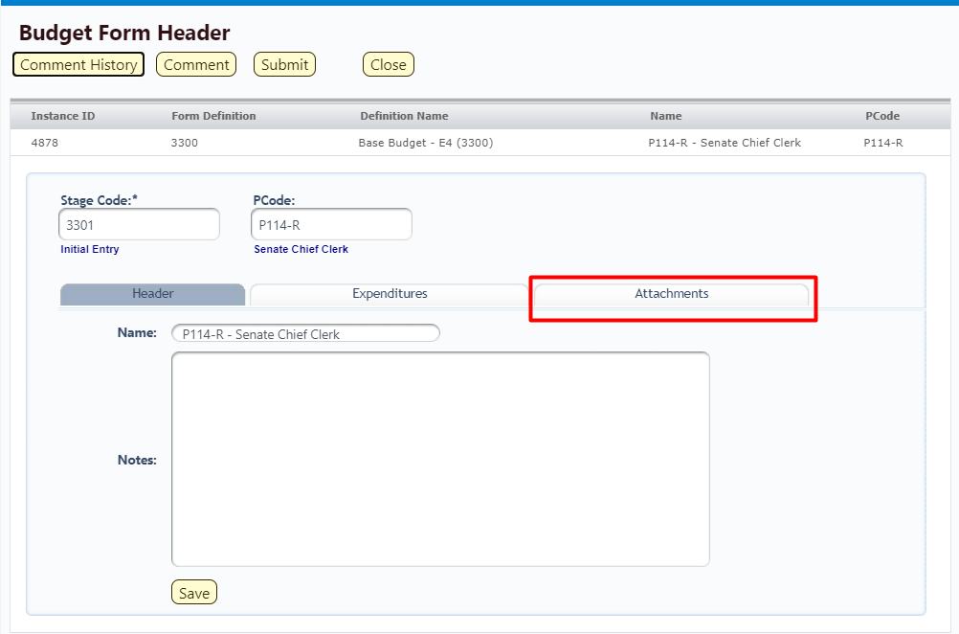

Budget Header – Attachments tab
The Attachments tab contains the documents attached to the form. There are pre-defined file types that are acceptable for uploads. If a file you want to upload is not a valid file type, contact your BFM Administrator to request additional file types to be added.
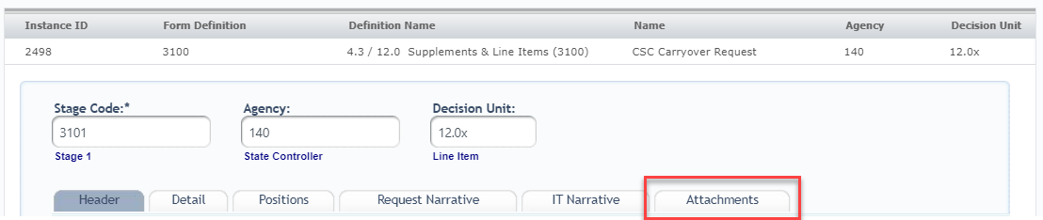

Click the Attachments tab.

Click the Upload File(s) button

Click Browse For Files to open Folder Structure. If you get an Active X warning, please contact your system administrator. You will not be able to upload a file until a change is made to your Internet Explorer.

Select the file to attach. Currently Word, Excel, and PDF are supported file types.

Click Upload button. You will get a confirmation when your file uploads.

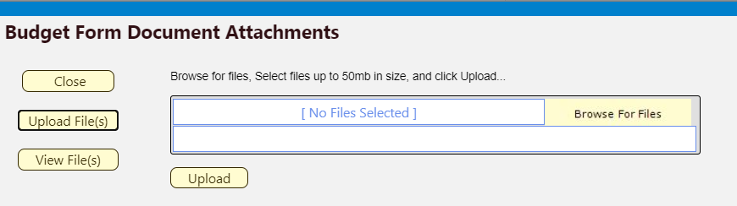

Click on View Files to see attachments that are on this form.

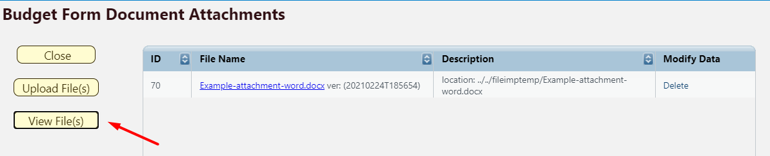

Submit Budget Form
Submission allows users to move a form instance to a different stage. A user can have access to submit a form instance to a stage even without the security rights to edit the form at the submission stage.
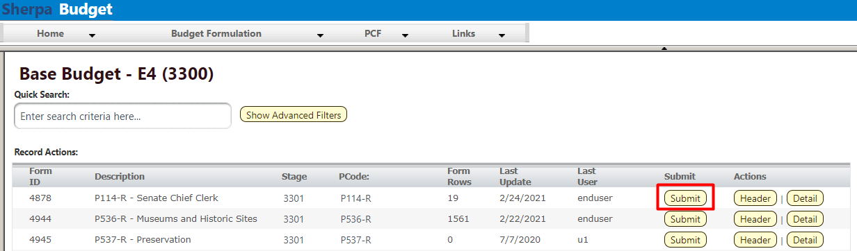

Select your budget form definition.

For the instance you wish to submit, click the Submit button on the main budget form screen or “List Page”.

On the Submit Budget Form screen, Select a Stage from the dropdown menu. Based on individual security settings, this dropdown will display which stages you have access to submit to. If you do not see a Stage Code, this means you do not have security to submit. Note: depending on your security permissions, you may be able to submit a form to a prior stage, that is send it back to the previous stage.
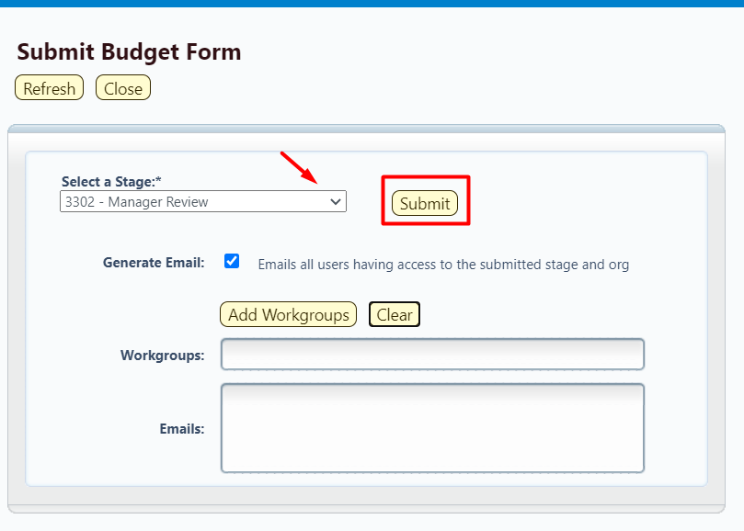

Generate Email (Checkbox) – If this is checked upon submit, a notification will be generated to the individual(s) who have stage and organization access at the submitted stage.

Workgroups – This can be used to select individual users to be notified that a budget form was submitted to the selected stage. This option ignores stage and organization security. Click Add Workgroups and use the list to select the users who should receive an email notification. Click Add Emails for Selected Groups. The Workgroup and Emails will appear in the corresponding fields on the Submit Budget Form screen.

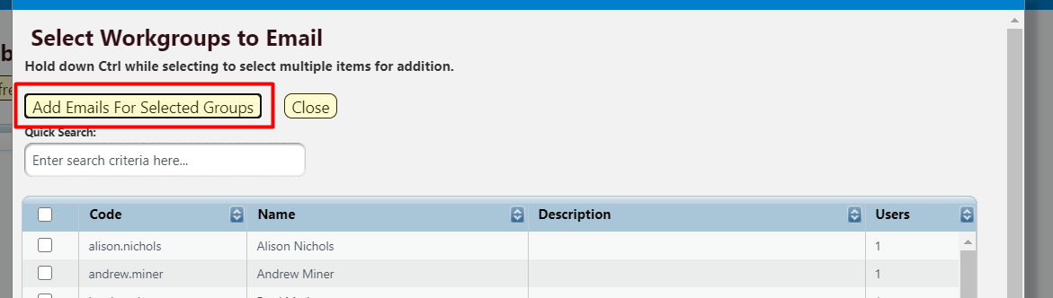

Click Submit.

Once submitted, the budget request will no longer be visible on the Budget Forms List Page if the user does not have security rights to edit at the new stage. If the form needs to be edited, contact the BFM Administrator to request the form be reverted to the appropriate stage.

Reports
Data from the Base Budget E-4 3300 form can be viewed in the S-8 Financial Summary and S-9 Account Code Summary. See Section 21 BFM Reporting for instructions on how to access reports.

Contracts E-5
The Contracts E-5 form will be used to submit appropriation requests for contractual services and provide a detailed listing of contractual agreements by contract purpose.

Similar to the Base Budget E-4 forms, BFM has two Contracts E-5 forms available: Contracts by DeptID form 3800 and Contracts by PCode form 4800. Agencies will select one form, either by DeptID 3800 or by PCode 4800, for each PCode to complete and submit for appropriations request.

The following instructions show screenshots for the Contracts by Dept ID 3800 form, but these instructions apply to both Contracts forms.

Create New Contracts Form

Navigate to the Contracts form by hovering over the Budget Formulation menu and select the appropriate Contracts E-5 form from the dropdown menu. 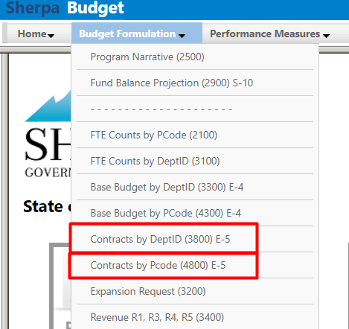

Click Add New to begin a new form. Alternatively, click Detail for an existing form to edit and proceed to step 9.1.5.

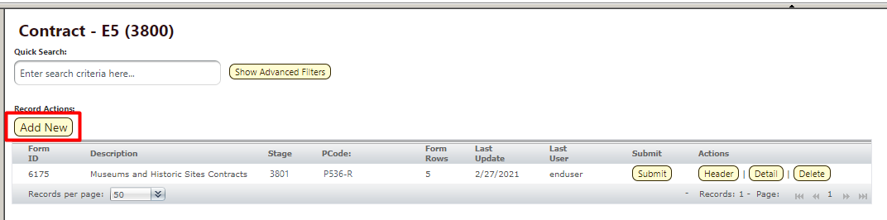

Select Stage Code 3801 – Initial Entry from the dropdown. Enter the PCode and Name of the Contract form. Click Save.
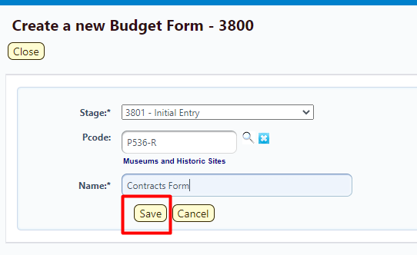

The budget form header will load. Click Contracts to load the Details screen.
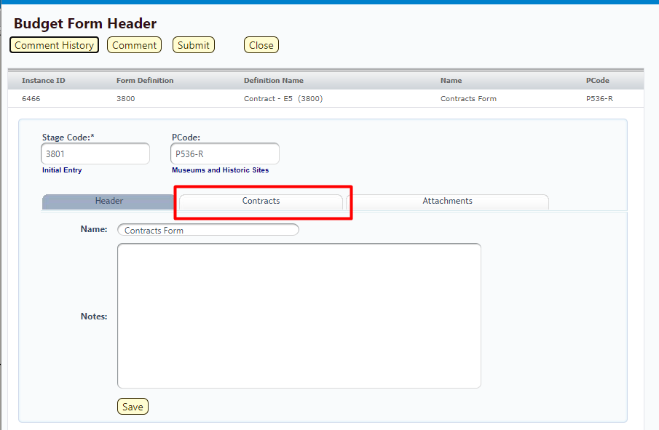

The budget form will load.
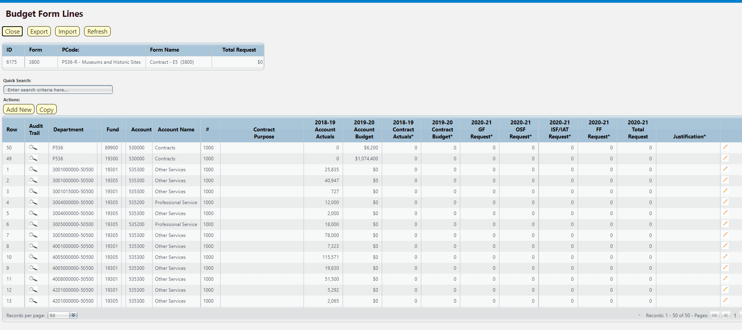

The top table shows a read-only summary of form. The columns are described below.
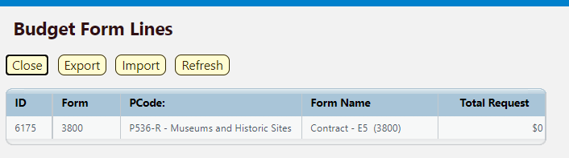

Screen: | Contract E-5 3800 Budget Form Lines
Field (Column Name) | Description
ID | Read Only. Form Instance ID
Form | Read Only. Form number
PCode | Read Only. PCode and Program Name
Form Name | Read Only. Form Name
Total Request | Read Only. Total request amount for form

The second table contains the budget request data. Some columns contain read-only data; this data is either system data, imported from another source such as the financial system, or are calculated based on other values in the form. Columns with an asterisk (*) are data entry columns, where users enter the budget request data. The table below describes the columns for the Contracts E-5 form.
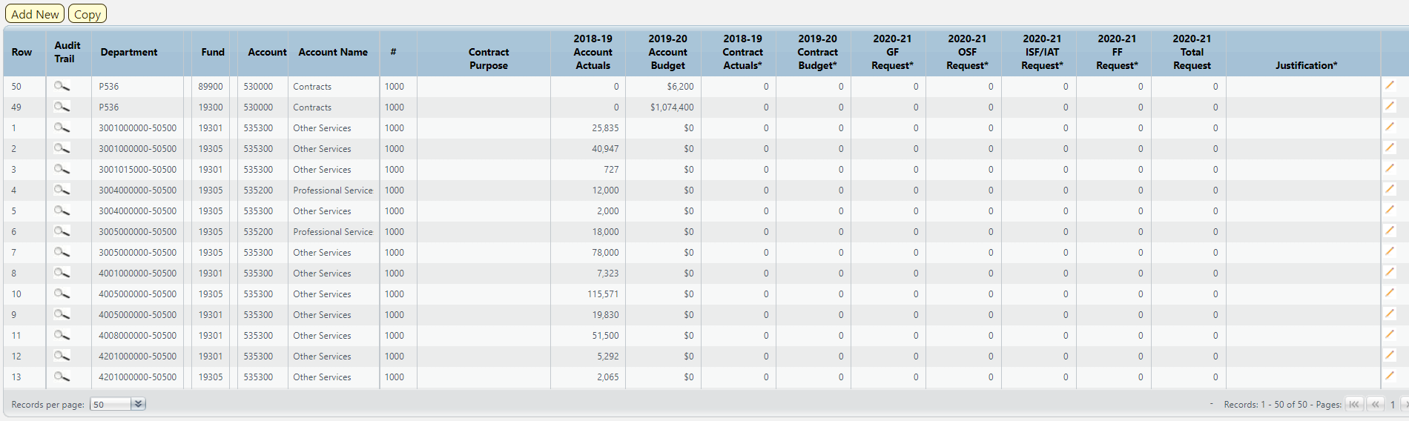

Screen: | Contract E-5 3800 Budget Form Lines
Field (Column Name) | Description
Row | Read Only. Number indicating row count.
Audit Trail | Magnifying Glass button. Opens a window to display the audit trail records for the selected row.
Department | Read Only. Contains PCode Number.
Department Name | Read Only. This column is minimized, use double arrows to expand.
Fund | Read Only. Budget line for Fund
Fund Name | Read Only. This column is minimized, use double arrows to expand.
Account | Read Only. Budget line for Account
Account Name | Read Only. Budget line for Account Name
# | Read Only. Line item number for each new contract added.
Contract Purpose* | Data Entry Column. Enter description of contract purpose
20XX-XX Account Actuals | Read Only. Budget line for previous year Account Actuals data from SHARE
20XX-XX Account Budget | Read Only. Budget line for current year Account Budget data from SHARE
20XX-XX Contract Actuals * | Data Entry Column. Enter previous year Contract Actuals data by contract
20XX-XX Contract Budget* | Data Entry Column. Enter current year Contract Budget by contract
20XX-XX GF Request* | Data Entry Column. Enter General Fund request by contract
20XX-XX OSF Request* | Data Entry Column. Enter Other State Funds request by contract
20XX-XX ISF/IAT Request* | Data Entry Column. Enter Internal Service Funds / Interagency Transfer request by contract
20XX-XX FF Request* | Data Entry Column. Enter Federal Funds request by contract
20XX-XX Total Request | Read Only. Sum of data entry requests columns
Justification* | Entry Column. Enter text justification
Pencil (edit) Icon | Edit icon. When clicked, the Line Detail screen will display to allow budget request entries. Double-clicking a row performs the same action.

Enter data into the budget form following the instructions from Section 8.4 Excel Export/Import or Section 8.11 Add New Budget Entry.

To complete this budget form, enter a new line for each contract by clicking Add New. This can also be accomplished through the Excel Export/Import spreadsheet.
- Enter the Department, Fund, and Account Numbers
- Enter a new line number in Contract #, for example 1001, 1002, 1003, etc.
- Enter the Justification
- Enter a description of the Contract Purpose
- Enter the previous fiscal year’s Contract Actuals amount by contract
- Enter the current Contract Budget amount by contract
- Enter the Budget request by funding source for each contract

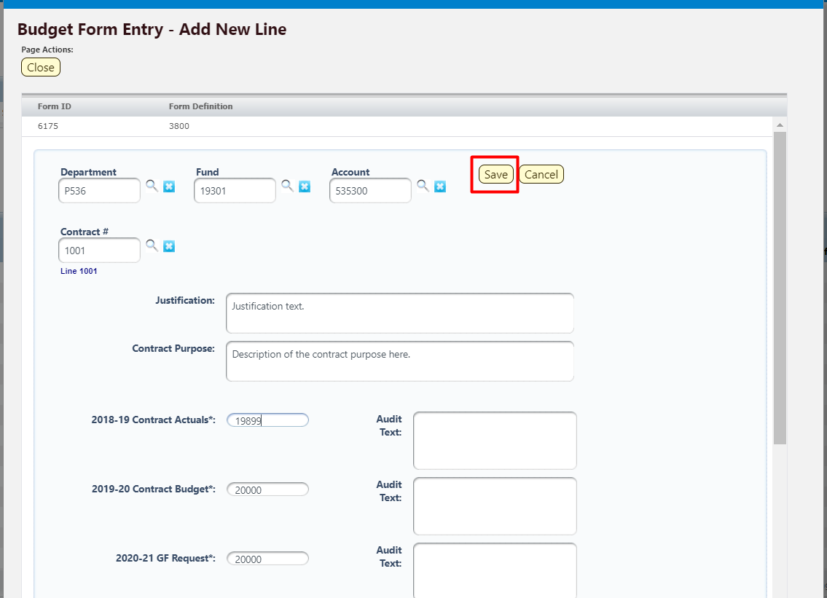

Click Save. The new line item will appear in the list.

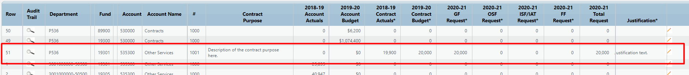

Once all contracts have been added to the form, submit Budget form following instructions from 8.14 Submit Budget Form.

Reports

Data from the Contracts E5 3800 form can be viewed in the S-8 Financial Summary and S-9 Account Code Summary. See Section 21 BFM Reporting for instructions on how to access reports.

Expansion Request
Expansion requests are designed to expand the scope or scale of an agency’s service delivery system. These requests are for recurring expenditures.

Create New Expansion Request

Navigate to the Expansion Request form by hovering over the Budget Formulation menu and selecting Expansion Request (3200) from the dropdown menu.
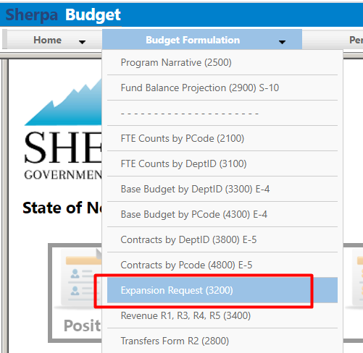

Click Add New to begin a new Expansion Request or select the form instance to edit and click Header to open the budget form.

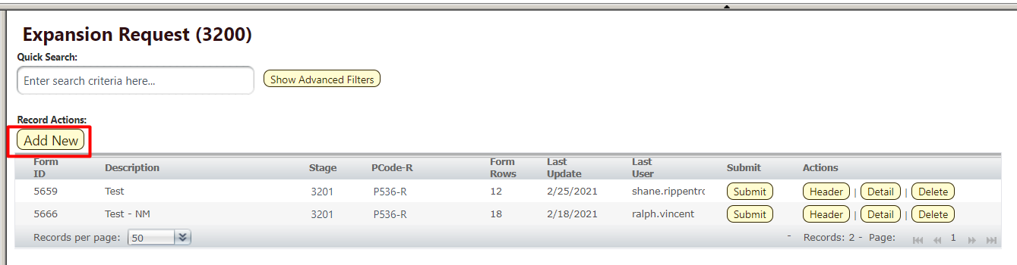

On the Create a new Budget Form 3200 screen, select Stage Code 3201 – Initial Entry from the dropdown. Enter the PCode and Name of the Expansion Request. Click Save.
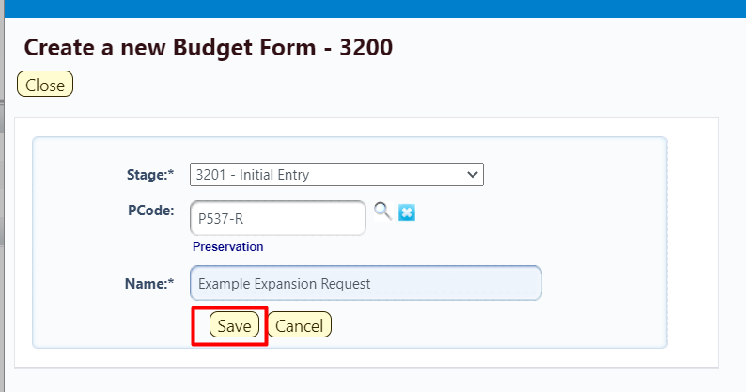

Header Tab

The new Expansion Request form will open to the Header tab. Complete the Header fields including a Description and Rank. Check boxes next to Analyst Recommended, Include in Gov Budget, and LFC Approved, if necessary. Click Save.
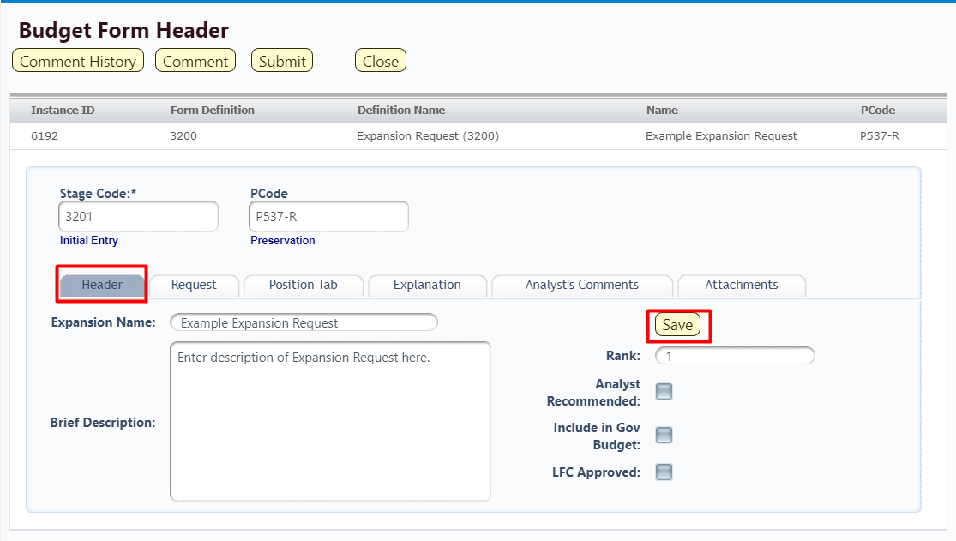

Notice the additional tabs on the Expansion Request form including Request which

Position Tab
The Position Tab appears on the Expansion Request budget form and can be used for different purposes. On this tab, new positions can be requested, existing positions can be reclassed, Group/Temp positions can be requested, and vacant positions can be funded.

Navigate from the Header tab; locate the Position Tab and click to open. 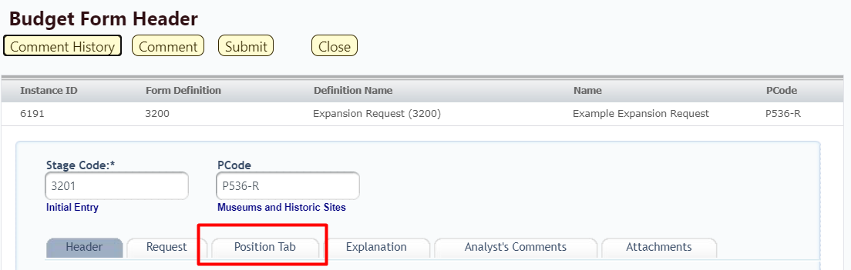

Position Tab Overview
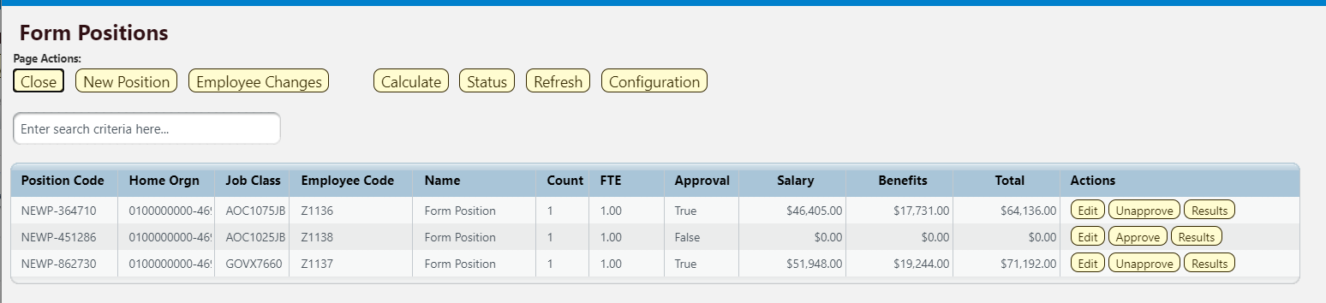

Calculate - If no changes or additional allocations are needed, click the calculate button to calculate the salary and benefit amounts. The totals will feed over to the Details (Request) tab. Note: Calculating can take 45 seconds or longer. If you select “Calculate” again, the system restarts the calculation from the beginning, so only select “Calculate” once.

Data Fields/columns on the Position Tab Summary Overview Screen:
- Position Code – A unique number generated by the system for each position request.
- Home Orgn – The Home Organization or Department of the requested position.
- Job Class – The job class and title selected in the initial request set-up.
- Employee Code – Employee is the system generated number for the position request. Z in the number signifies a vacant position.
- Name – Name of the Position, if it is a new position, Form Position will appear.
- Count – Number of positions requested for this FTE.
- FTE – Full Time Equivalent refers to the specific job class or position that is being requested, 1.0 is full-time, .5 is part-time.
- Approval – True will appear in this field if the position has been approved and the salary, benefits and totals columns will reflect what has been requested. Once unapproved the field will reflect False and the salary, benefits and totals will appear as zero.
- Salary – The salary requested for the position.
- Benefits – These are the calculated benefits for the position requested.
- Total – Total cost of the position(s) requested.

Record Action Buttons (light yellow buttons)
- Close – Will close the screen and go back to a screen where all the tabs will appear to make the next selection.
- New Position – This will start the process of requesting a new position and all the appropriate codes.
- Calculate – When initially entering a position or changing some data in an existing position request, calculate will update the numbers in the request. This may take a few seconds to provide the update. Pressing the “Calculate” button will calculate the salary and benefit amounts and push them over to the detail tab.
Note: Calculating can take 45 seconds or longer. If you select “Calculate” again, the system restarts the calculation from the beginning, so only select “Calculate” once.
- Status – Shows the history of the Projection calculation, including the status, date, and runtime of each time the Calculate button is clicked by any user.
- Refresh – As with other screens, this will refresh any data changes to the position request.
- Edit – This provides a method to update the position request. More information below.
- Unapprove – This provides the option to unapprove a position request. When the “Unapprove” button is visible on the position line item, this indicates the position has been approved and the salary and benefit amounts will show on this screen. Selecting this button will unapprove the position and a box will come up to ensure the action to un-approve the position is desired. Once selected, the button will change to Approve and the salary and benefits will go to zero.
- Approve – When the approved button is visible, there will be no costs for the position populated. This indicates the position request has NOT been approved. Costs will only show if the position has been approved.

Note: A position can be approved or unapproved at any time. If not approved, the dollars will not transfer over to the Detail Tab.

- Results – Opens the Projected Employee Results screen, which provides the complete breakdown of benefit costs and salary for the line item position request. The Results screen shown below will only display for “approved” positions.

Note: The Total reflected on the Projected Employee Results screen, highlighted with a red box below, will feed to the PCF Total in the Detail (Request) Tab. To review the detail of the position request, return to the Position Tab for a breakdown.
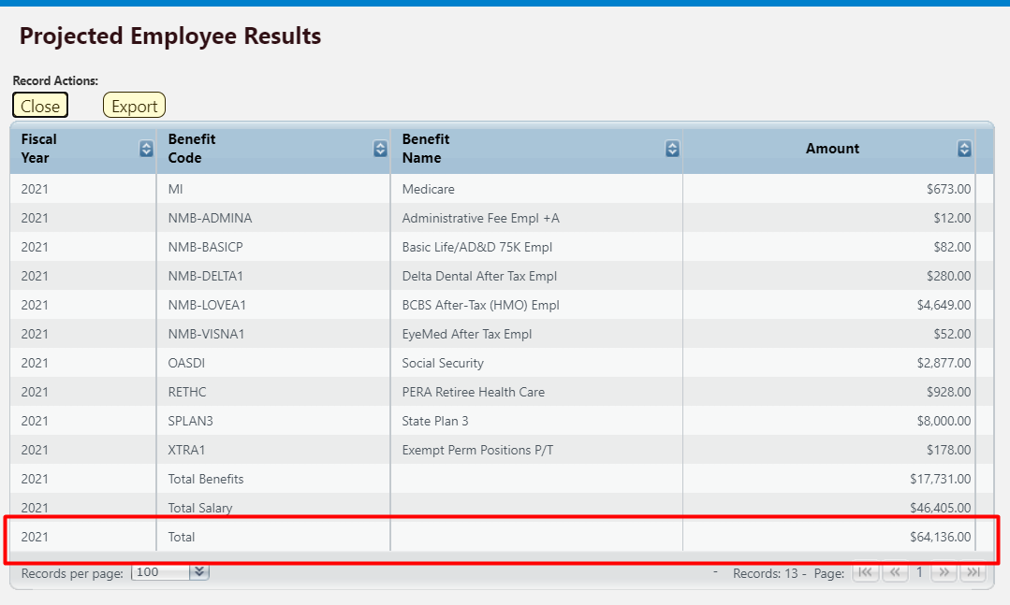

New Position Wizard
On the Position Tab click New Positions to open the New Position Wizard.

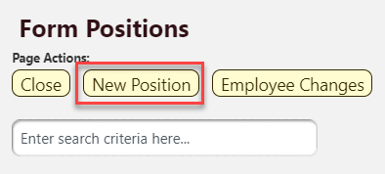
Follow each step to completion. If you click Cancel or Back in many cases the position will be cleared out and you will have to start over.
Position Tab | New Position Wizard
Step | Description
Step 1  - Select the Job Class  - Click Advance to Finish | 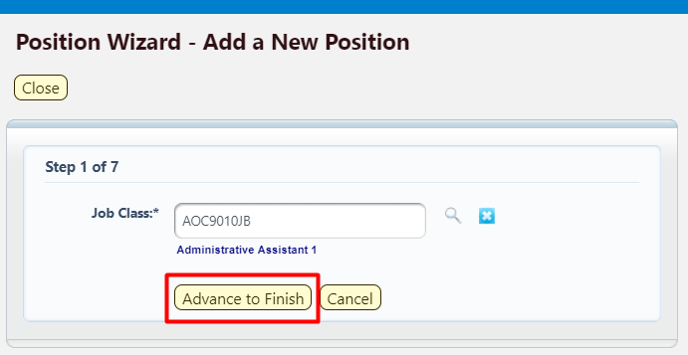
Step 2  - Ensure all fields designated with an asterisk (*) are completed.  - If Salary Override is checked, then the amount in the Override Salary field will be used in the PCF calculations.  - If requesting multiple positions for the same job class, change the Authorized Count to a different integer value, such as 5  - Enter desired Authorized FTE to the position being request. An FTE from 0 to 1 can be entered.  - Filled FTE for a new position will be 0 | 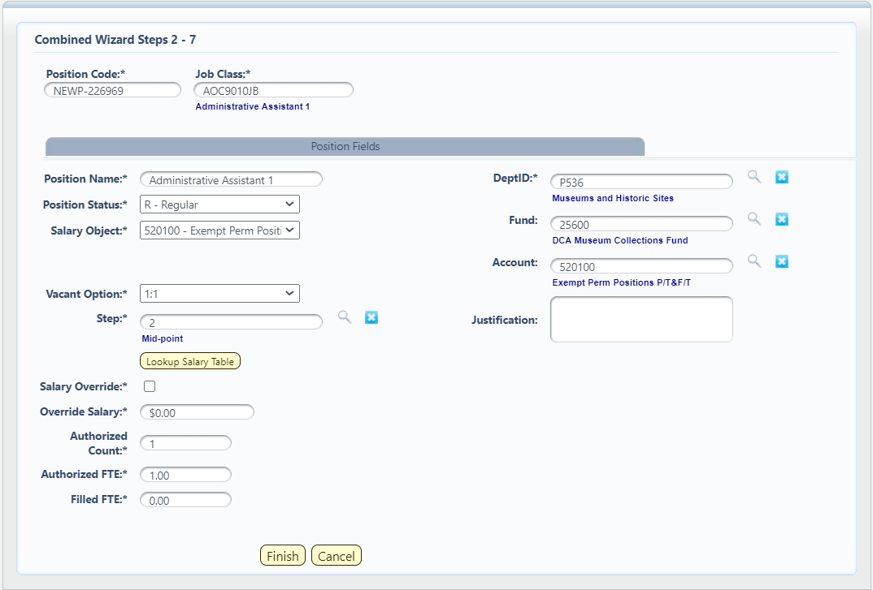
- Note – The Lookup Salary Table button displays the salary amount of the chosen Step. |   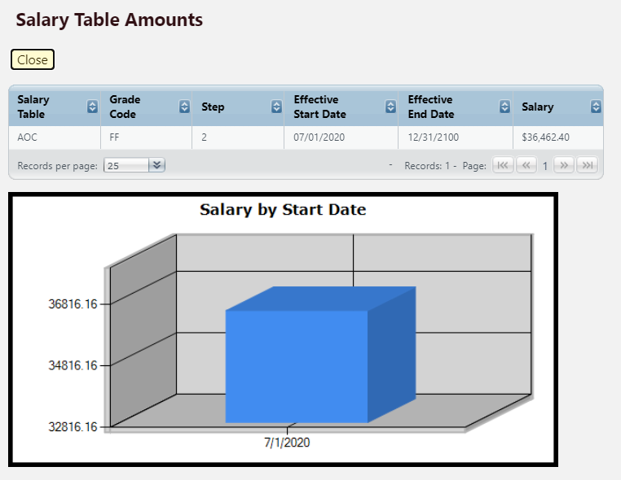
Step 4  - Click Finish and the position is created and appears on the Position Tab of the form. Or click Cancel to delete the position request. | 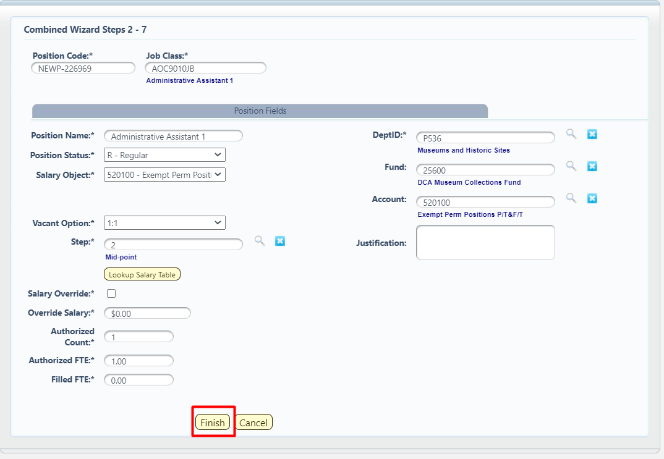

Employee Changes
The Position Tab may also contain an Employee Changes Button. This button is used to add and make changes to existing employee. Potential changes may include but are not limited to funding allocations, salary and benefit modifications, FTP adjustments, position reclasses.
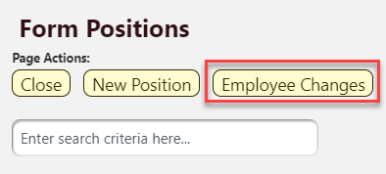

Position Tab | Employee Changes
Step | Description
Step 1  - Select an Employee from the list. The list of employees is filtered based on the Agency on the form header. | 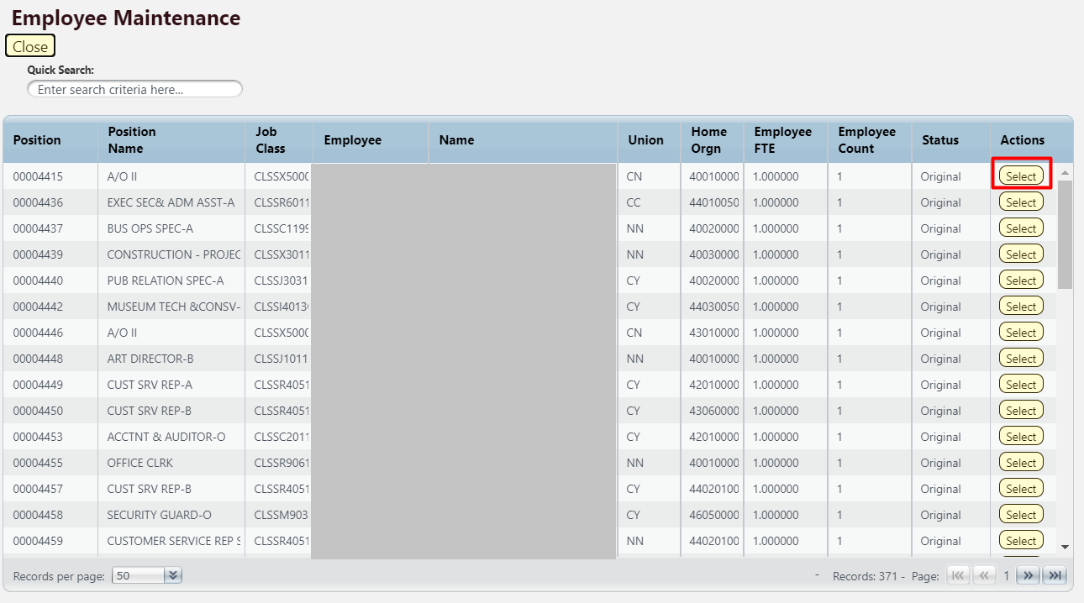
Step 2  - After an employee is selected, a new popup appears which contains the Employees data  - On the Employee Tab, the Job Class, Default Home Org, Employee Status, Position, Bargaining Unit, and Active and Vacant checkboxes can be modified.  - On the Salary Tab, Employee FTE, Salary Percentage, Benefit Percentage and Employee Count can be modified.  - If the Salary Override box is checked, then the Override Salary amount will be used in the PCF Calculations. If not, then the salary amount on the salary table will be used.  - After completing the changes click Add to Form | 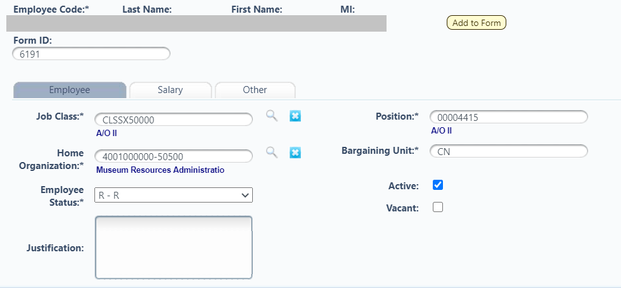  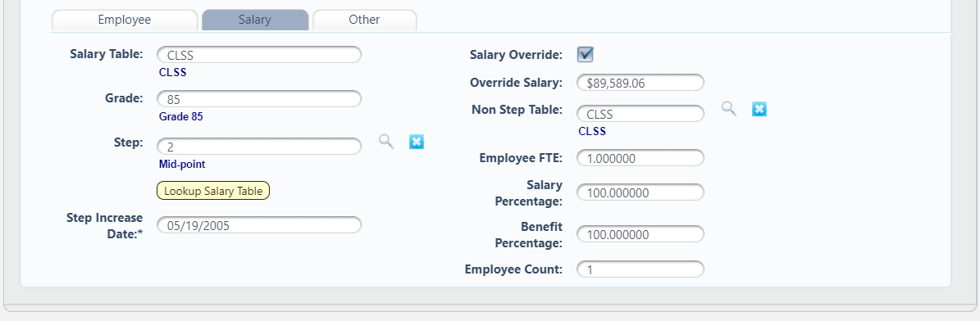
Step 3  - Click Close on the Employee Maintenance Screen and you will be redirected to the Position Tab | 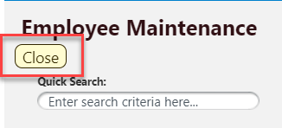
Step 4
- The Position Tab will refresh will contain two positions. The negative position is a reversing entry to back out the existing position. The positive or form position contains the new position along with any adjustments made on the Salary and Employee tab.
Step 5  - In order to view the results, click the Calculate button. The results may take up a minute to be displayed and the Refresh button can be used to check if the results are ready.  - Only click the Calculate button once. Clicking Calculate multiple times may delay the process and the results. | 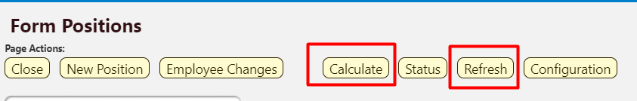
Step 6  - When the projection is completed, the results will be displayed in the Position Tab grid.  - Unapprove – There is no Delete button, so this is used to cancel a change made to a position  - Results – This button will display a breakdown of the PCF results by Salary amount, benefit type, and benefit amount.  - Edit – This button directs the user to the Salary and Employee tabs where additional changes can be made. | 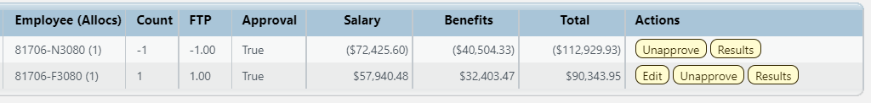

Detail or Request Tab
The Detail Tab, also labeled Request, shows the detailed costs of the Expansion Request.

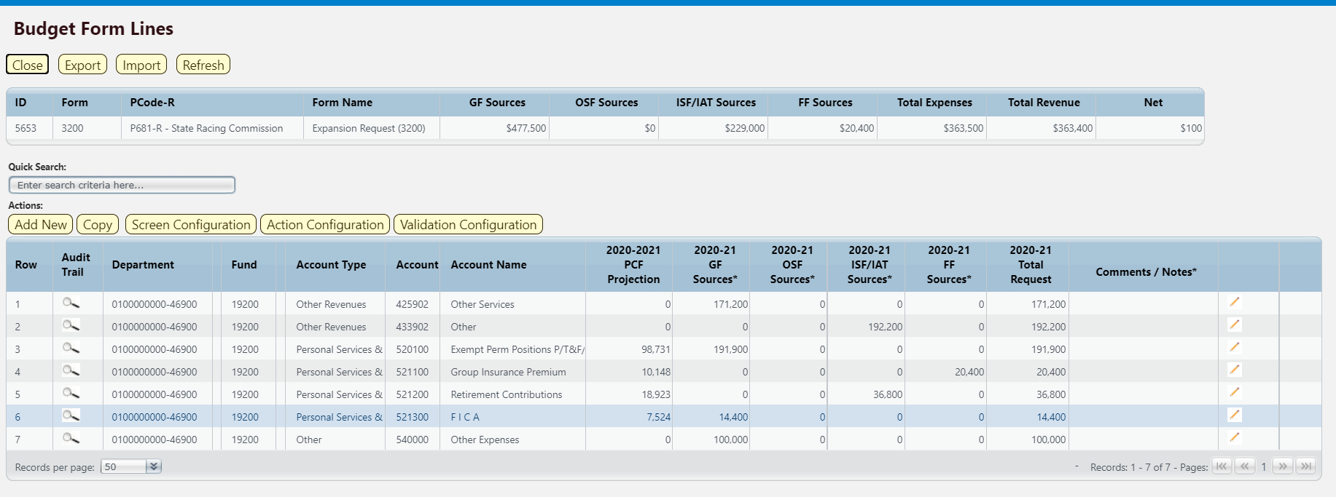

The top table shows a read-only summary of the Expansion Request. The columns are described below.

Screen: | Expansion Request 3200 Budget Form Lines
Field (Column Name) | Description
ID | Read Only. Form Instance ID
Form | Read Only. Form number
PCode | Read Only. PCode and Program Name
Form Name | Read Only. Form Name
GF Sources | Read Only. Total Request of General Fund
OSF Sources | Read Only. Total Request of Other State Funds
ISF/IAT Sources | Read Only. Total Request of Internal Services Fund or Inter Agency Transfers
FF Sources | Read Only. Total Request of Federal Funding
Total Expenses | Read Only. Total Expenses entered in request form
Total Revenue | Read Only. Total Revenues entered in request form
Net | Read Only. Difference between Total Expenses and Total Revenue columns. Must equal zero.

The second table contains the Expansion Request budget data. Some columns contain read-only data; this data is either system data, imported from another source such as the financial system, or are calculated based on other values in the form. Columns with an asterisk (*) are data entry columns, where users enter the budget request data. The table below describes the columns for the Expansion Request 3200 Form.
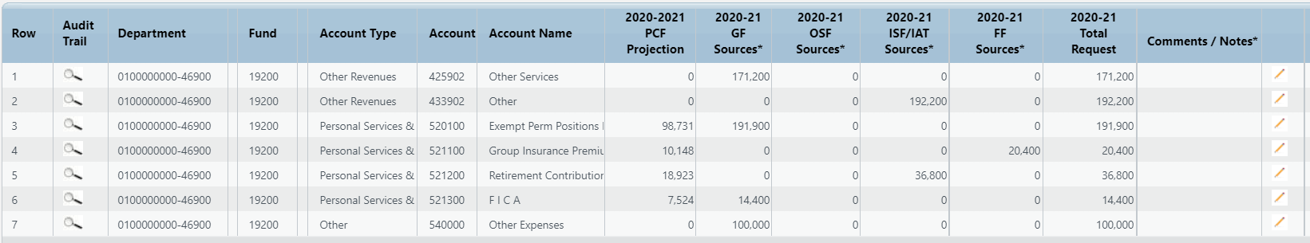
Screen: | Expansion Request 3200 Budget Form Lines
Field (Column Name) | Description
Row | Read Only. Number indicating row count.
Audit Trail | Magnifying Glass button. Opens a window to display the audit trail records for the selected row.
Department | Read Only. Contains PCode Number.
Department Name | Read Only. This column is minimized, use double arrows to expand to see.
Fund | Read Only. Budget line for Fund
Fund Name | Read Only. This column is minimized, use double arrows to expand to see.
Cat | Read Only. Budget line for Category code
Account | Read Only. Budget line for Account
Account Name | Read Only. Budget line for Account Name
20XX-XX PCF Projection | Read Only. Budget line for requests made on Position Tab
20XX-XX GF Sources* | Data Entry Column. Enter General Fund request
20XX-XX OSF Sources* | Data Entry Column. Enter Other State Funds request
20XX-XX ISF/IAT Sources* | Data Entry Column. Enter Internal Service Funds / Interagency Transfer request
20XX-XX FF Sources* | Data Entry Column. Enter Federal Funds request
20XX-XX Total Request | Read Only. Sum of data entry requests columns.
Comments/Notes* | Entry Column. Enter text justification
Pencil (edit) Icon | Edit icon. When clicked, the Line Detail screen will display to allow budget request entries. Double-clicking a row performs the same action.

Enter data into the Expansion Request form following the instructions from Section 8.4 Excel Export/Import or Section 8.11 Add New Budget Entry.

Note: PCF Projections will be calculated to the dollar, but the system will apply natural rounding to the nearest hundred dollars for budget requests.
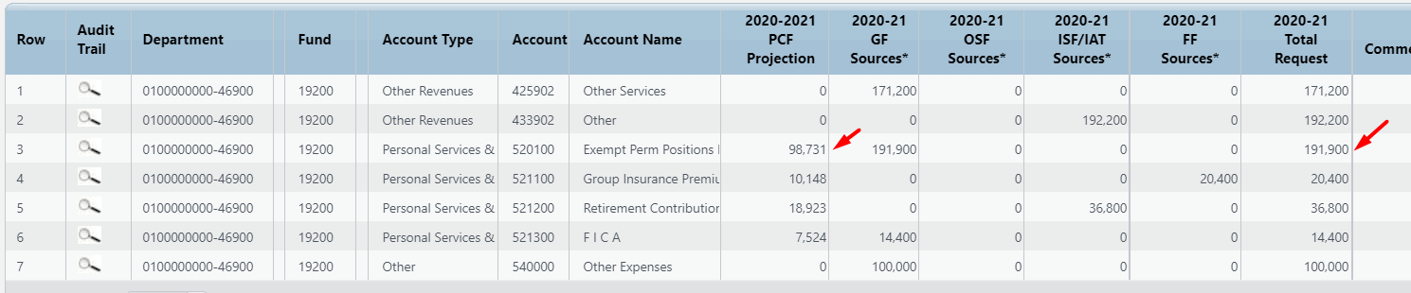

Request must include expenses and revenues which must balance. The top table will show the Total Expenses and Total Revenues as the form is updated. The Net column will display the difference between the Total Expenses and Total Revenues and should equal zero.

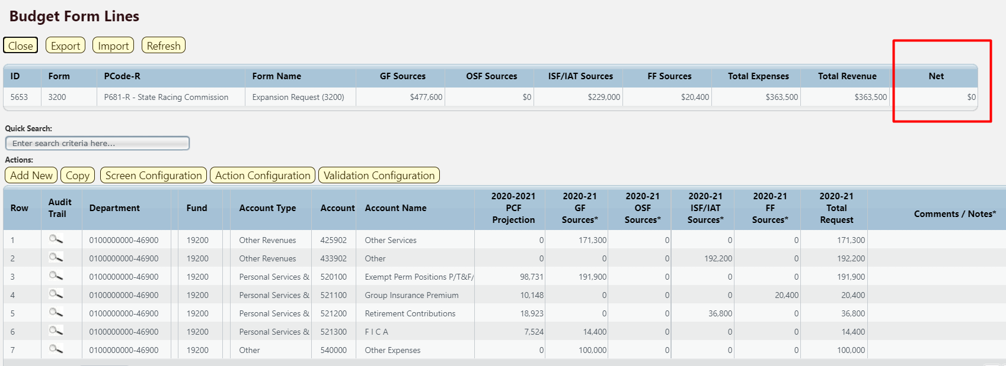

Explanation Tab
The Explanation Tab consists of fields to provide detailed narrative on the budget form.

Navigate to the Header tab, then locate and click Explanation to open.

Enter justification text in the appropriate fields. Click Save to update the form.

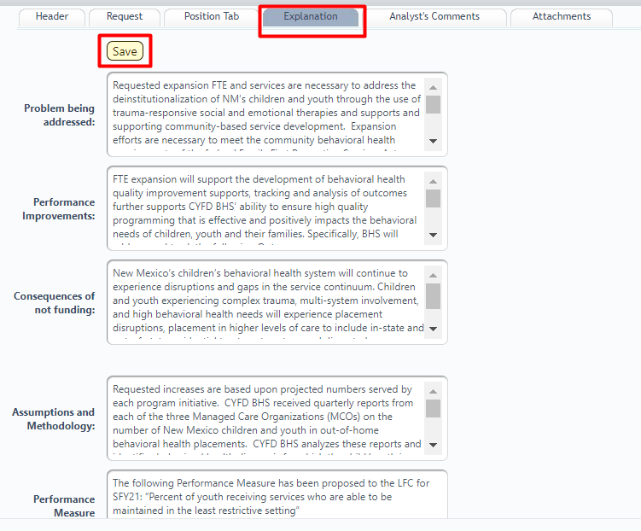

Analyst Comments Tab
The form includes an Analyst Comments Tab for Budget Analysts to make remarks on the Expansion Request.

Navigate to the Header tab, then locate and click Analyst Comments to open.

Enter text into the field, as needed, and click Save to update the form.
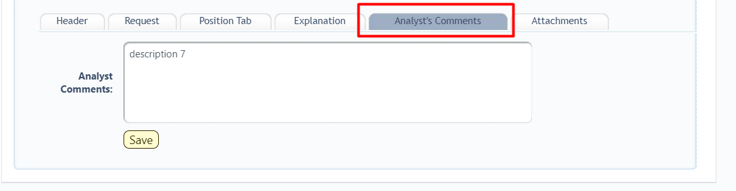

Attachments Tab
Attachments can be added to the form following the instructions outlined in Section 8.13 Attachments Tab.

Submit Expansion Request
Once the Expansion Request form is complete. Submit the form following the instructions in Section 8.14 Submit Budget Form.

Report

Data from the Expansion Request 3200 form can be viewed in the Expansion Request EB-1, EB-2, EB-3 Reports. See Section 21 BFM Reporting for instructions on how to access reports.

Revenue R-1, R-3, R-4, R-5
The legacy Revenue forms R-1, R-3, R-4, and R-5 are combined into a single Revenue Form 3400 in BFM.

Navigate to the Revenue form by hovering over the Budget Formulation menu and clicking Revenue R1, R3, R4, R5 (3400).
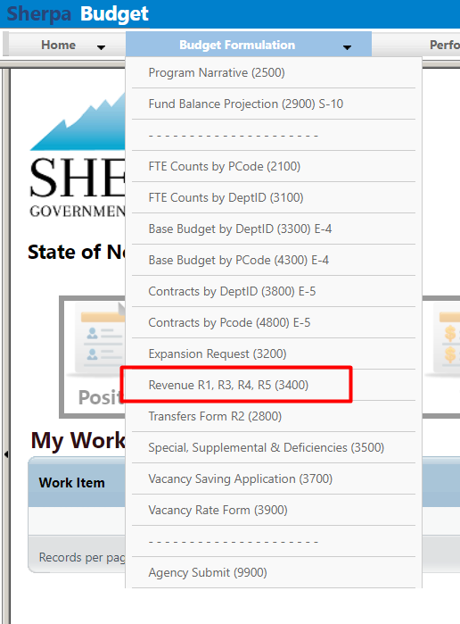

Select an available form from the main Revenue form screen or "List Page." This page will return a form for each agency or program based on your security. If there are no agencies or programs assigned for your security role, this list will be blank. If you believe there is an error in the list of agencies or programs available in your list, then contact the BFM Administrator to update your security role.

To edit the form, click Detail. The Header tab contains some general information about the form, but data will be entered on the Detail screen.
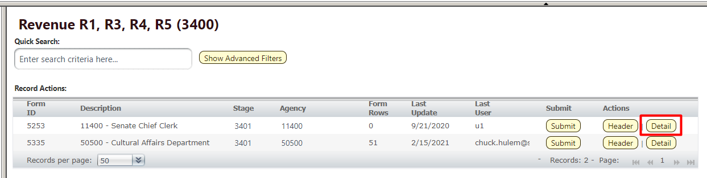

The Revenue form will load.
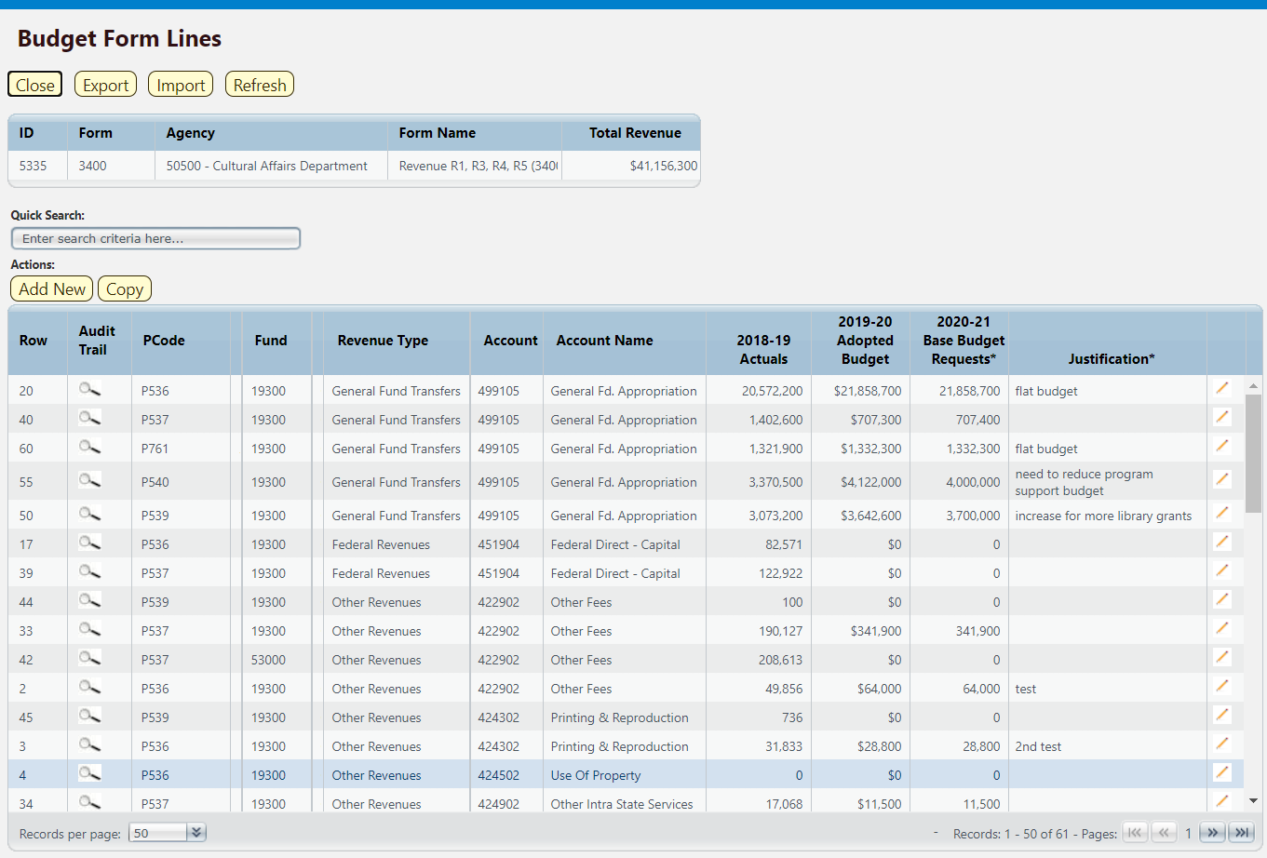

The top table shows a read-only summary of the budget revenue request. The columns are described below.
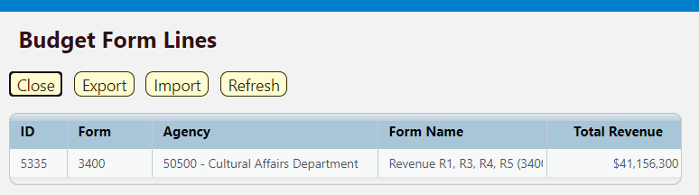

Screen: | Revenue R1, R3, R4, R5 3400 Budget Form Lines
Field (Column Name) | Description
ID | Read Only. Form Instance ID
Form | Read Only. Form number
Agency | Read Only. Agency Code and Name
Form Name | Read Only. Form Name
Total Revenue | Read Only. Total revenue entered into form

The second table contains the budget revenue data. Some columns contain read-only data; this data is either system data, imported from another source such as the financial system, or are calculated based on other values in the form. Columns with an asterisk (*) are data entry columns, where users enter the budget request data. The table below describes the columns for the Revenue R1, R3, R4, R5 3400 Form.

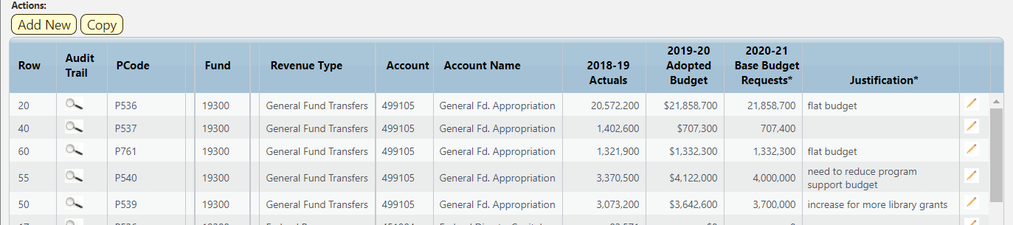

Screen: | Revenue R1, R3, R4, R5 3400 Budget Form Lines
Field (Column Name) | Description
Row | Read Only. Number indicating row count.
Audit Trail | Magnifying Glass button. Opens a window to display the audit trail records for the selected row.
PCode | Read Only. Contains PCode Number.
PCode Name | Read Only. This column is minimized, use double arrows to expand to see.
Fund | Read Only. Budget line for Fund
Fund Name | Read Only. This column is minimized, use double arrows to expand to see.
Revenue Type | Read Only. Budget line for Revenue Type, will populate based on Account
Account | Read Only. Budget line for Account
Account Name | Read Only. Budget line for Account Name
20XX-XX Actuals | Read Only. Budget line for previous year Actuals data from SHARE
20XX-XX Adopted Budget | Read Only. Budget line for current year Adopted Budget data from SHARE
20XX-XX Base Budget Requests * | Data Entry Column. Enter base budget revenue request
Justification* | Entry Column. Enter text justification
Pencil (edit) Icon | Edit icon. When clicked, the Line Detail screen will display to allow budget request entries. Double-clicking a row performs the same action.

Edit an existing budget line or click Add New. This can also be accomplished through the Excel Export/Import spreadsheet. Detailed instructions are found in Section 8.4 Excel Export/Import and Section 8.11 Add New Budget Entry.

- Enter the PCode; click the Magnifying Glass to select from a filtered list of PCodes based on your security
- Enter the Fund code; click the Magnifying Glass to see a list of all funds
- Enter the Account number; click the Magnifying Glass to select from a list filtered to Revenue and Equity accounts. The Revenue Type column will be automatically populated in the form based on the selected Account
- Enter the Justification
- Enter the Base Budget Request

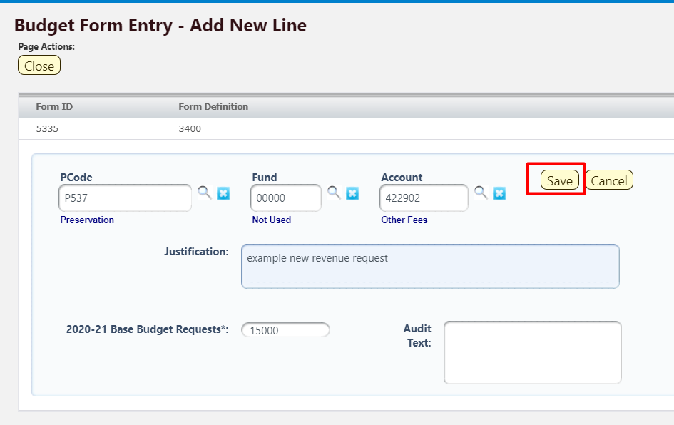
Click Save. The new revenue request will appear in the form. 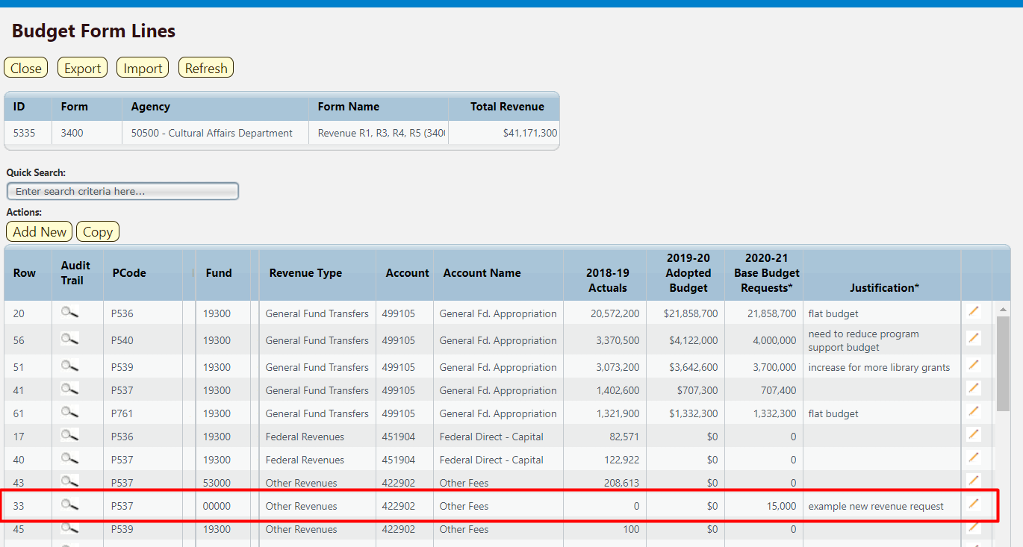

Once all revenue requests have been added to the form, submit the Revenue form following instructions from 8.14 Submit Budget Form.

Report

Data from the Revenue R-1, R-3, R-4, R-5 2800 form can be viewed in the S-8 Financial Summary and S-9 Account Code Summary. See Section 21 BFM Reporting for instructions on how to access reports.

Transfers R-2
Non-General Fund transfers are entered into the Transfers Form R-2, numbered 3400 in BFM>

Navigate to the Revenue form by hovering over the Budget Formulation menu and clicking Transfers Form R2 (3400).
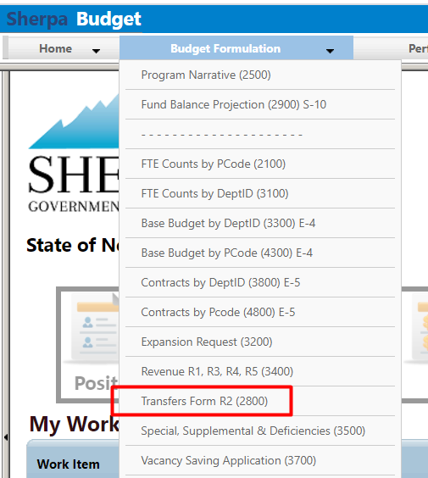

Add New Transfers Form

Click Add New on the Transfers main screen, or “List Page”.
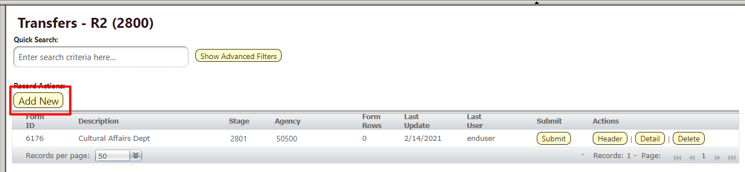

Select Stage 2801 – Initial Entry. Enter Agency code or use the Magnifying Glass to select from a filtered list based on user security. Enter Name for the proposed Transfer.

Click Save.
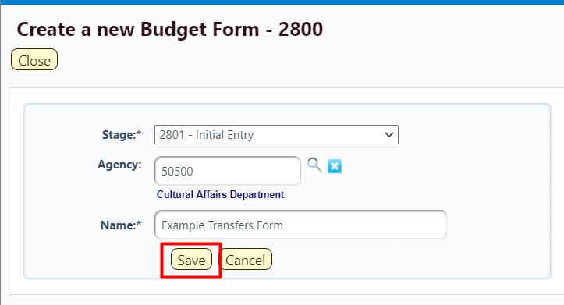

The Transfers form Header tab will open. Click the Transfers tab to navigate to the Details or data entry tab.
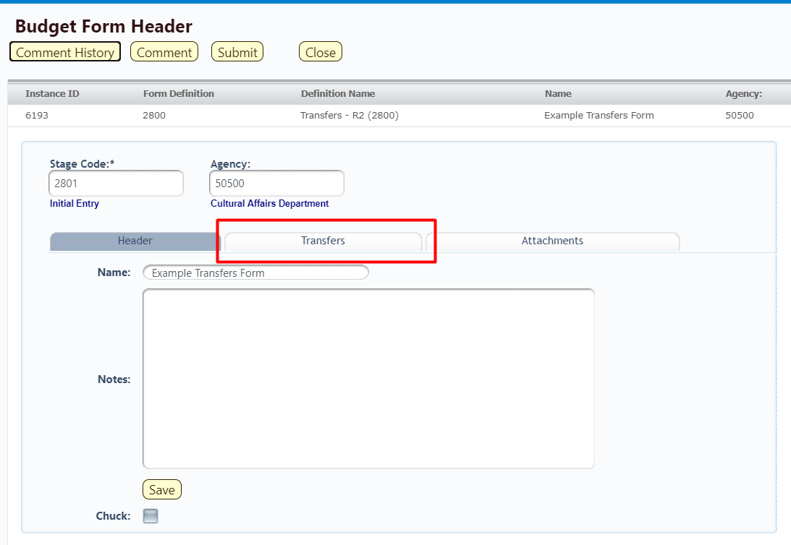

The Transfers form will load. The form will be blank for a new form.
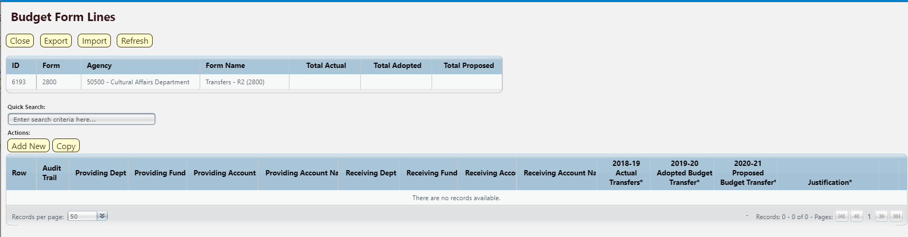

The top table shows a read-only summary of the proposed Transfers. The screenshot below shows an example form that is populated. The columns are described below.

Screen: | Transfers R-2 2800 Budget Form Lines
Field (Column Name) | Description
ID | Read Only. Form Instance ID
Form | Read Only. Form number
Agency | Read Only. Agency Code and Name
Form Name | Read Only. Form Name
Total Actual | Read Only. Total Actual Transfers for previous fiscal year entered on form
Total Adopted | Read Only. Total Adopted Budget Transfers for current fiscal year entered on form
Total Proposed | Read Only. Total Proposed Transfers entered on form

The second table contains the proposed transfer budget data. Again, the example screenshot below shows a form populated with data. Some columns contain read-only data; this data is either system data, imported from another source such as the financial system, or are calculated based on other values in the form. Columns with an asterisk (*) are data entry columns, where users enter the budget request data. The table below describes the columns for the Transfers R-2 form.

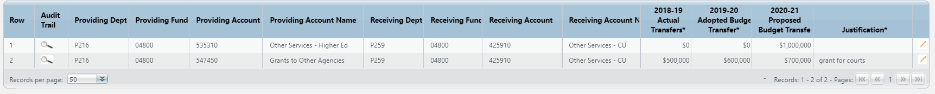

Screen: | Transfers R-2 2800 Budget Form Lines
Field (Column Name) | Description
Row | Read Only. Number indicating row count.
Audit Trail | Magnifying Glass button. Opens a window to display the audit trail records for the selected row.
Providing Dept | Read Only. PCode Number of the Department providing the transfer
Providing Fund | Read Only. Fund providing the transfer
Providing Account | Read Only. Account providing the transfer
Providing Account Name | Read Only. Name of account providing the transfer
Receiving Dept | Read Only. PCode Number of the Department receiving the transfer
Receiving Fund | Read Only. Fund receiving the transfer
Receiving Account | Read Only. Account receiving the transfer
Receiving Account Name | Read Only. Name of account receiving the transfer
20XX-XX Actual Transfers* | Data Entry Column. Enter previous fiscal year’s Actual Transfers amount.
20XX-XX Adopted Budget Transfer* | Data Entry Column. Enter current fiscal year’s Adopted Budget Transfer amounts
20XX-XX Proposed Budget Transfers* | Data Entry Column. Enter Proposed Budget Transfers amounts
Justification* | Entry Column. Enter text justification
Pencil (edit) Icon | Edit icon. When clicked, the Line Detail screen will display to allow budget request entries. Double-clicking a row performs the same action.

Click Add New. This can also be accomplished through the Excel Export/Import spreadsheet. Detailed instructions are found in Section 8.4 Excel Export/Import and Section 8.11 Add New Budget Entry.

- Enter the Providing PCode; click the Magnifying Glass to select from a filtered list of PCodes based on the Agency selected during form creation
- Enter the Providing Fund code; click the Magnifying Glass to see a list of all funds
- Enter the Providing Account; click the Magnifying Glass to select from a list filtered to available Accounts for transfers
- Enter the Receiving PCode; click the Magnifying Glass to select from list of PCodes
- Enter the Receiving Fund code; click the Magnifying Glass to see a list of all funds
- Enter the Receiving Account; click the Magnifying Glass to select from a list filtered to available Accounts for transfers
- Enter the Justification
- Enter the Base Budget Request
- Enter previous fiscal year’s Actual Transfers
- Enter current fiscal year’s Adopted Budgeted Transfers
- Enter Proposed Budget Transfers

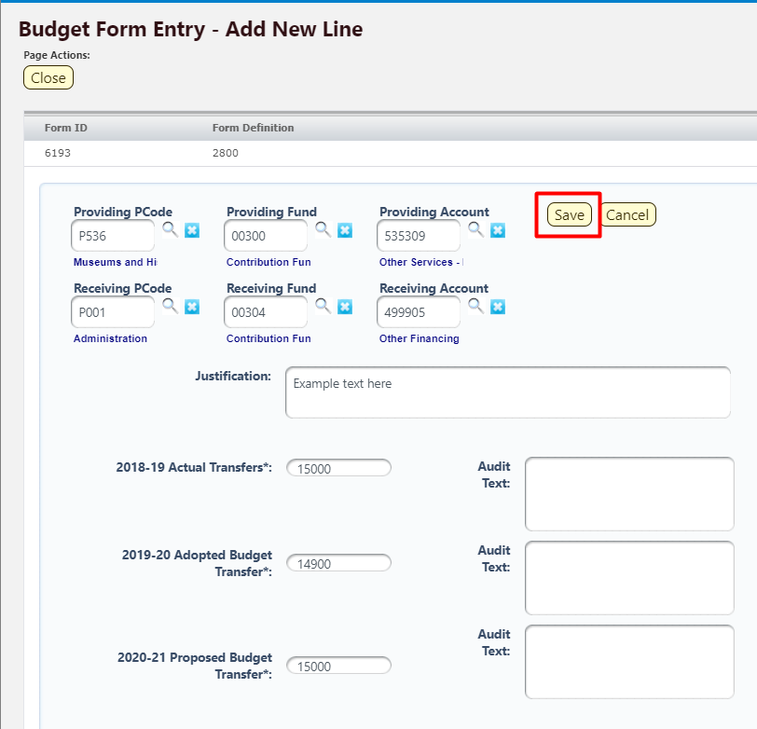

Click Save. The new revenue request will appear in the form. 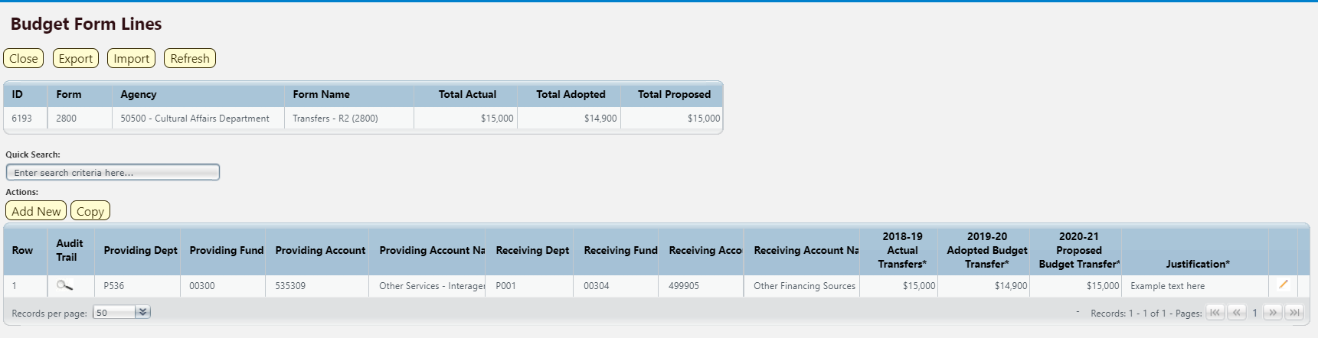

Once all transfers have been added to the form, submit the Transfers form following instructions from 8.14 Submit Budget Form.

Reports

Data from the Transfers R-2 Form 2800 form can be viewed in the S-8 Financial Summary and S-9 Account Code Summary. See Section 21 BFM Reporting for instructions on how to access reports.

Special, Supplemental & Deficiencies
Special nonrecurring, deficiency and supplemental appropriation requests are captured in the Special, Supplemental & Deficiencies form 3500. Requests in this form is intended for nonrecurring appropriations to meet specific identified needs. Prepare a separate form for each request.

Navigate to the Specials form by hovering over the Budget Formulation menu and clicking Special, Supplemental & Deficiencies (3500).
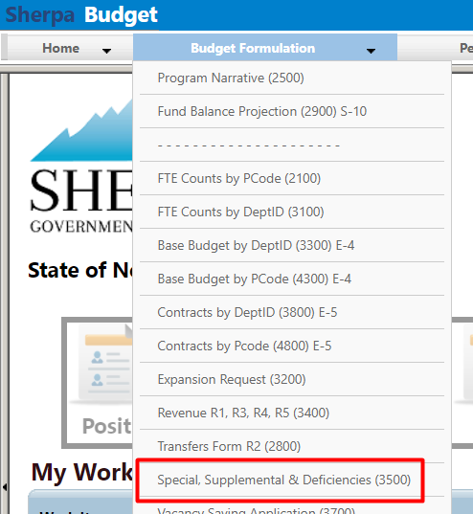

Add New

Click Add New on the form main screen or “List Page.” Note: prepare a separate form for each request.
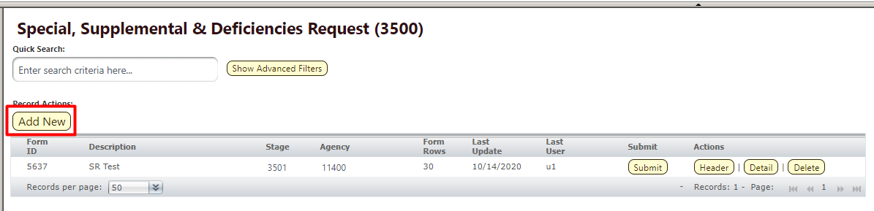

Select Stage 3501 – Initial Entry. Enter Agency code or use the Magnifying Glass to select from a filtered list based on user security. Enter Name for the request.

Click Save.
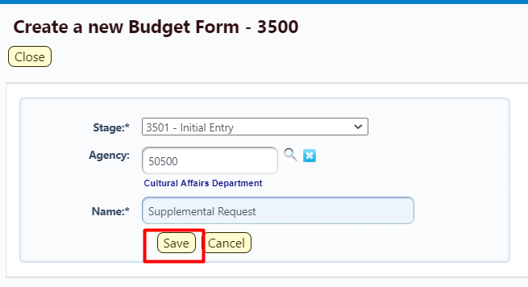

Header Tab

The form Header tab will open. Complete the fields and click Save before navigating to another tab.
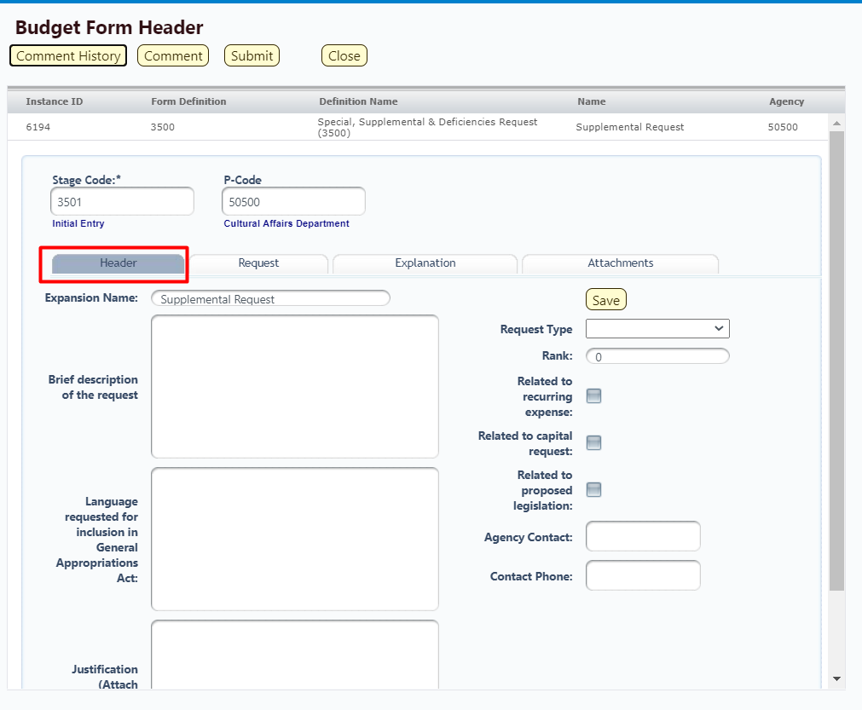

Request (Details) Tab

From the Header tab, click the Request tab.
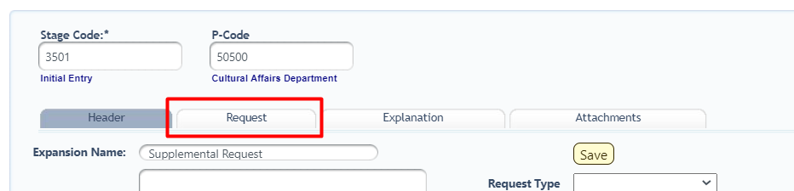

The budget data entry form will load. When a new form is created, it will be blank as shown below.
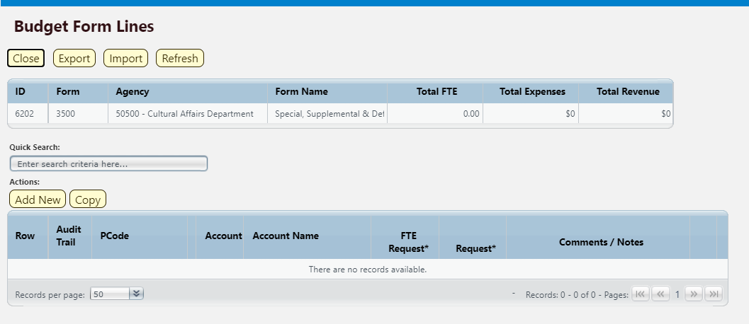

The top table shows a read-only summary of the form. The screenshot below shows an example form that is populated. The columns are described below.
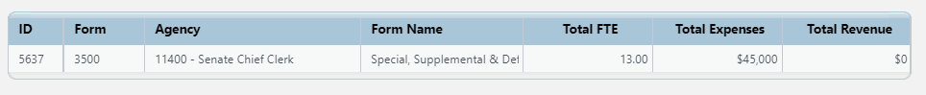

Screen: | Special, Supplemental & Deficiencies (3500) Budget Form Lines
Field (Column Name) | Description
ID | Read Only. Form Instance ID
Form | Read Only. Form number
Agency | Read Only. Agency Code and Name
Form Name | Read Only. Form Name
Total FTE | Read Only. Total Full Time Equivalent requested in form
Total Expenses | Read Only. Total Expenses requested in form
Total Revenue | Read Only. Total Revenue entered in form

The second table contains the Special, Supplemental & Deficiencies request data. Again, the example screenshot below shows a form populated with data. Some columns contain read-only data; this data is either system data, imported from another source such as the financial system, or are calculated based on other values in the form. Columns with an asterisk (*) are data entry columns, where users enter the budget request data. The table below describes the columns for the form.
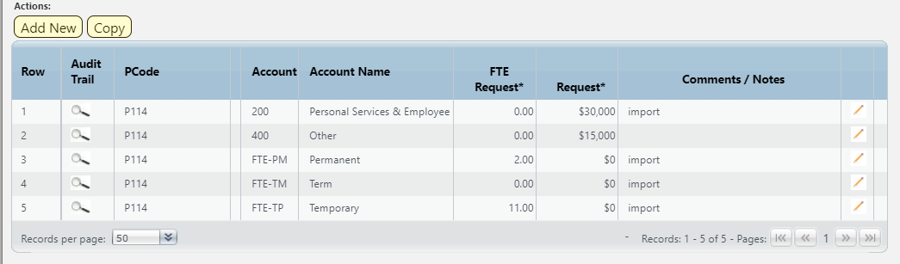

Screen: | Special, Supplemental & Deficiencies (3500) Budget Form Lines
Field (Column Name) | Description
Row | Read Only. Number indicating row count.
Audit Trail | Magnifying Glass button. Opens a window to display the audit trail records for the selected row.
PCode | Read Only. Contains PCode Number.
PCode Name | Read Only. This column is minimized, use double arrows to expand.
Account | Read Only. Budget line for Account
Account Name | Read Only. Budget line for Account Name
FTE Request* | Data Entry Column. Enter number of Full Time Equivalent requested
Request* | Data Entry Column. Enter Requested amount
Comments / Notes * | Data Entry Column. Enter Comments or Notes related to budget line
Pencil (edit) Icon | Edit icon. When clicked, the Line Detail screen will display to allow budget request entries. Double-clicking a row performs the same action.

Click Add New. This can also be accomplished through the Excel Export/Import spreadsheet. Detailed instructions are found in Section 8.4 Excel Export/Import and Section 8.11 Add New Budget Entry.

- Enter the PCode; click the Magnifying Glass to select from a filtered list of PCodes based on the Agency selected during form creation
- Enter the Comments / Notes, if needed
- Enter amount in FTE Request
- Enter Request amount

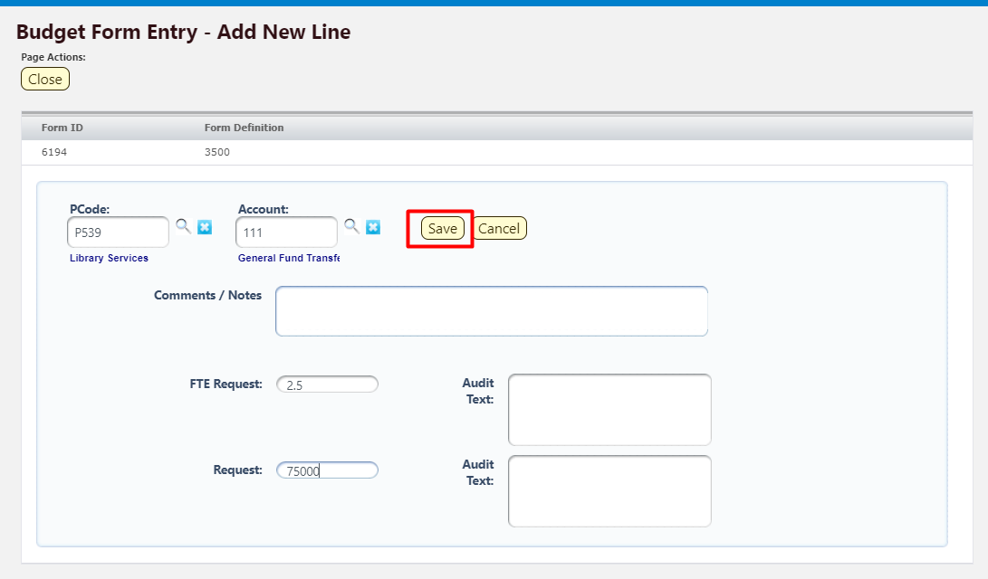

Click Save. The new request will appear in the form. 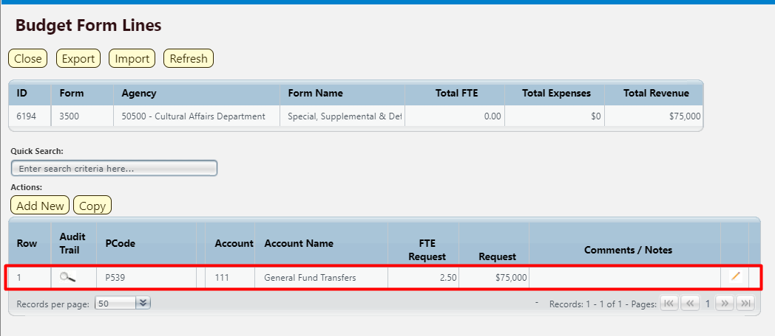

Explanation Tab
Detailed explanations for the request are entered on the Explanation tab.

Navigate to the Header tab, click Explanation to open.

Complete required fields. Click Save to update form.
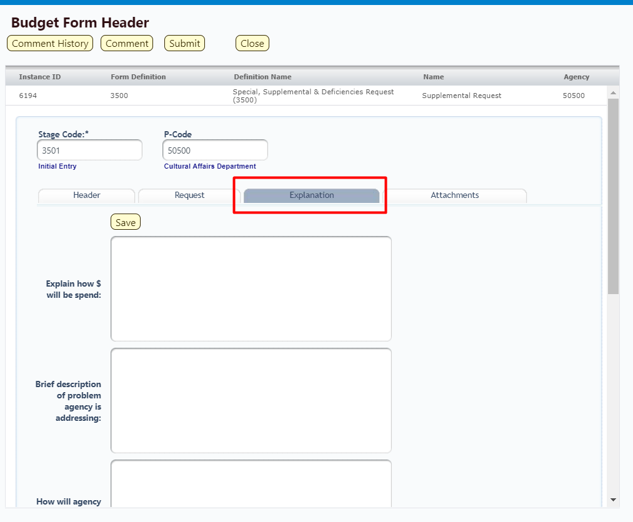

Attachments Tab

Attachments can be added to the form following the instructions outlined in Section 8.13 Attachments Tab.

Submit

Once all transfers have been added to the form, submit the Transfers form following instructions from 8.14 Submit Budget Form.

Program Narrative
Detailed descriptions of Programs are updated from the Program Narrative (2500) form. Existing narrative text from previous budget cycles will appear in the form. Users can edit text when needed following these instructions.

Select the Program Narrative (2500) form from the Budget Formulation menu.
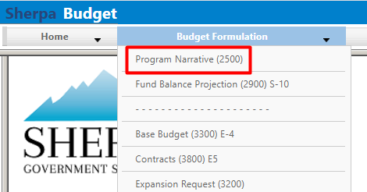

Select an available form from the main Budget form screen or "List Page" and click Header. This page will return a form for each agency or program based on your security. If there are no agencies or programs assigned for your security role, this list will be blank. If you believe there is an error in the list of agencies or programs available in your list, then contact the BFM Administrator to update your security role.

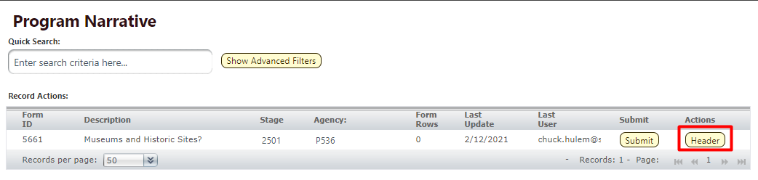

The Header tab will load. Review or Enter text into the fields. Click Save to update the Program narrative.
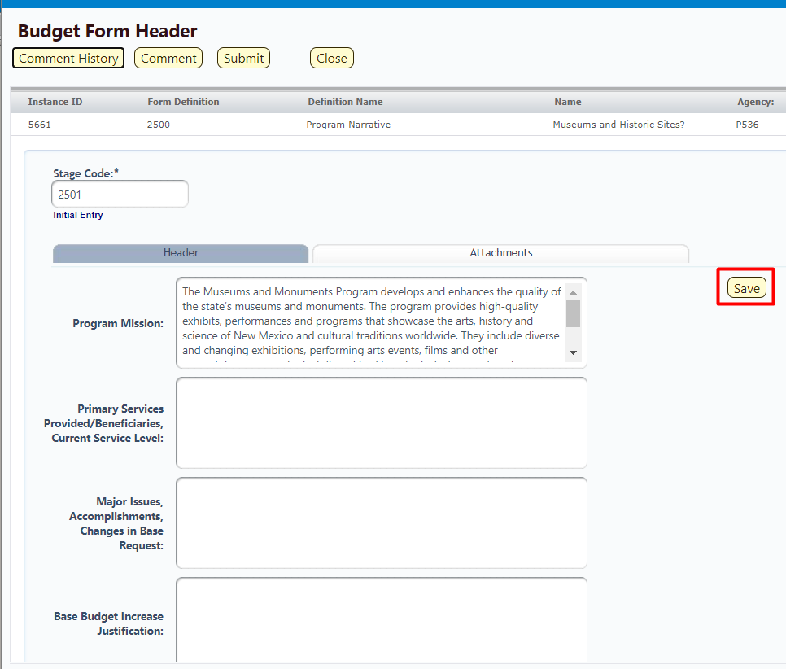

Attachments can be added to the form following the instructions outlined in Section 8.13 Attachments Tab.

Once Program Narrative is updated, submit the form following instructions from 8.14 Submit Budget Form.

Fund Balance Projection
The Fund Balance Projection form To reflect the adjusted fund balance amount available at the end of prior fiscal year, as well as projected fund balances at the end of the current fiscal year, and the appropriation request for next fiscal year.

Select the Fund Balance Projection (2900) S-10 form from the Budget Formulation menu.

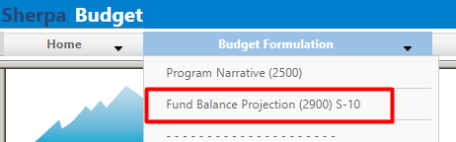

Click Add New. Alternatively, click Header for an existing form and skip to Section 15.2.1 to continue to the Header tab.
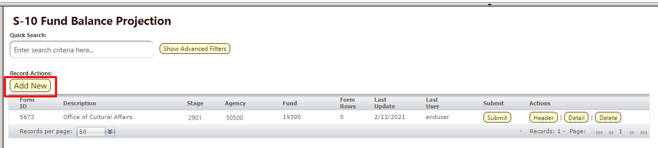

On the Create a new Budget Form 3200 screen, select Stage Code 2901 – Initial Entry from the dropdown. Enter the Agency and Fund and Name of the Fund Balance Projection. Click Save.
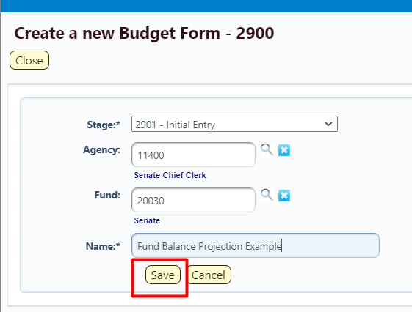

Header Tab

Enter the Legal Authority on and click Save to update the form.
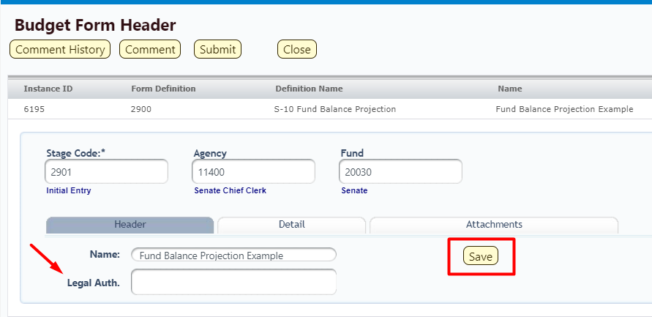

Detail Tab

Locate Detail and click to open the tab.
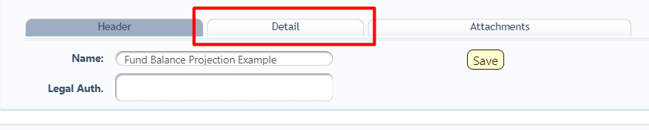

The Fund Balance Projection form will load.
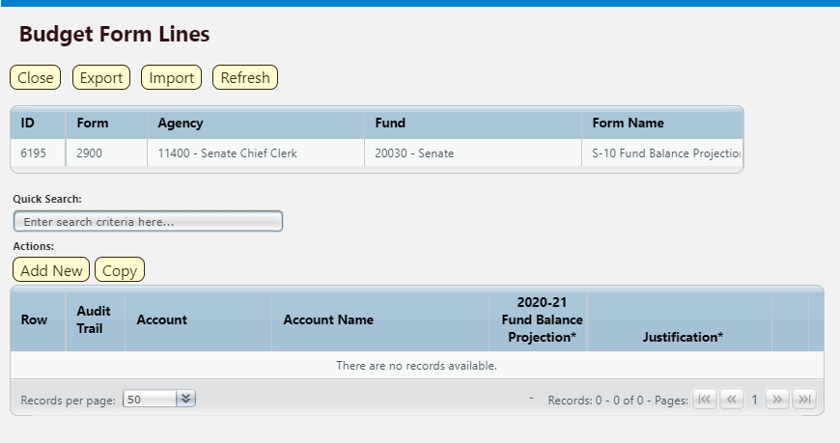

The top table shows a read-only summary of the form. The columns are described in the table below.

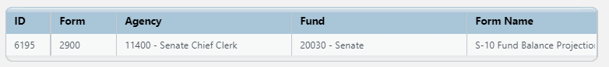

Screen: | Fund Balance Projection S-10 (2900) Budget Form Lines
Field (Column Name) | Description
ID | Read Only. Form Instance ID
Form | Read Only. Form number
Agency | Read Only. Agency Code and Name
Fund | Read Only. Fund Code and Name
Form Name | Read Only. Name of Form

The second table contains the Special, Supplemental & Deficiencies request data. Again, the example screenshot below shows a form populated with data. Some columns contain read-only data; this data is either system data, imported from another source such as the financial system, or are calculated based on other values in the form. Columns with an asterisk (*) are data entry columns, where users enter the budget request data. The table below describes the columns for the form.

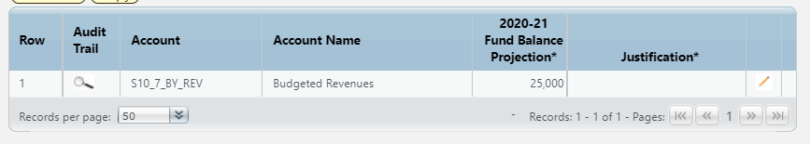

Screen: | Fund Balance Projection S-10 (2900) Budget Form Lines
Field (Column Name) | Description
Row | Read Only. Number indicating row count.
Audit Trail | Magnifying Glass button. Opens a window to display the audit trail records for the selected row.
Account | Read Only. Contains PCode Number.
Account Name | Read Only. Budget line for Account Name
20XX-XX Fund Balance Projection* | Data Entry Column. Enter Fund Balance Projection for the end of the current fiscal year
Justification * | Data Entry Column. Enter Justification text
Pencil (edit) Icon | Edit icon. When clicked, the Line Detail screen will display to allow budget request entries. Double-clicking a row performs the same action.

Click Add New. This can also be accomplished through the Excel Export/Import spreadsheet. Detailed instructions are found in Section 8.4 Excel Export/Import and Section 8.11 Add New Budget Entry.

- The Agency and Fund will be pre-populated with the Agency and Fund selected at form creation.
- Enter the Account code; click the Magnifying Glass to select from a list filtered to S-10 Report Account Codes
- Enter the Justification
- Enter the Fund Balance Projection for the end of the current fiscal year

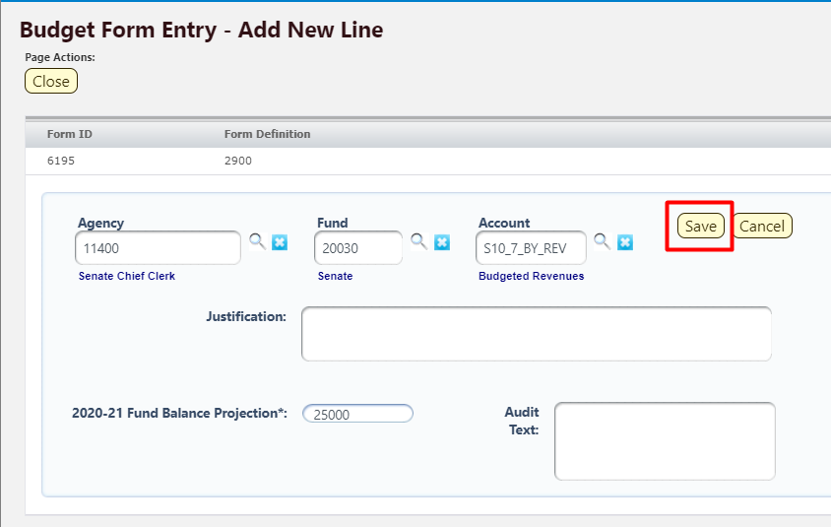

Click Save. The Fund Balance Projection form will load with new data.

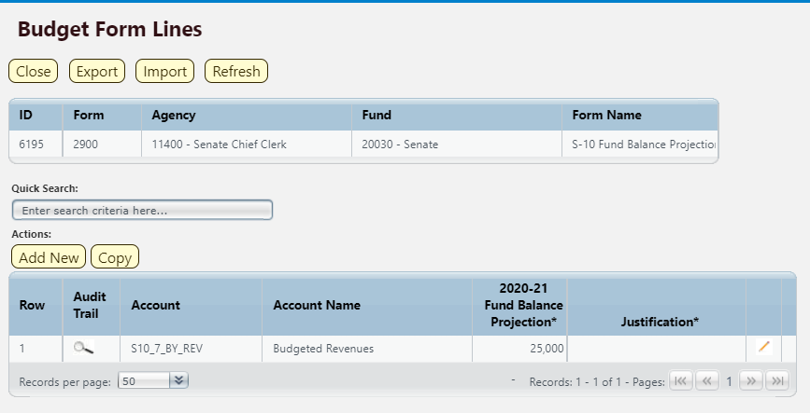

Once Fund Balance Projection is updated, submit the form following instructions from 8.14 Submit Budget Form.

Report

Data from the Fund Balance Projection form can be viewed in the S-10 Fund Balance Projection Report. See Section 21 BFM Reporting for instructions on how to access reports.

FTE Counts
The FTE Counts form displays the Full Time Equivalents calculated by the BFM Personnel Cost Forecasting (PCF) tool, including filled and vacant positions. The FTE Counts form provides Agencies the ability to request the number of FTEs to include in the budget.

Similar to the Base Budget E-4 and Contracts E-5 forms, the FTE Counts has two forms available: FTE Counts by DeptID form 2100 and FTE Counts by PCode form 3100. Agencies will select one form, either by DeptID 2100 or by PCode 3100, for each PCode to complete and submit for appropriations request.

The following instructions show screenshots for the FTE Count by Dept ID 2100 form, but these instructions apply to both FTE Counts forms.

Create New Form

Navigate to the FTE Counts form by hovering over the Budget Formulation menu and select the appropriate FTE Counts form from the dropdown menu.
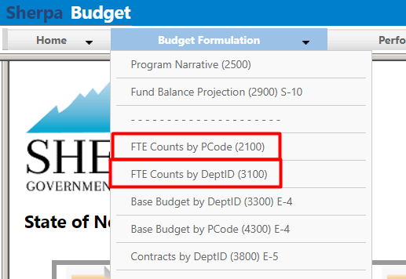

Click Add New to begin a new form. Alternatively, click Detail for an existing form to edit and proceed to step 16.1.5.

Select Stage Code 3101 – Initial Entry from the dropdown. Enter the PCode and Name of the form. Click Save.
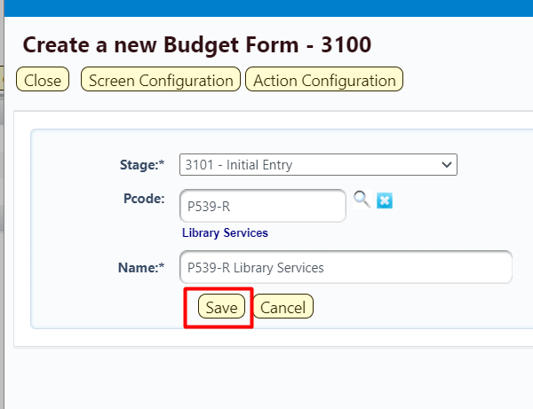

The budget form header will load. Click FTE Counts to load the Details screen.
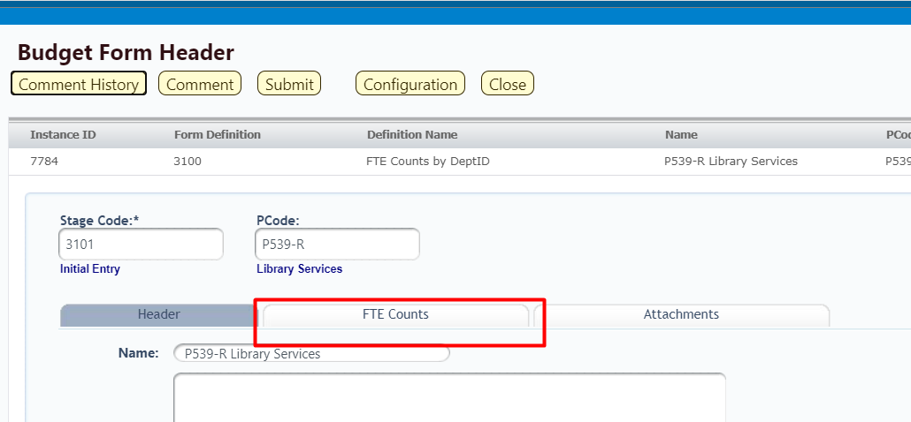

The budget form will load.
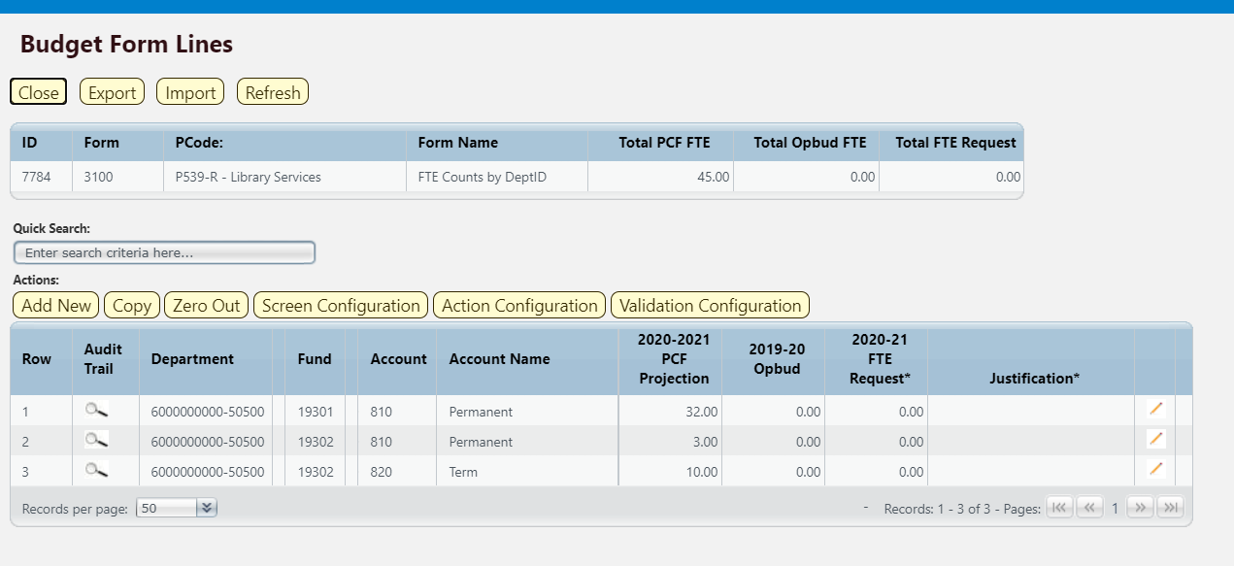

The top table shows a read-only summary of the form. The columns are described below.
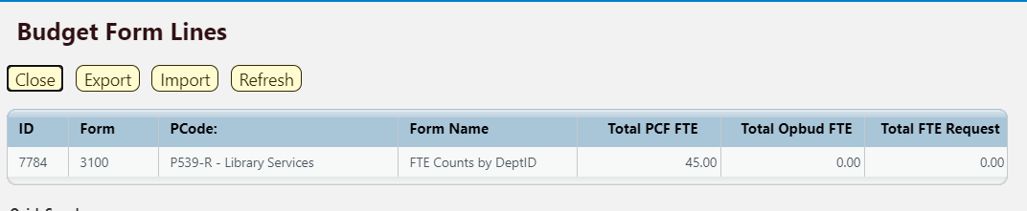

Screen: | FTE Counts by DeptID 3100 Budget Form Lines
Field (Column Name) | Description
ID | Read Only. Form Instance ID
Form | Read Only. Form number
PCode | Read Only. PCode and Program Name
Form Name | Read Only. Form Name
Total PCF FTE | Read Only. Total FTEs calculated in PCF Projection
Total OpBud FTE | Read Only. Total FTEs included in current year OpBud
Total FTE Request | Read Only. Total FTE requested on form

The second table contains the FTE Counts request data. Some columns contain read-only data; this data is either system data, imported from another source such as the financial system, or are calculated based on other values in the form. Columns with an asterisk (*) are data entry columns, where users enter the budget request data.

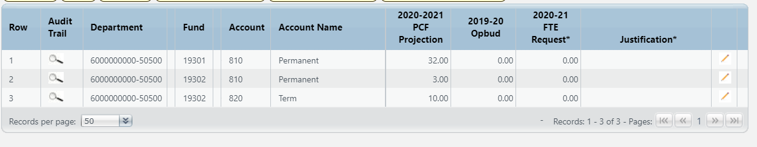

Screen: | FTE Counts by DeptID 3100 Budget Form Lines
Field (Column Name) | Description
Row | Read Only. Number indicating row count.
Audit Trail | Magnifying Glass button. Opens a window to display the audit trail records for the selected row.
Department | Read Only. Contains 10 digit DeptID Number + Agency Code.
Department Name | Read Only. This column is minimized, use double arrows to expand.
Fund | Read Only. Budget line for Fund
Fund Name | Read Only. This column is minimized, use double arrows to expand.
Account | Read Only. Budget line for Account
Account Name | Read Only. Budget line for Account Name
20XX-20XX PCF Projection | Read Only. FTE Count calculated by PCF Projection
20XX-20XX OpBud* | Data Entry Column. Enter current year OpBud FTE Count.  Note: During the first year of using BFM, users must enter this amount. In future years, this will be pre-populated based on previous year’s form data.
20XX-XX FTE Request* | Data Entry Column. Enter requested FTE Count for budget.
Justification* | Entry Column. Enter text justification
Pencil (edit) Icon | Edit icon. When clicked, the Line Detail screen will display to allow budget request entries. Double-clicking a row performs the same action.

Enter data into the budget form following the instructions from Section 8.4 Excel Export/Import or Section 8.11 Add New Budget Entry.

To complete this budget form, enter a new line for each contract by clicking Add New. This can also be accomplished through the Excel Export/Import spreadsheet.
- Enter the Department, Fund, and Account Numbers
- Enter the Justification
- Enter the current OpBud FTE Count (in the first year of using the system, in subsequent years this will be auto-populated based on previous year’s form data)
- Enter the FTE Request

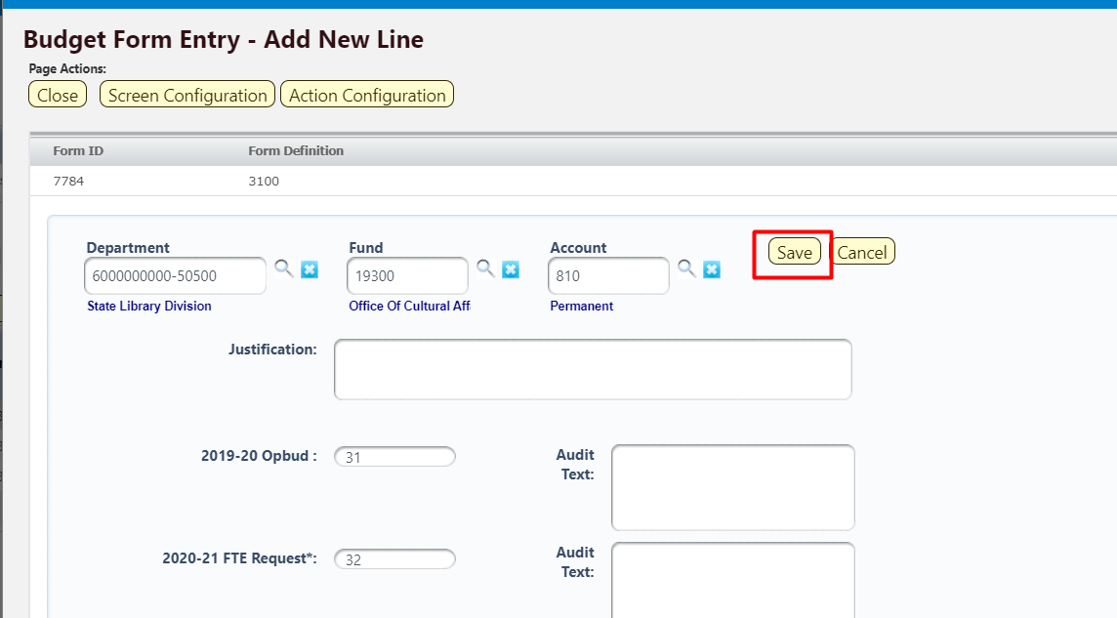

Click Save. The new line item will appear in the list. The Total OpBud FTE and Total FTE Request amounts will be updated in the top table on the form screen.

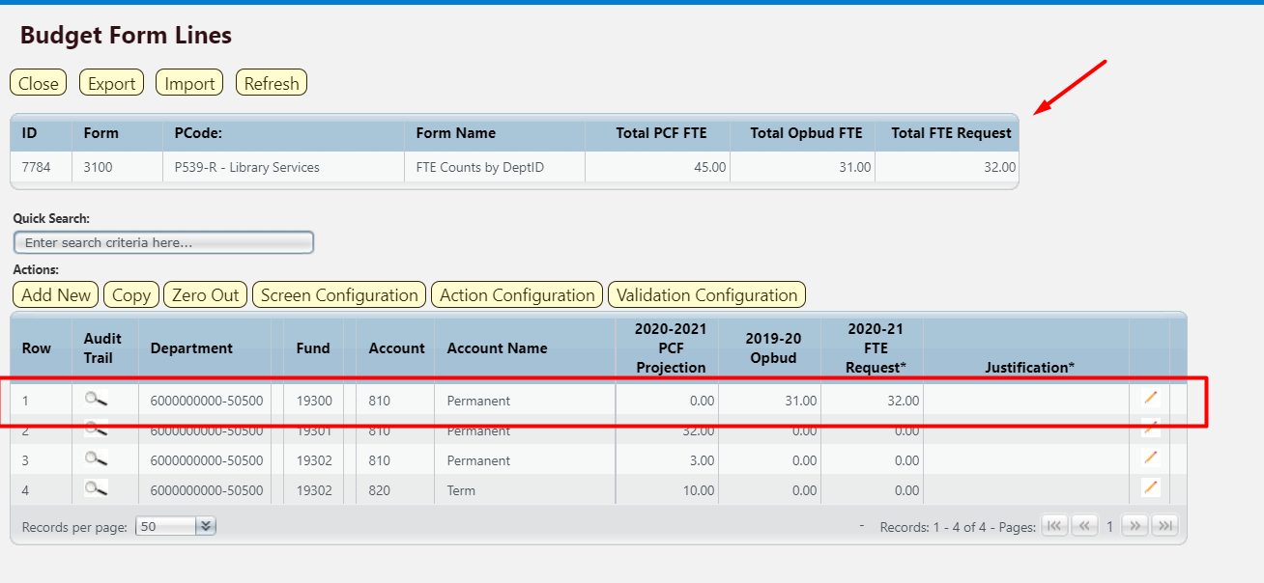

Once all FTE Counts have been added to the form, submit Budget form following instructions from 8.14 Submit Budget Form.

Report

Data from the FTE Counts forms can be viewed as reports. The FTE Count Requests By DeptID and FTE Count Requests by PCode reports can be accessed in 3.2 Personnel folder.

See Section 21 BFM Reporting for detailed instructions on how to access reports.

Vacancy Savings Application
The Vacancy Savings Application (3700) form allows users to enter a vacancy savings percentage to adjust PCF Projection calculated by BFM.

Navigate to the form by hovering over the Budget Formulation menu and clicking Vacancy Savings Application (3700).
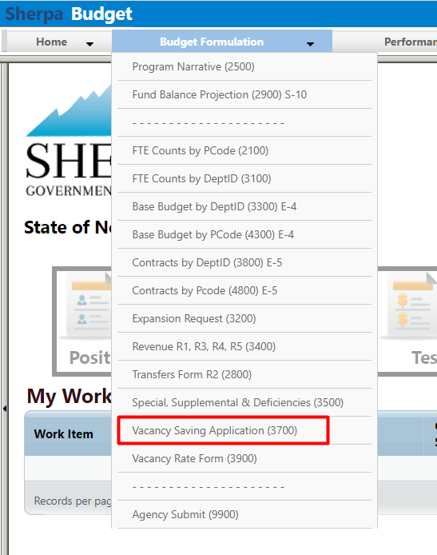

Click Add New. Alternatively, click Detail for an existing form and skip to Section 17.1.5 to continue to the Header tab.

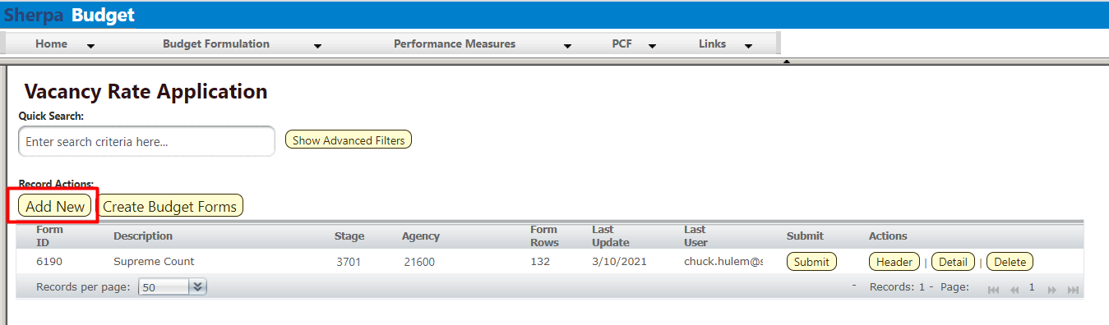

For Stage, select 3701 – Initial Entry from the dropdown menu. Enter the appropriate Agency code or use the Magnifying Glass to select from a filtered list. Enter a Name for the form. Click Save to create the form.
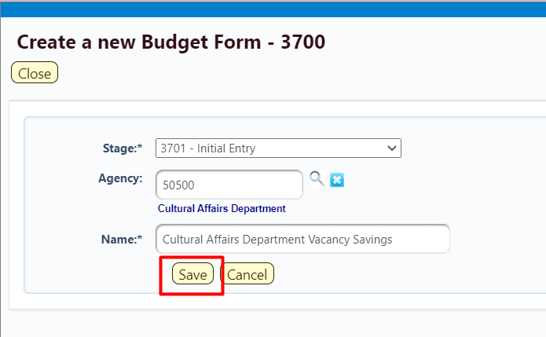

The Header tab will open. Click the Request tab to navigate to the Details screen.

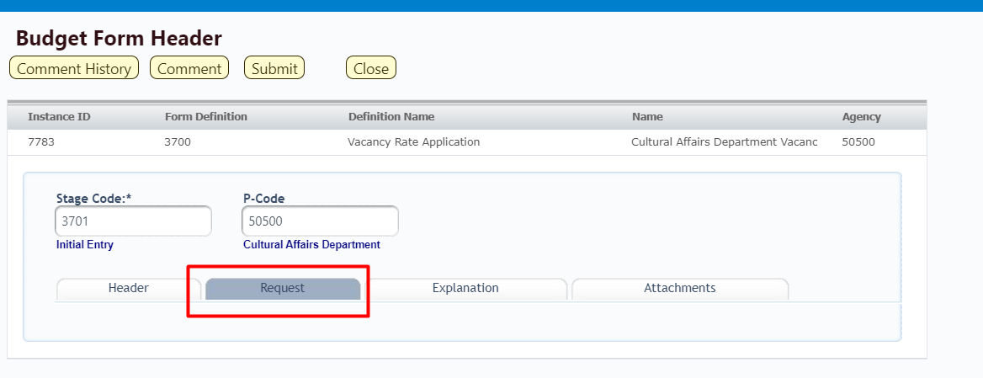

The Vacancy Savings Application form will load.
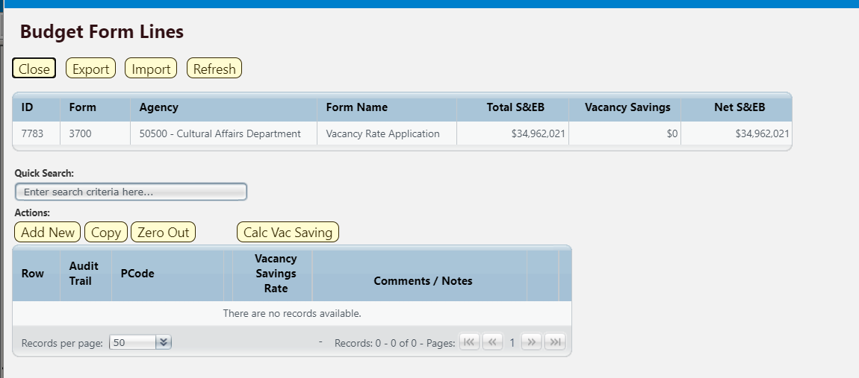
The top table shows a read-only summary of the form. The columns are described in the table below.

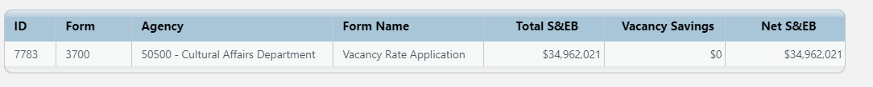

Screen: | Vacancy Rate Application 3700 Budget Form Lines
Field (Column Name) | Description
ID | Read Only. Form Instance ID
Form | Read Only. Form number
Agency | Read Only. Agency Code and Name
Form Name | Read Only. Name of Form
Total S&EB | Total S&EB calculated in the PCF projection
Vacancy Savings | Calculated based on Vacancy Savings Rate entered on form
Net S&EB | Total S&EB less Vacancy Savings

The second table contains the Special, Supplemental & Deficiencies request data. Again, the example screenshot below shows a form populated with data. Some columns contain read-only data; this data is either system data, imported from another source such as the financial system, or are calculated based on other values in the form. Columns with an asterisk (*) are data entry columns, where users enter the budget request data. The table below describes the columns for the form.

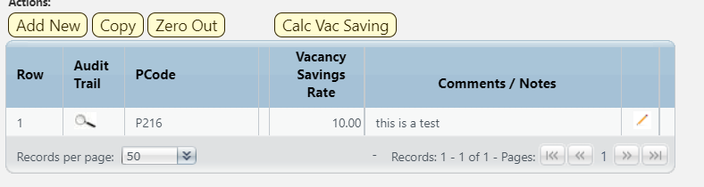

Screen: | Vacancy Rate Application 3700 Budget Form Lines
Field (Column Name) | Description
Row | Read Only. Number indicating row count.
Audit Trail | Magnifying Glass button. Opens a window to display the audit trail records for the selected row.
PCode | Read Only. PCode
PCode Name | Read Only. This column is minimized, use double arrows to expand to see.
Vacancy Savings Rate* | Data Entry Column. Enter the Vacancy Savings percentage.
Comments / Notes* | Data Entry Column. Enter Comments.
Pencil (edit) Icon | Edit icon. When clicked, the Line Detail screen will display to allow budget request entries. Double-clicking a row performs the same action.

Click Add New.
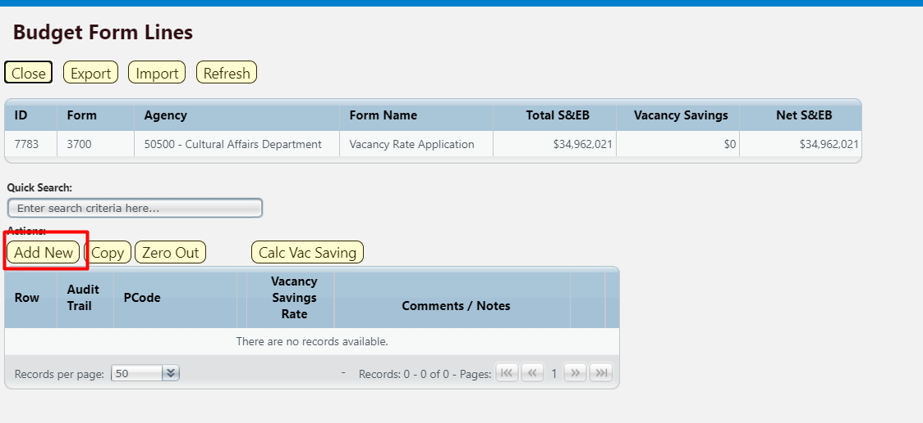

Complete the Budget Form.
Note: this can also be accomplished through the Excel Export/Import spreadsheet. Detailed instructions are found in Section 8.4 Excel Export/Import and Section 8.11 Add New Budget Entry.

- Enter the PCode; click the Magnifying Glass to select from a filtered list of PCodes based on the Agency selected during form creation
- Enter the Comments / Notes, if needed
- Enter percentage amount in Vacancy Savings Rate

Click Save.

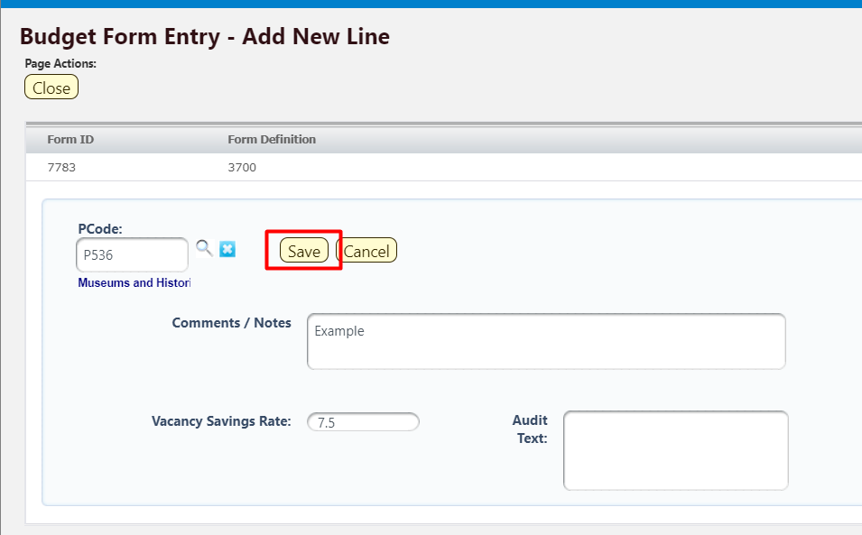

The line item will appear on the form. Click Calc Vac Savings.
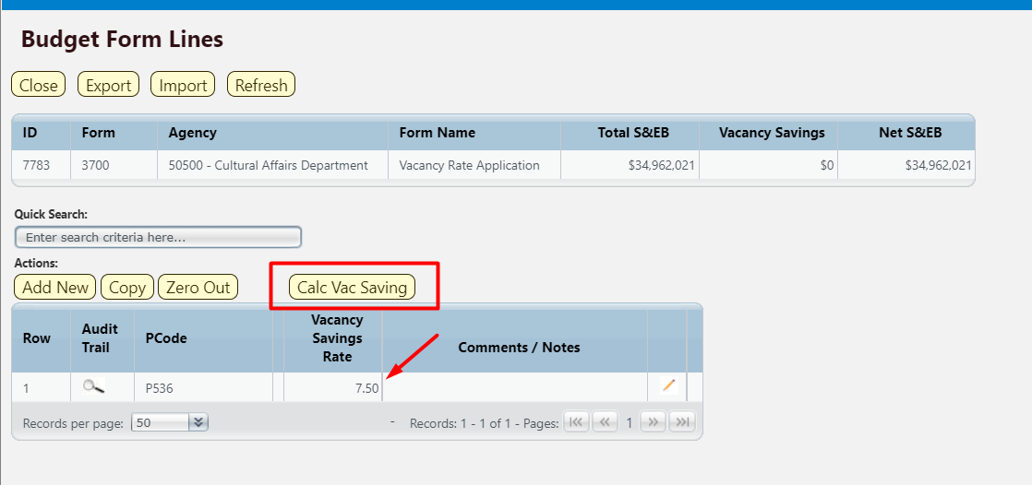

Click Run.

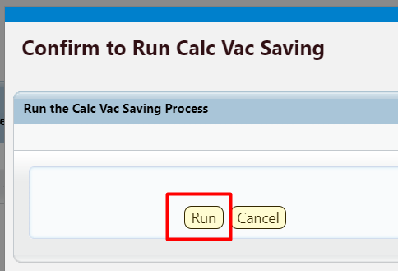

When the calculation is completed, the Vacancy Savings amount will appear in the table at the top of the screen, and the Net S&EB will be calculated.

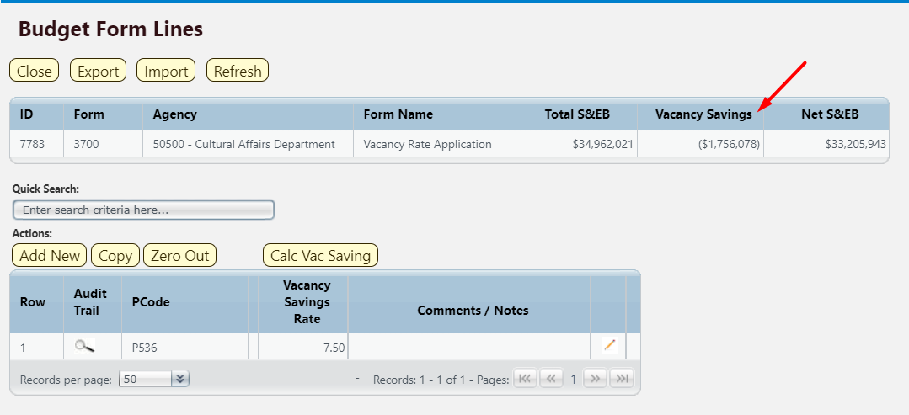

Vacancy Rate Form
The Vacancy Rate Form (3900) provides a way to enter monthly vacancy rate.

Navigate to the form by hovering over the Budget Formulation menu and clicking Vacancy Rate Form (3900).
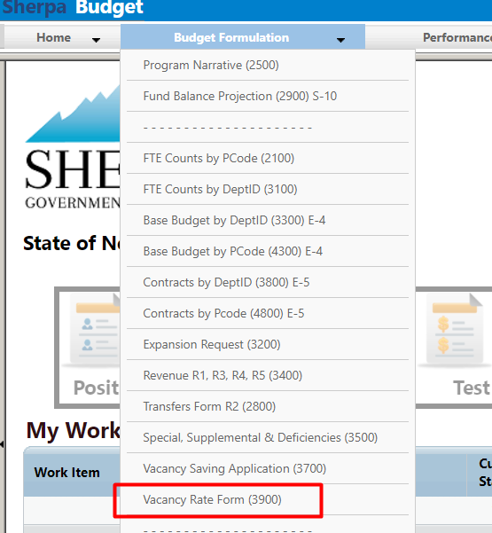

Select an available form from the main Vacancy Rate form screen or "List Page." This page will return a form for each agency based on your security. If there are no agencies assigned for your security role, this list will be blank. If you believe there is an error in the list available to you, then contact the BFM Administrator to update your security role.

To edit, click Detail.

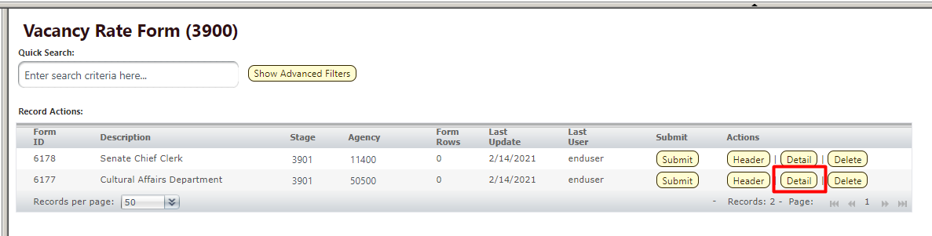

The Vacancy form will load.

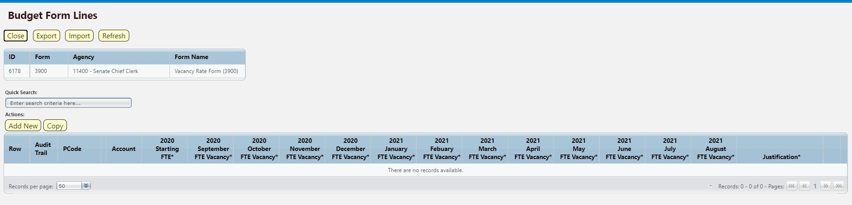

The top table shows a read-only summary of the form.

Screen: | Vacancy Rate Form 3900 Budget Form Lines
Field (Column Name) | Description
ID | Read Only. Form Instance ID
Form | Read Only. Form number
Agency | Read Only. Agency Code and Name
Form Name | Read Only. Form Name

The second table contains the form data. Some columns contain read-only data; this data is either system data, imported from another source such as the financial system, or are calculated based on other values in the form. Columns with an asterisk (*) are data entry columns, where users enter the budget request data.

Screen: | Vacancy Rate Form 3900 Budget Form Lines
Field (Column Name) | Description
Row | Read Only. Number indicating row count.
Audit Trail | Magnifying Glass button. Opens a window to display the audit trail records for the selected row.
PCode | Read Only. Contains PCode Number.
PCode Name | Read Only. This column is minimized, use double arrows to expand to see.
Account | Read Only. Budget line for Account
20XX Starting FTE* | Data Entry Column. Authorized FTE count for beginning of year.
20XX September – August FTE Vacancy* | Data Entry Columns. Enter FTE Vacancy count for each month.
Justification* | Entry Column. Enter text justification
Pencil (edit) Icon | Edit icon. When clicked, the Line Detail screen will display to allow budget request entries. Double-clicking a row performs the same action.

Edit an existing budget line or click Add New. This can also be accomplished through the Excel Export/Import spreadsheet. Detailed instructions are found in Section 8.4 Excel Export/Import and Section 8.11 Add New Budget Entry.

- Enter the PCode; click the Magnifying Glass to select from a filtered list of PCodes based on Agency form selected
- Enter the Account ; click the Magnifying Glass to select Authorized FTE or Vacancy FTE
- Enter the Justification
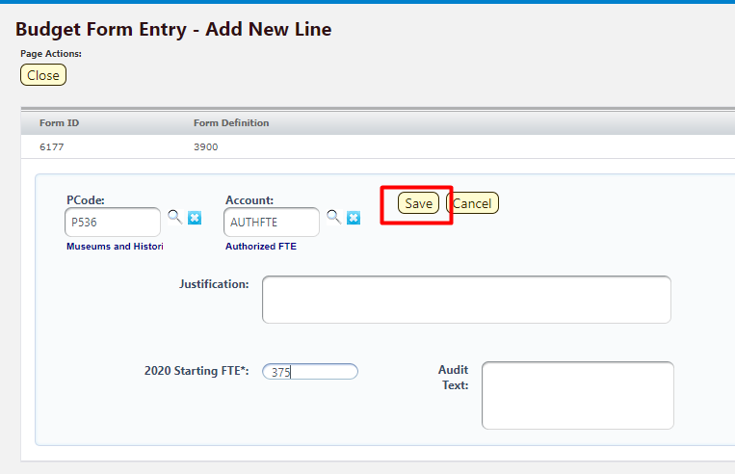

Click Save. The new vacancy rate form will appear in the list. 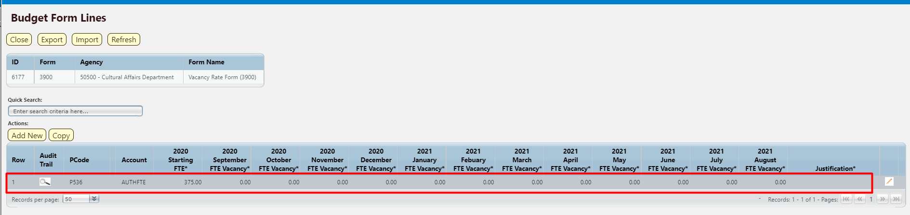

Double-click the line or click the Pencil Icon to edit the monthly vacancy rate. Click Save All.

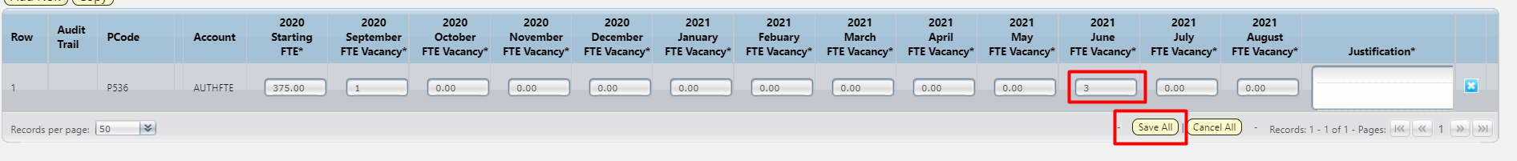

Once the monthly Vacancy Rate is updated, submit the form following instructions from 8.14 Submit Budget Form.

Performance Measures
Forms for Performance Measures tracking are located in the Performance Measures top level navigation menu.
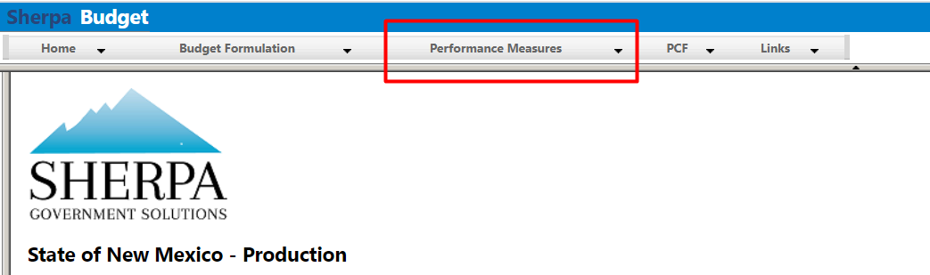

Performance Measures
Performance Measures are captured in BFM in the Performance Measures 4000 form.

Navigate to the form by hovering over the Performance Measures menu and clicking Performance Measures (4000).
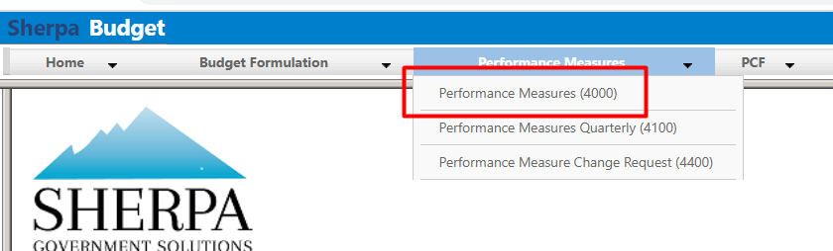

Select an available form from the main Performance Measures form screen or "List Page" and click Detail. This page will return a form for each Agency based on your security. If there are no agencies or programs assigned for your security role, this list will be blank. If you believe there is an error in the list of agencies or programs available in your list, then contact the BFM Administrator to update your security role.
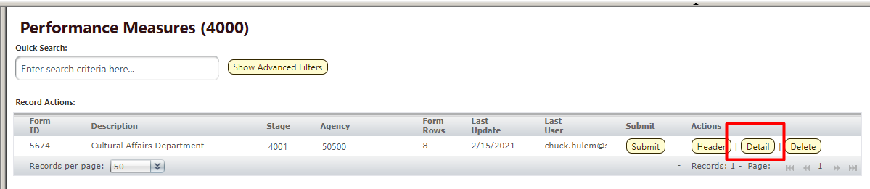

The Performance Measures Detail form will load.
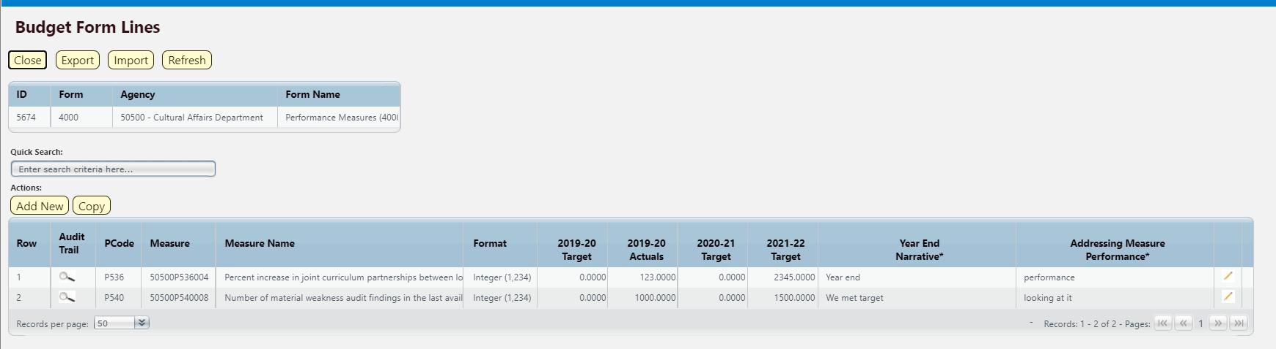

The top table shows a read-only summary of the form.

Screen: | Performance Measures 4000 Form Lines
Field (Column Name) | Description
ID | Read Only. Form Instance ID
Form | Read Only. Form number
Agency | Read Only. Agency Code and Name
Form Name | Read Only. Form Name

The second table contains the performance measures data. Some columns contain read-only data; this data is either system data, imported from another source such as the financial system, or are calculated based on other values in the form. Columns with an asterisk (*) are data entry columns, where users enter the budget request data. The table below describes the columns for the Performance Measures 4000 form.
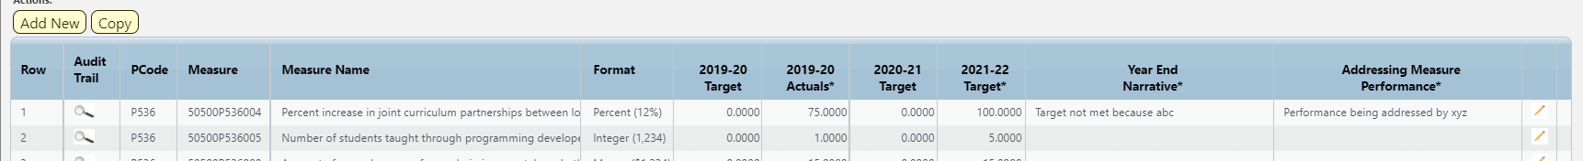

Screen: | Performance Measures 4000 Form Lines
Field (Column Name) | Description
Row | Read Only. Number indicating row count.
Audit Trail | Magnifying Glass button. Opens a window to display the audit trail records for the selected row.
PCode | Read Only. PCode Number
Measure | Read Only. Measure Number
Measure Name | Read Only. Measure Name / Description
Format | Read Only. The format for the Performance Measure Value, this will be based on the measure selected
20XX-XX Target | Read Only. Previous fiscal year’s Target Performance Measure Value
20XX-XX Actuals* | Data Entry Column. Enter previous fiscal year’s Actuals Performance Measure Value
20XX-XX Target | Read Only. Current fiscal year’s Target Performance Measure Value
20XX-XX Target* | Data Entry Column. Enter the proposed Target Performance Measure Value
Year End Narrative* | Data Entry Column. Enter Year End Narrative text
Addressing Measure Performance* | Data Entry Column. Enter how measured performance is being addressed
Pencil (edit) Icon | Edit icon. When clicked, the Line Detail screen will display to allow budget request entries. Double-clicking a row performs the same action.

Click Add New. This can also be accomplished through the Excel Export/Import spreadsheet. Detailed instructions are found in Section 8.4 Excel Export/Import and Section 8.11 Add New Budget Entry.

- Agency will be populated based on Performance Measure form selected.
- Select Performance Measure Number; click the Magnifying Glass to select from a list filtered to available Measures based on Agency
  - Note: Once Measure is selected, blue text beneath field will display the type of the Performance Measure Value. In the example below, the type is number. The format (displayed on the Measures/Detail screen) for this measure type is integer.
- Enter the Year End Narrative, describe if the performance measure was met or not
- Enter the Addressing Measure Performance, describe how performance is being address
- Enter previous fiscal year’s Actual Performance Measure Value
  - Note: if entering data on an existing Performance Measure, then values will combine with existing values (not overwrite) on form when updated
- Enter current fiscal year’s Target Performance Measure Value
  - Note: if entering data on an existing Performance Measure, then values will combine with existing values (not overwrite) on form when updated

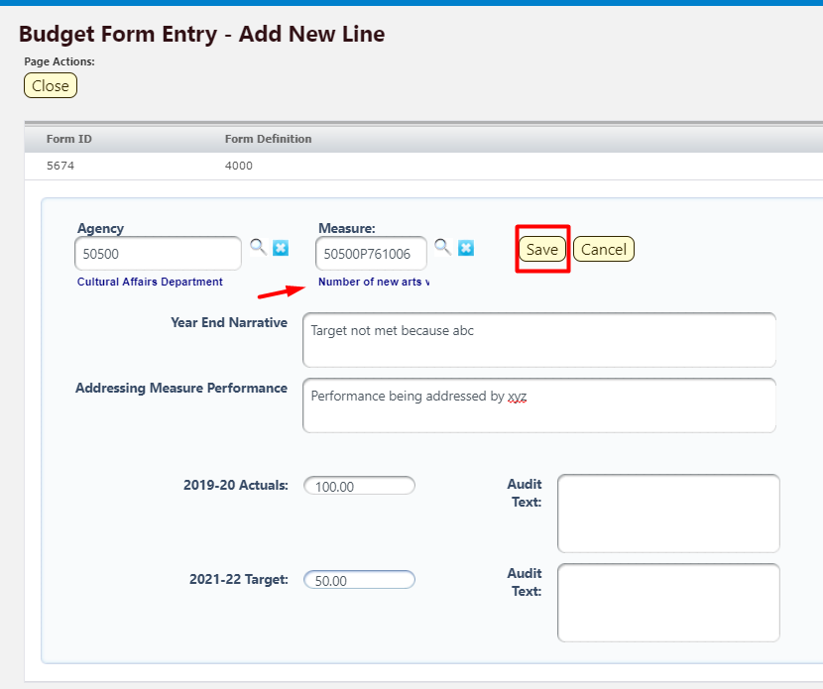

Click Save. The new Measure will appear in the form. 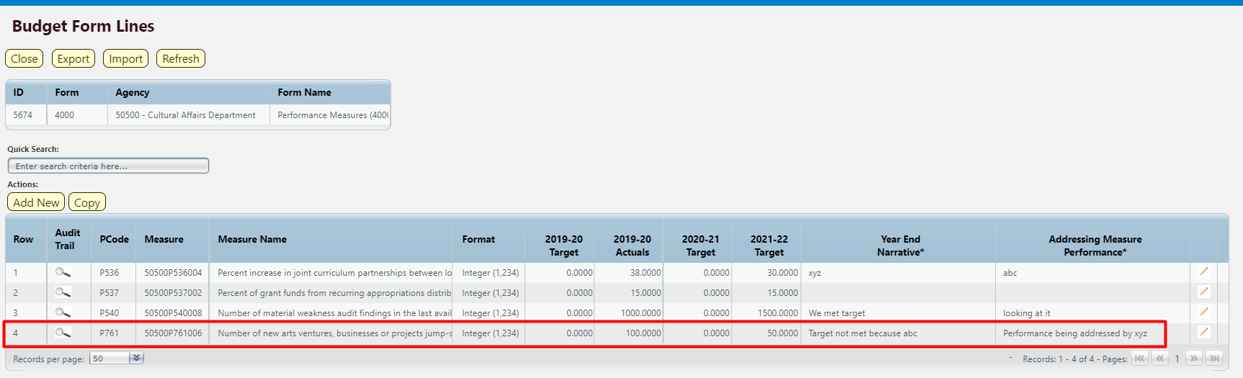

Once all Performance Measures are added to the form, submit the form following instructions from 8.14 Submit Budget Form.

Performance Measures Quarterly

Navigate to the form by hovering over the Budget Formulation menu and clicking Performance Measures Quarterly (4100).
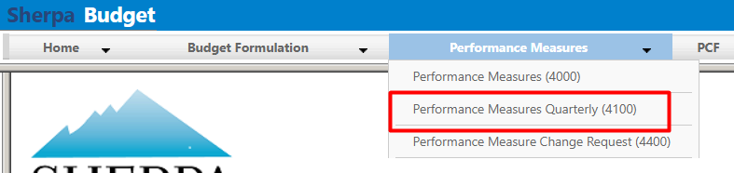

Select an available form from the main Performance Measures form screen or "List Page" and click Detail. This page will return a form for each Agency based on your security. If there are no agencies or programs assigned for your security role, this list will be blank. If you believe there is an error in the list of agencies or programs available in your list, then contact the BFM Administrator to update your security role.

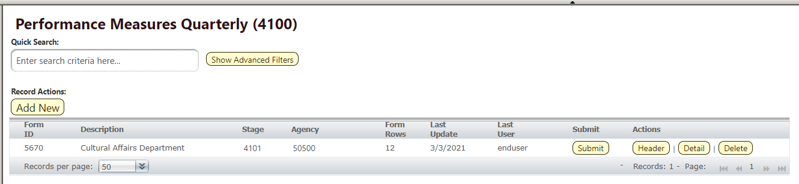

The Performance Measures Detail form will load.
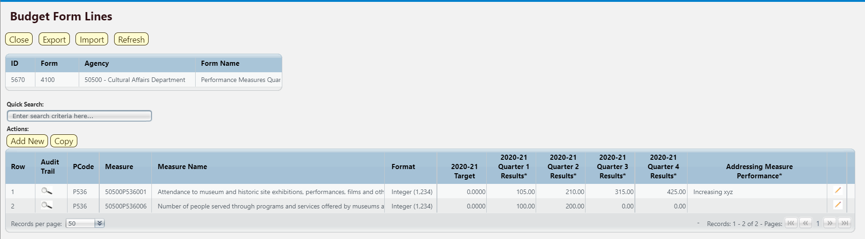

The top table shows a read-only summary of the form.

Screen: | Performance Measures Quarterly 4100 Form Lines
Field (Column Name) | Description
ID | Read Only. Form Instance ID
Form | Read Only. Form number
Agency | Read Only. Agency Code and Name
Form Name | Read Only. Form Name

The second table contains the quarterly performance measures data. Some columns contain read-only data; this data is either system data, imported from another source such as the financial system, or are calculated based on other values in the form. Columns with an asterisk (*) are data entry columns, where users enter the budget request data. The table below describes the columns for the Performance Measures Quarterly form.

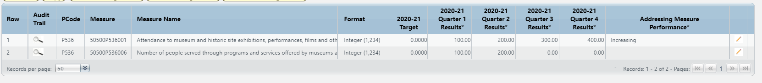

Screen: | Performance Measures Quarterly 4100 Form Lines
Field (Column Name) | Description
Row | Read Only. Number indicating row count.
Audit Trail | Magnifying Glass button. Opens a window to display the audit trail records for the selected row.
PCode | Read Only. PCode Number
Measure | Read Only. Measure Number
Measure Name | Read Only. Measure Name / Description
Format | Read Only. The format for the Performance Measure Value, this will be based on the measure selected
20XX-XX Target | Read Only. Previous fiscal year’s Target Performance Measure Value
20XX-XX Quarter 1 Results* | Data Entry Column. Enter Performance Measure Results from Q1
20XX-XX Quarter 2 Results* | Data Entry Column. Enter Performance Measure Results from Q2
20XX-XX Quarter 3 Results* | Data Entry Column. Enter Performance Measure Results from Q3
20XX-XX Quarter 4 Results* | Data Entry Column. Enter Performance Measure Results from Q4
Addressing Measure Performance* | Data Entry Column. Enter how measured performance is being addressed
Pencil (edit) Icon | Edit icon. When clicked, the Line Detail screen will display to allow budget request entries. Double-clicking a row performs the same action.

Click Add New. This can also be accomplished through the Excel Export/Import spreadsheet. Detailed instructions are found in Section 8.4 Excel Export/Import and Section 8.11 Add New Budget Entry.

- Agency will be populated based on Performance Measure form selected.
- Select Performance Measure Number; click the Magnifying Glass to select from a list filtered to available Measures based on Agency.
  - Note: Once Measure is selected, blue text beneath field will display the type of the Performance Measure Value. In the example below, the type is number. The format (displayed on the Measures/Detail screen) for this measure type is integer.
- Enter the Addressing Measure Performance, describe how performance is being address.
- Enter the appropriate Quarter Results.

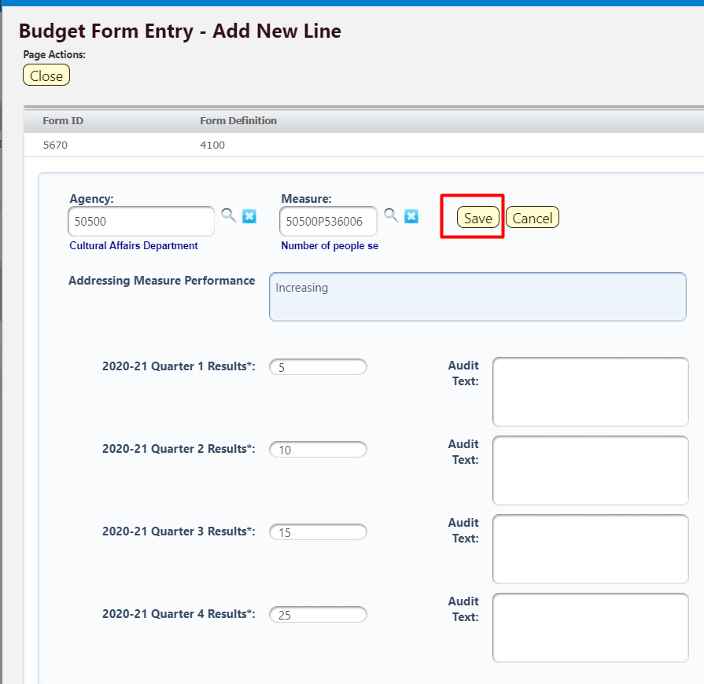

Click Save. The Measure will appear in the form.
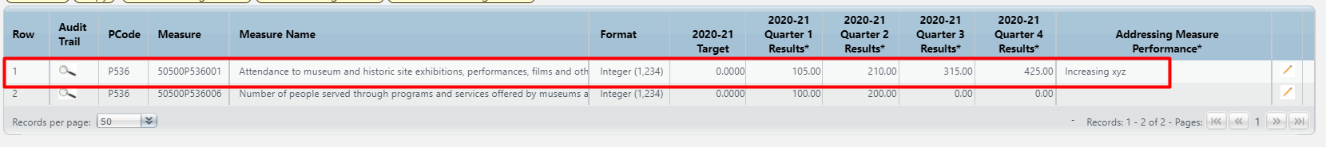

Once all Performance Measures are added to the form, submit the form following instructions from 8.14 Submit Budget Form.

Performance Measure Change Request
Changes to existing Performance Measures can be requested through the BFM Performance Measure Change Request Form 4400.

Navigate to the form by hovering over the Budget Formulation menu and clicking Performance Measures Quarterly (4400).
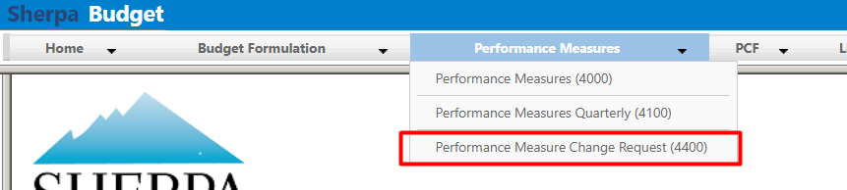

Select an available Change Request from the main form screen or "List Page" and click Header; or click Add New to create a new change request.
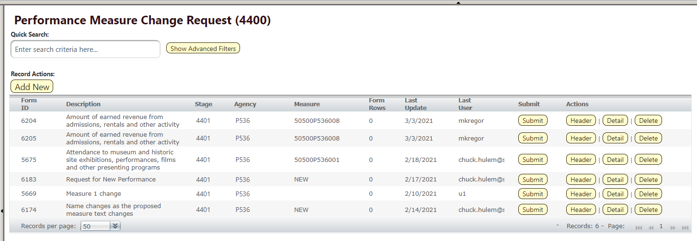

Select Stage 4401 – Initial Entry. Enter Agency code or use the Magnifying Glass to select from a filtered list based on user security. Enter Name for the proposed Transfer.

Click Save.
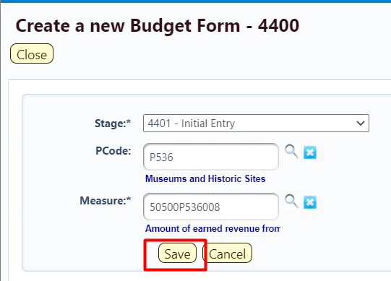

On the Header tab, update the form fields.

- Existing Measure (Changes Not Saved) will be populated based on the existing Performance Measure text. Any changes to this text will be ignored when saved.
- Proposed Measure – enter the new proposed Measure text.
- Explanation of Change – enter text to explain the requested change.
- SBD’s Analyst Comments – text field for Analyst’s comments.
- Consensus Reached – check if applies to measure
- Current HB2 Flag – check if applies to measure
- Proposed HB2 Flag – check if applies to measure
- Proposed Key Flag – check if proposed key measure
- FY Last Reviewed/Updated – select the year
- Inactive Year – select Keep Active, or select a date to set this measure as inactive
- Measure Type –
- Measure Format – select appropriate format, i.e., integer, money, percent, etc.
- Direction Good – set the desirable outcome of the target performance measure value
  - Result Over Target = Target Met
  - Result Under Target = Target Met
- Sort Order – select the sort order
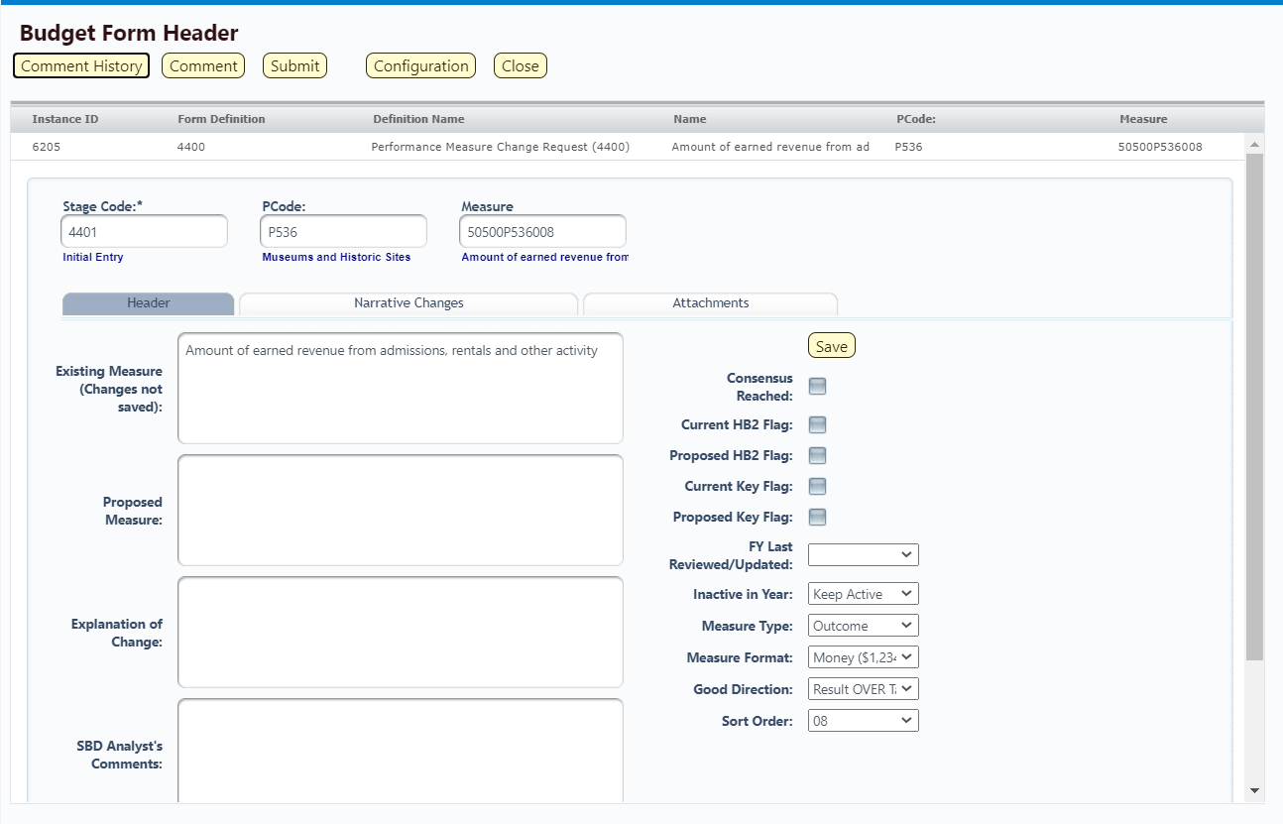

Click Save. The Measure will save. Navigate to the Narrative Changes tab.

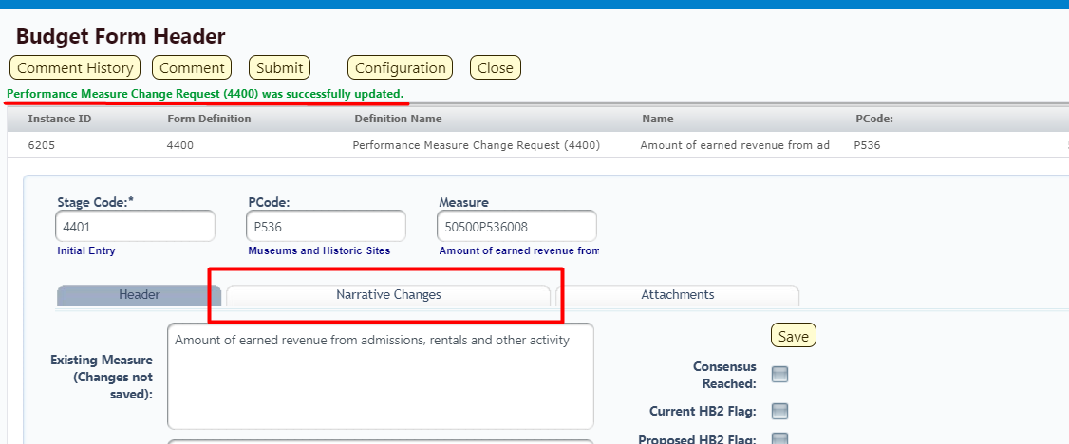

Enter Proposed Text into the fields on the Narrative Changes tab. Click Save.
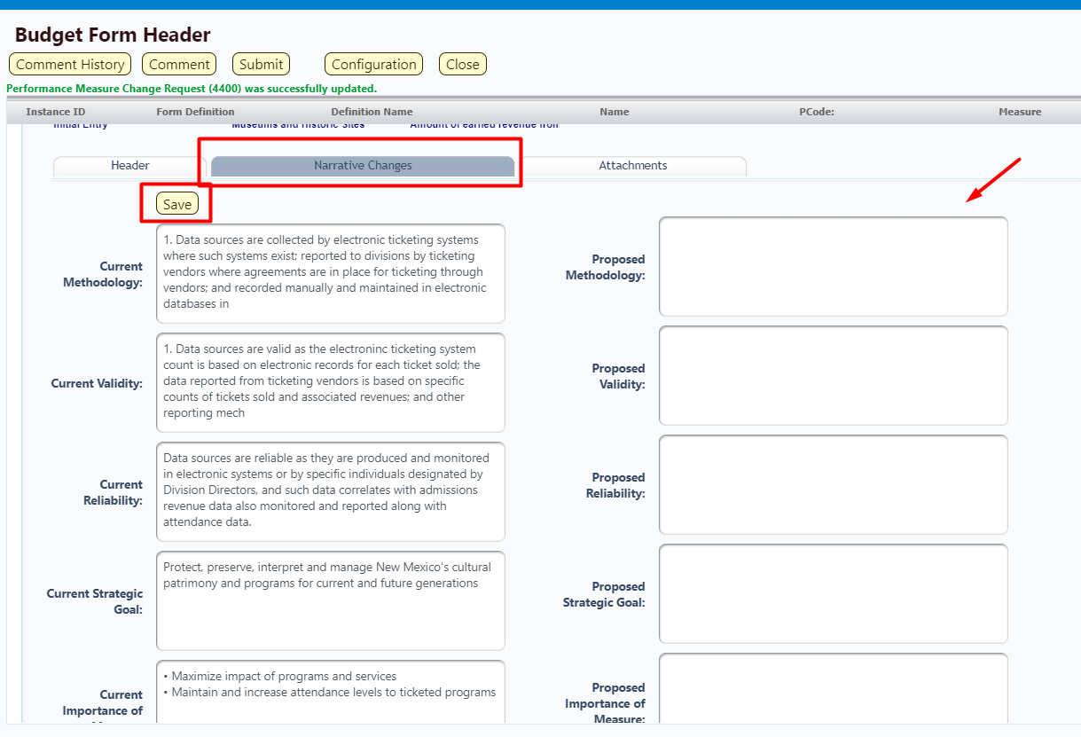

Click Close.
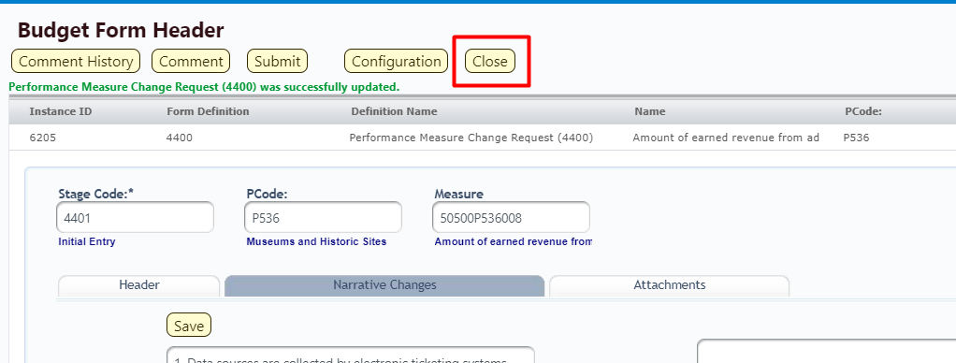

The new Change Request appears in the list.
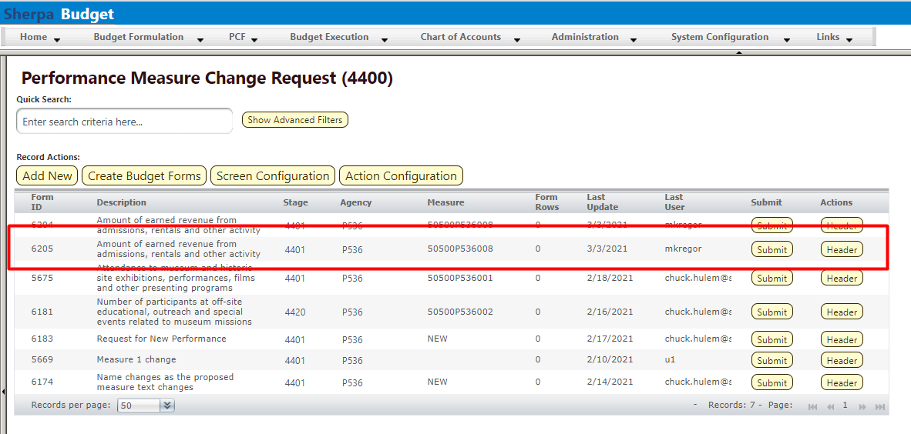

Click Header if additional edits are required.

Once the Change Request is finished, submit the form following instructions from 8.14 Submit Budget Form.

Personnel Cost Forecasting (PCF)
PCF is the BFM tool that calculates base salary and benefit information based on employee data loaded into the system. The PCF main navigation menu provides access to forms that allow for updates to personnel data in BFM. Note: BFM data is not used to update data in the human resources system. This is for budgeting purposes only.

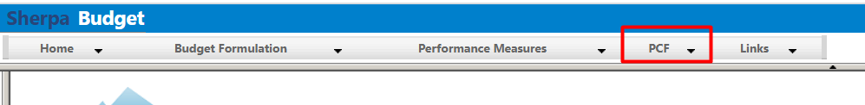

Employee Allocation Updates
The Employee Allocation Updates 7100 form allows agencies to change employee allocations.

Navigate to the form by hovering over the PCF menu and clicking Employee Allocation Updates (7100).
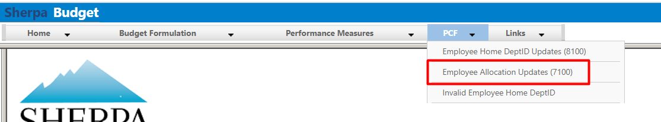

Click the Detail button for an available form on the main Employee Allocation form screen or "List Page." This page will return a form for each agency or program based on your security. If there are no agencies or programs assigned for your security role, this list will be blank. If you believe there is an error in the list available to you, then contact the BFM Administrator to update your security role.

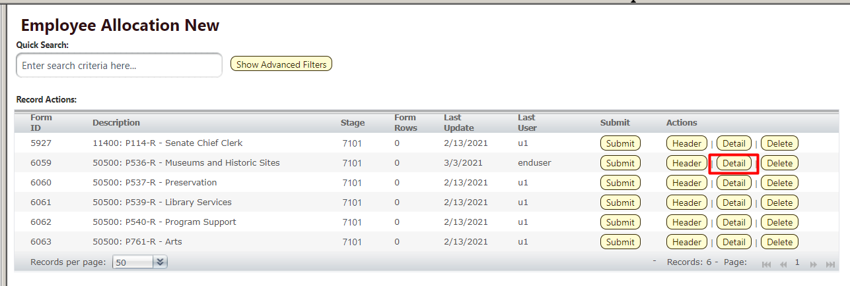

The Employee Allocation Updates form will load.

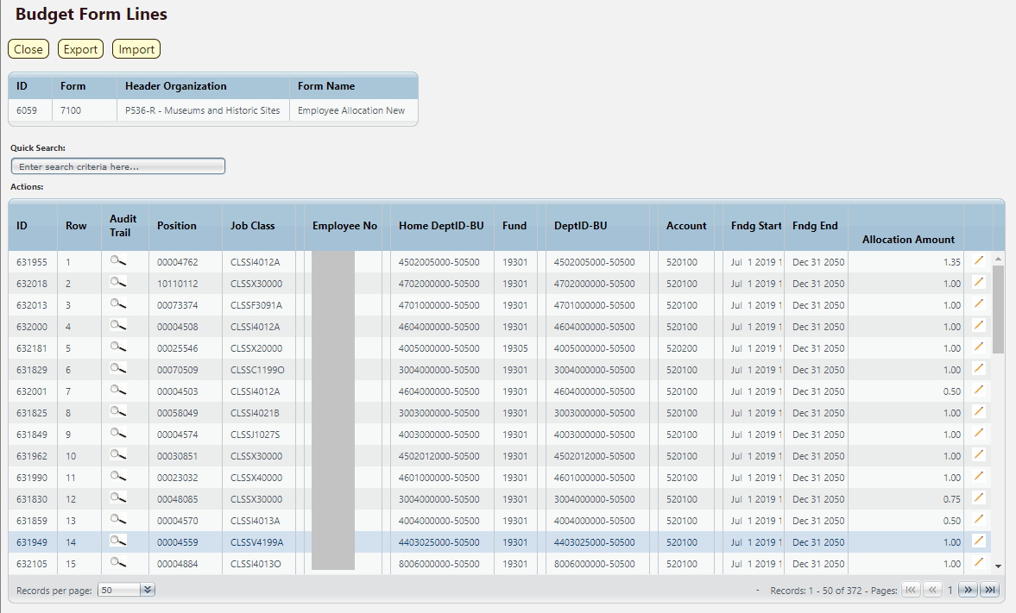
The second table contains the employee allocation data described in the table below.

Screen: | Employee Allocation Update 3900 Form Lines
Field (Column Name) | Description
ID | Read Only. Record ID.
Row | Read Only. Number indicating row count.
Audit Trail | Magnifying Glass button. Opens a window to display the audit trail records for the selected row.
Position | Read Only. Position Number
Job Class | Read Only. Job Class Code
Class Name | Read Only. This column is minimized, use double arrows to expand to see.
Employee No | Read Only. Employee Number (redacted in screenshot)
Employee Full Name | Read Only. This column is minimized, use double arrows to expand to see.
Home DeptID-BU | Read Only. Home Organization code for Employee
Fund | Read Only. Fund Code
Fund Name | Read Only. This column is minimized, use double arrows to expand to see.
DeptID-BU | Read Only. Department code for Employee
DeptID Name | Read Only. This column is minimized, use double arrows to expand to see.
Account | Read Only. Account number of employee.
Fndg Start | Read Only. Funding Start Date.
Fndg End | Read Only. Funding End Date.
Allocation Amount* | Data Entry Column. Enter updated allocation amount.
Pencil (edit) Icon | Edit icon. When clicked, the Line Detail screen will display to allow budget request entries. Double-clicking a row performs the same action.

Locate the record to be updated and double-click to edit. Use the Quick Search feature to narrow the record list.

This can also be accomplished through the Excel Export/Import spreadsheet. Detailed instructions are found in Section 8.4 Excel Export/Import

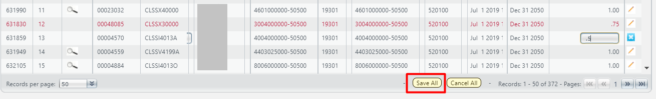

Click Save All to update edited records. An edited record will appear in red text until it is saved. Important: Save All before paging through records. Data entered will be lost if you page through the records list before saving edits.

Important: Each Employee Allocations must equal 100% (1.0) for the form to be submitted to the next stage.

When Allocation updates are complete, click Close. Then Submit using the instructions from 8.14 Submit Budget Form.

Note: Each Employee Allocations must equal 100% (1.0) for the form to be submitted to the next stage. If an employee allocation is greater than or less than 100% (1.0), then an error message will appear when attempting to submit the form, as shown below. If the error message appears, return to the form and correct the allocation amounts before attempting to submit the form again.

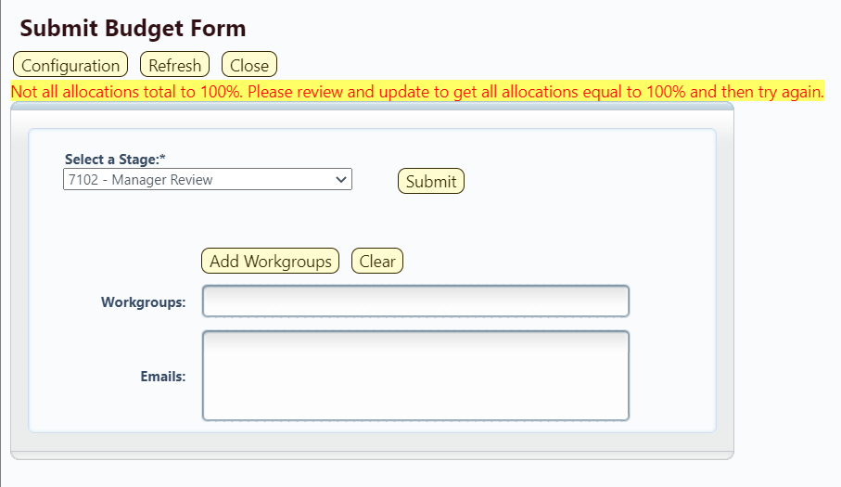

Invalid Employee Home Dept ID
The Invalid Employee Home Dept ID screen shows a listing of employee records that do not have a valid home organization assigned in the system. The list will only show employee records that are assigned to a user’s Business Unit (BU), based on system security. If an employee record has an invalid home organization in the system, then that record will not be included in any Personnel Cost Forecasting (PCF) calculations or on any other PCF screens.

The list on this screen can be exported to Excel for further analysis by the Department. Corrections to the employee record home organization should be made on the Employee Home DeptID Updates (8100) form.

Navigate to the screen by hovering over the PCF menu and clicking Invalid Employee Home DeptID.
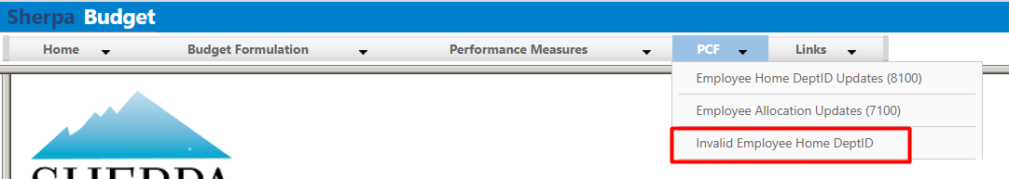

Click Export to XLSX.

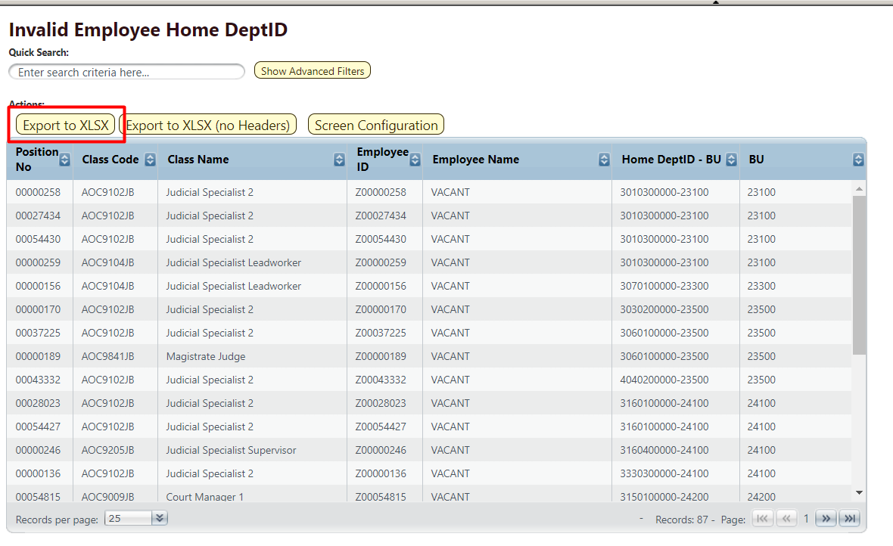

Proceed to Employee Home DeptID Updates (8100) form to correct invalid home orgs in the system.

Employee Home DeptID Updates
The Employee Home DeptID Updates (8100) form allows users to correct employee records in the system that have an invalid Home Dept ID assigned in BFM. If an employee record has an invalid home organization in the system, then that record will not be included in any Personnel Cost Forecasting (PCF) calculations or on any other PCF screens.

Navigate to the screen by hovering over the PCF menu and clicking Employee Home DeptID Updates (8100).
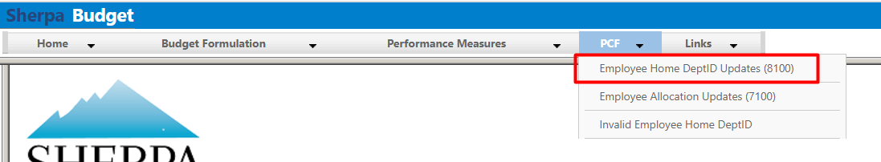

Select an available form from the main form screen or "List Page" and click Header. This page will only return forms for Business Units that have an employee record with an invalid ID assigned. If there are no forms, then the Business Units assigned to your user account do not contain any employee records that have invalid Home DeptIDs assigned.
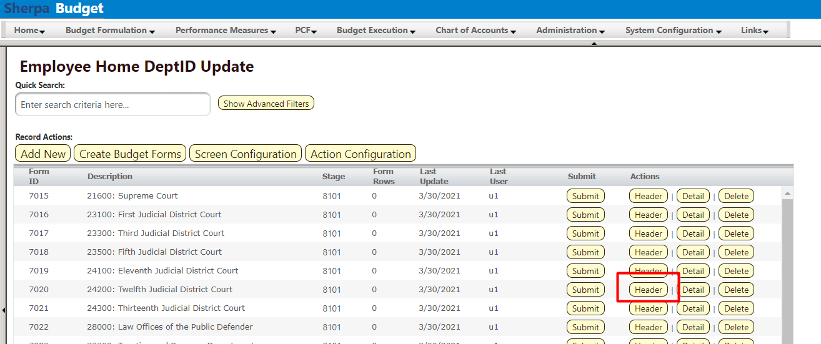

Click the Invalid Home Orgs tab.
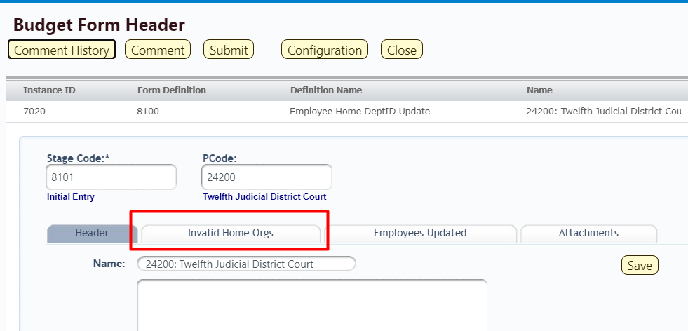

The listing of employee records with invalid home organizations will appear. Click Export.

For step-by-step Export instructions, see Section 8.4 Excel Export/Import.
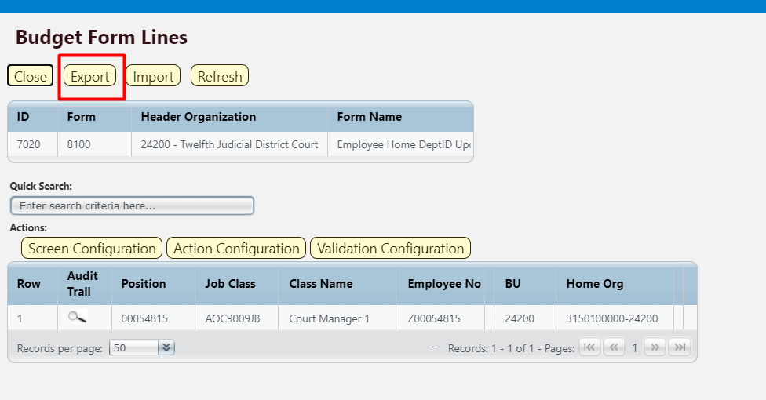

Locate the downloaded file in your browser’s bottom toobar. Right-click the arrow and select Open.
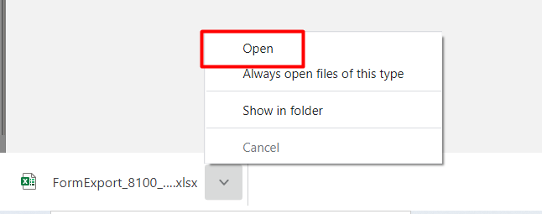

Click Enable Editing and Save the file.

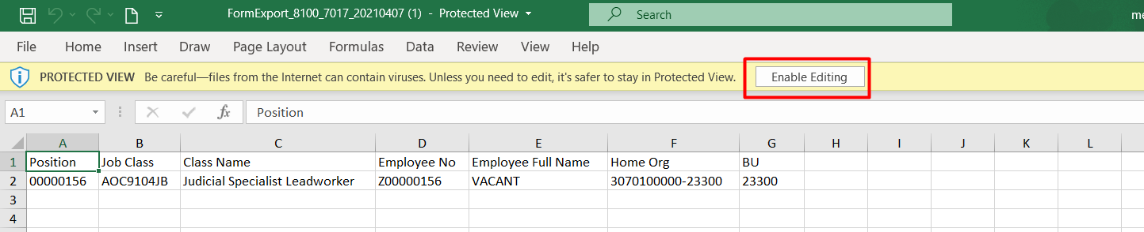

Update the Home Org(s) listed in Column F and Save the spreadsheet.
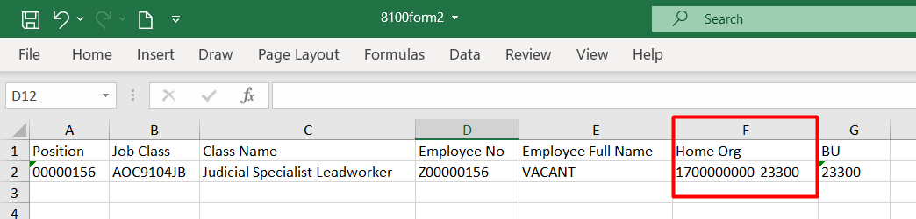

Return to BFM Form 8100 and click Import.

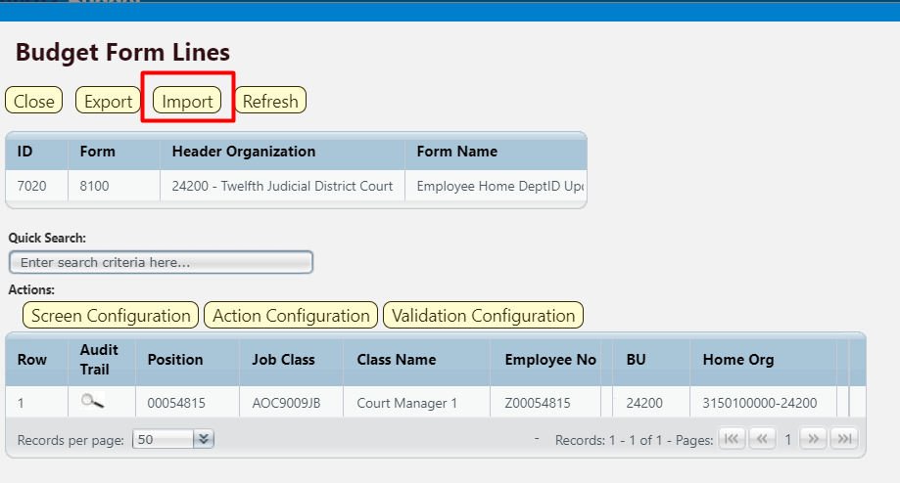

Click Browse and select the correct file. Click Load Selected File.
For detailed import instructions see Section 8.6 Import Spreadsheet.
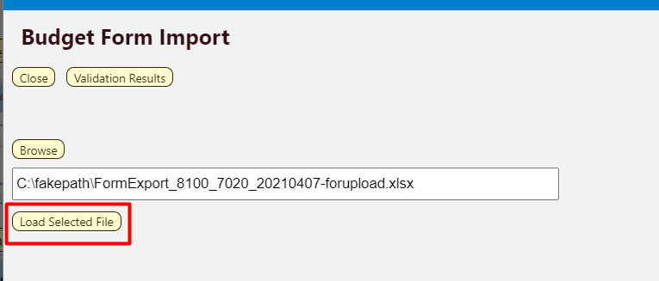

The system will validate the Home DeptID when the Excel spreadsheet is uploaded. If the DeptIDs area valid, then the upload will complete. Click Close.

If any DeptIDs are invalid, the rows with invalid DeptIDs will not load. Review the spreadsheet and correct the DeptIDs, before trying to upload the spreadsheet again.

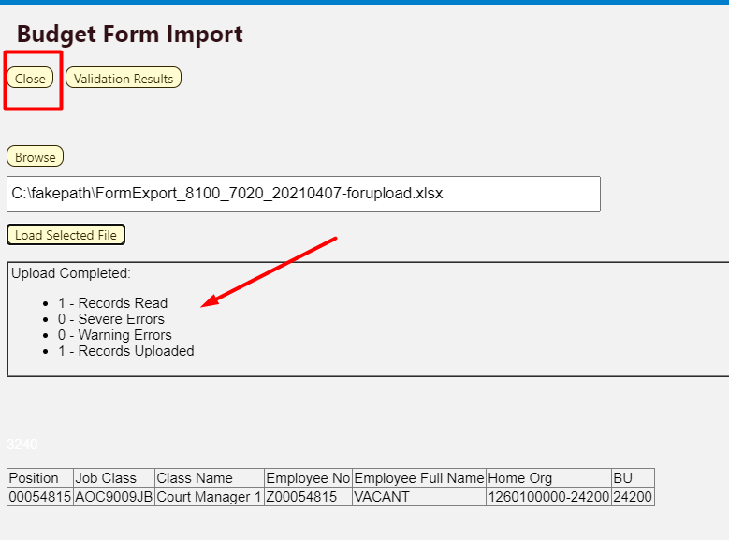

Employee Records that have been updated with valid DeptIDs will no longer appear in the list. Click Close to return to the form Header screen.
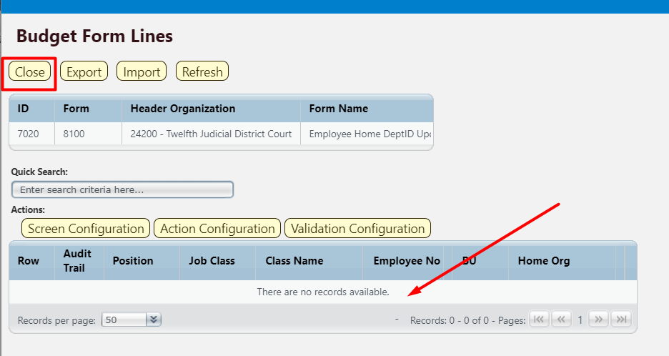

On the Header tab, click the Employees Updated tab to see the list of employee records updated during the upload.
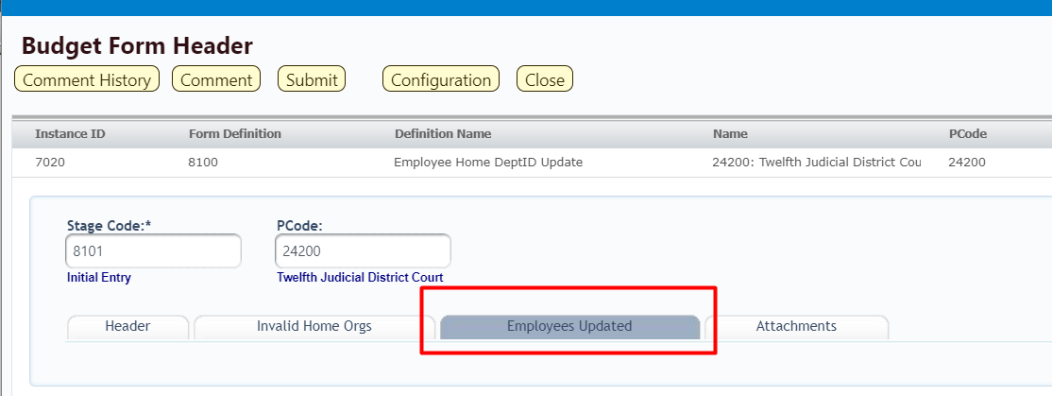

BFM Reporting

How to Access BFM Reports

- Access through BFM Links: Log in to BFM and click on the Links dropdown / BFM Reporting
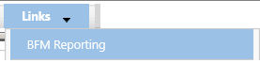

Multiple Sessions
BFM Reporting will open in a new tab. Drag the new tab to create a new instance of your browser. This will allow you to have reports open in one tab and the BFM application open in another window. You can enter data in BFM and refresh reports. This is especially useful if you have two monitors.

Logging In
Single-sign on is used to log onto BI Launch Pad, there is no second login.

Run Reports

Basic Navigation

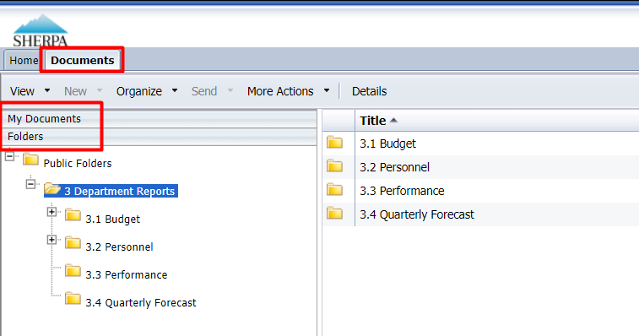

There are two tabs in the upper left, Home and Documents. Click on Documents to see the report folders.

There are sliders on the left-hand panel that are a bit tricky to use. The first is My Documents, where any personal documents may be saved, but this is not heavily used.

Folders is where all standard reports are housed. The active slider is above the white space; in this screen shot Folders is Active. If My Documents is Active, Folders is all the way at the bottom of the screen. When you click on Folders it will slide to the top and open the Folders section.

Click on the plus to the left of any folder to expand the folder structure.
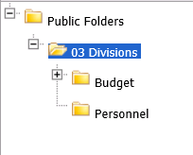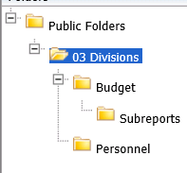

Click on any folder see the reports available.

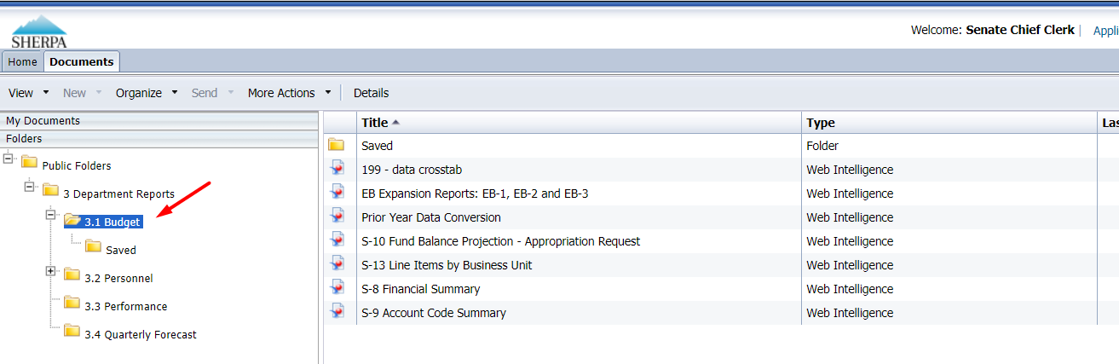

Open a Report

Navigate through the folders to the report to be run.

Double click on the report to be opened.
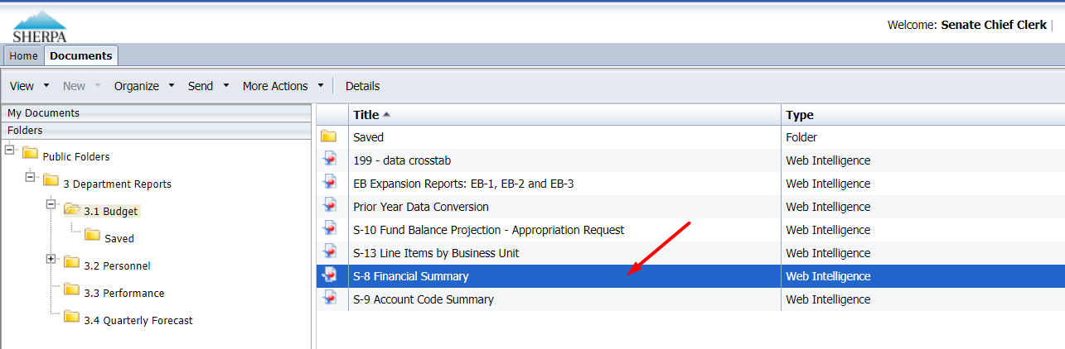

When the report is open, the report header will display as a tab along with the Home and Documents tabs:
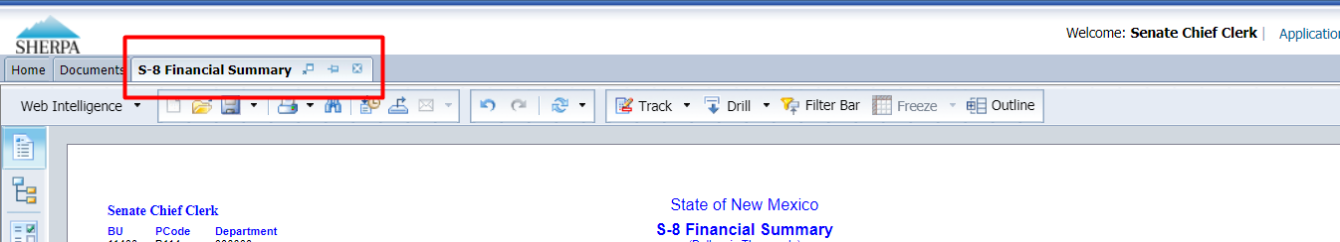

More than one report can be open in the same session. Each report will appear as an additional tab to the right of existing tabs. To open additional reports, click the Documents tab to return to the available reports.
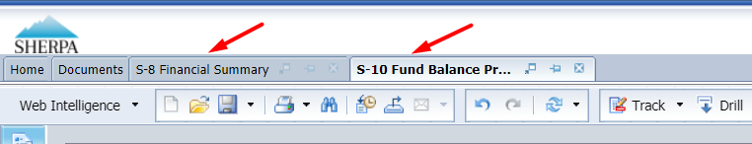

Most reports will be set to 'auto refresh’, meaning the report will refresh the data after you open it. All end user reports have prompts (see Report Prompts below) that must be completed.

Report Prompts
The prompt screen will display with default values selected when a report is opened or when a report is refreshed. In the Prompts Summary area there may be multiple prompts that appear.

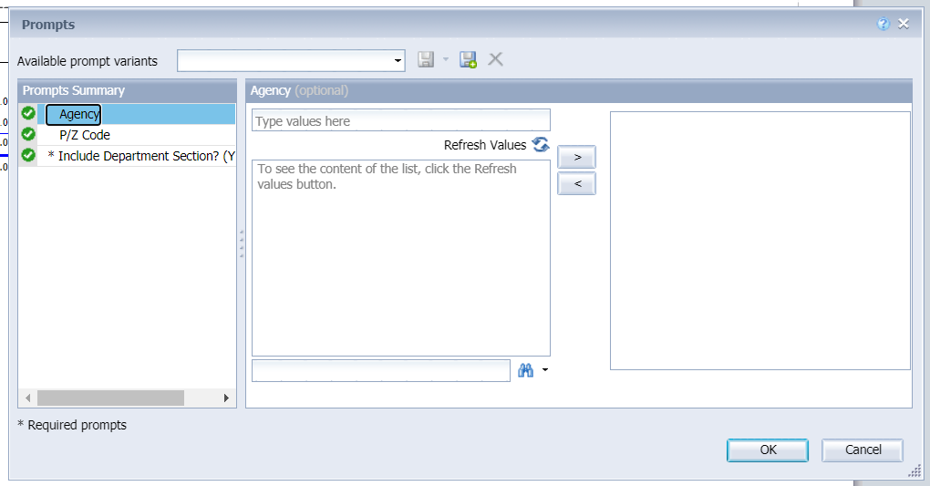
- You must click on each Prompt you wish to fill out (or is required) and follow the procedures below to complete them.
- The active Prompt (Agency) is highlighted in Blue; there are three prompts in the screenshot above (Agency, P/Z Code, *Include Department Section? Y/N)
- Optional prompts have a green circle with a checkmark when the prompt is empty.
- Required prompts have a red circle with a “x” when the prompt is empty.
- Depending on the report that is opened, all prompts (listed below) may not be available. Each report may have different prompts.

To change the default prompt value there are three options:
- Selecting a value from a list
- Entering a value
- Searching for a value

To select a value from a list, click the Refresh Values button. All of the valid prompt values will display in the box below. Highlight the value you wish to select and Double click or click the right arrow. For a LIST type prompt, you can repeat this and select multiple codes. You can also CTRL+Click to select multiples at one time.
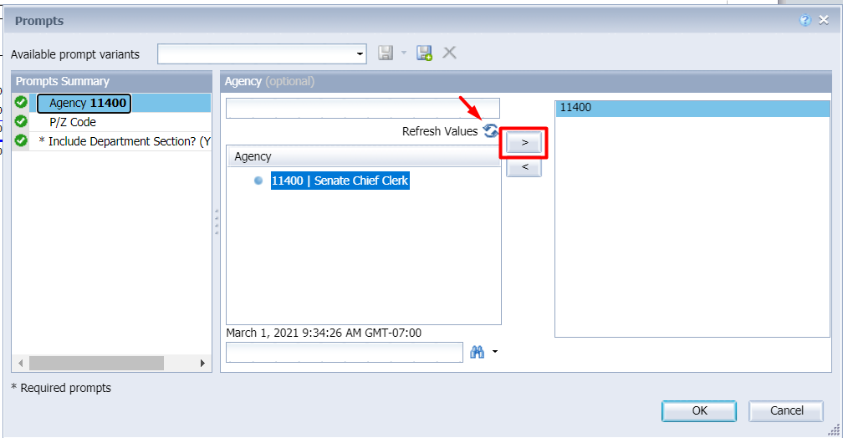

To enter a value, type the value into the "Type values here” box, then click the right arrow . This adds the selection to the report without using the Refresh Values list shown above.
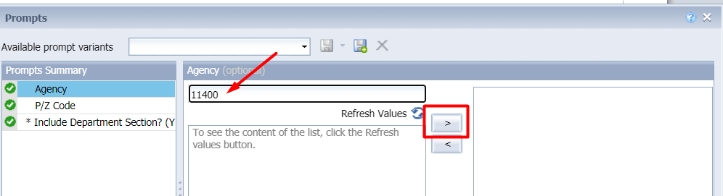

After clicking the right arrow, the default prompt value (if there is one) is replaced:
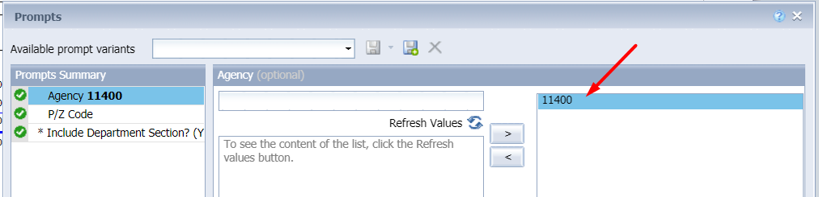

In many cases the lists are long. To search for a value, type the value in the field to the left of the binoculars , then click the binoculars. Partial values can be entered and all values that contain that partial value will be searched. Then double click the value to be used for the prompt.
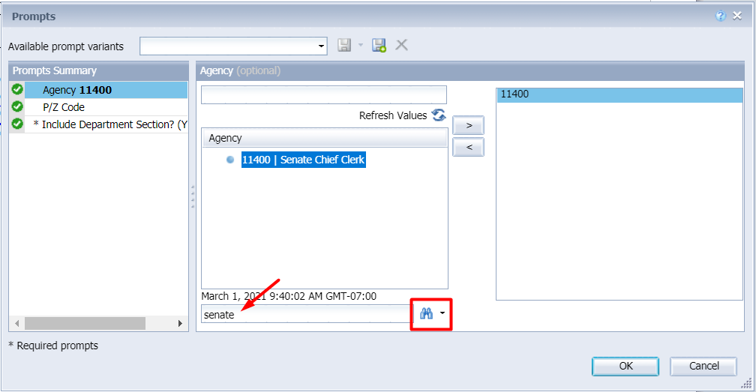

Once all prompt values have been selected, click the OK button. The report will run. If OK is NOT highlighted (it appears light gray), this means a required prompt has not been completed.
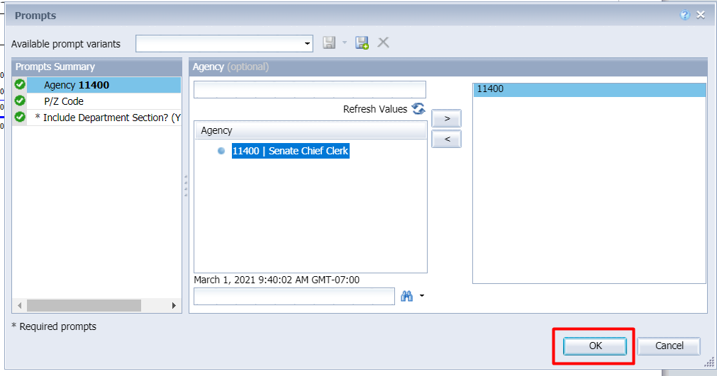

Report Icons
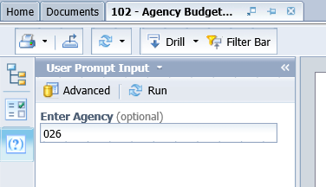
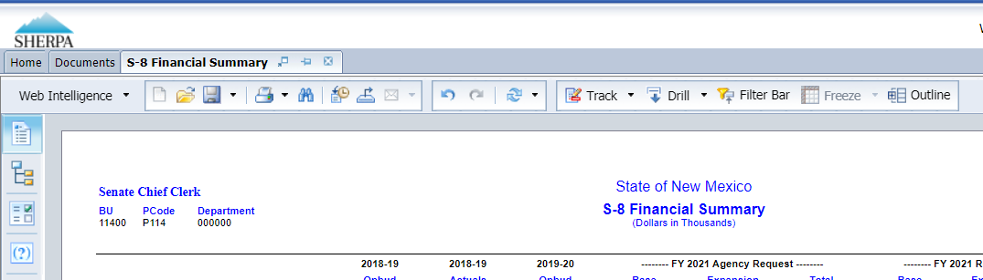

Toolbar Actions
 Save current report, click down arrow for Save As option.
 Print current report (tab) or all reports (all tabs).
Export current report (tab) or all reports (all tabs) into a PDF or Excel.
Refresh data by rerunning using the prompt window.
Enables the drill capability in the report.
Displays the filter bar at the top of the report. Objects can be added to the filter bar to restrict what is displayed in the report.
 Folder opens a new report in place of the existing report.

Side Panel Actions
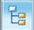 Displays the Navigation Map which includes all report tabs and any sections added to report navigation.
 Displays the Input Control options. Input controls are used to determine what data is displayed in the report.
Displays the User Prompt Input options.

Report Navigation – Document Tabs

Different views of the same data can be captured in report tabs. First, click on the “Navigation Map” button on far left side. The Navigation Map will appear. There are two ways to move between tabs within a report: the Navigation Map or the Tab Strip.

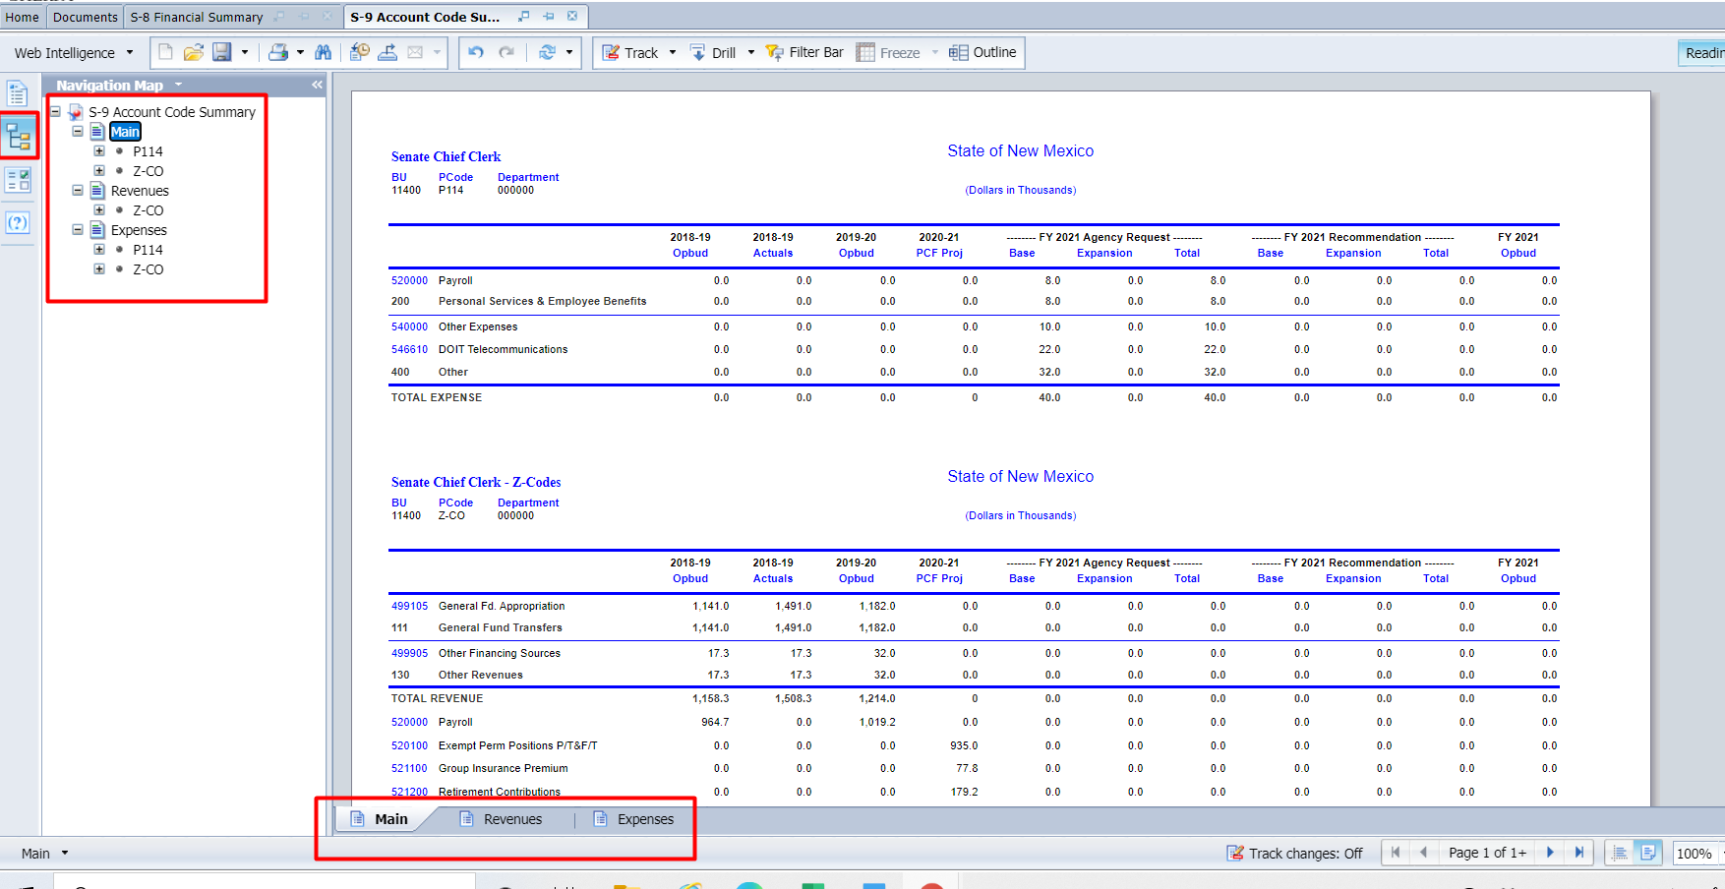

Navigation Map

To display the tab, click on the tab in the Navigation Map. The tab currently displayed is highlighted.
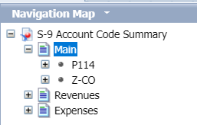

If a tab has a plus sign, report sections have been added to the navigation map.

Clicking on the sub-tab navigation item will display that specific section in the report.

Tab Strip

To display the tab, click on the tab in the Tab Strip. The tab displayed currently is highlighted.

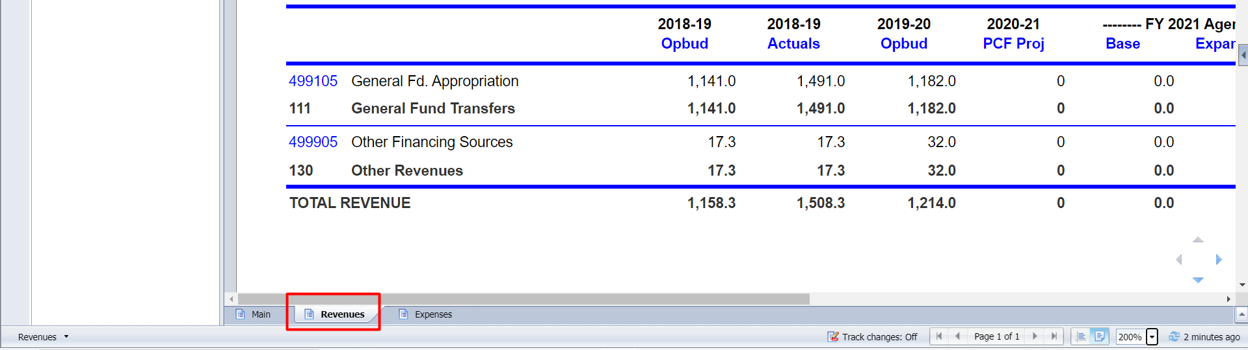

Paging
To move between pages of a report, click the arrows or enter a page number.
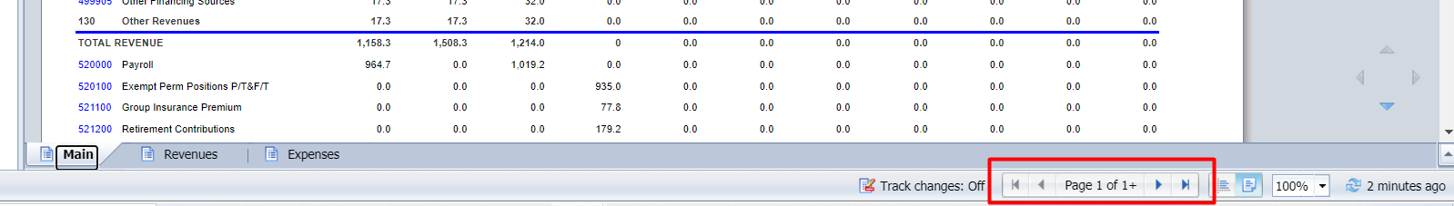

To advance pages, click the inner arrows to move one page at a time and the outer arrows to move to either the first or last page.


To select a specific page, click on the Page 1 of 1 to enter a page number and then click Enter.


Zoom

To change the viewable portion of a report, change the zoom percentage on the bottom tool bar.

Zoom options include:
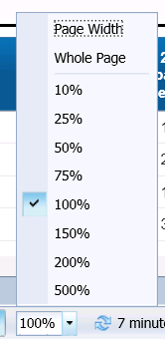

Refresh a Report While Open
Once a report is opened, the values in the report can be updated by refreshing the report.

Refresh with Prompts

Click the Refresh button in the tool bar under the report name:
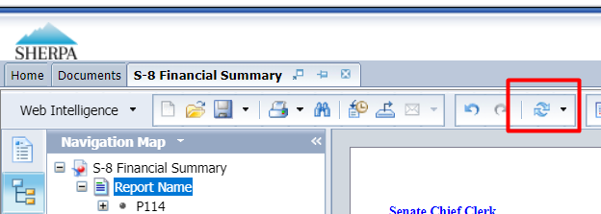

The prompt screen reappears. Complete the report prompts as described in Section 21.3 Report Prompts.

Refresh From User Prompt Input
In the upper left, the Navigation Map/Document Summary drop down contains an option for User Prompt Input. Selecting this allows you to change values by simply typing in new values and clicking Run. There is a slight time savings to using this method if constantly refreshing the report.

Select User Prompt Input
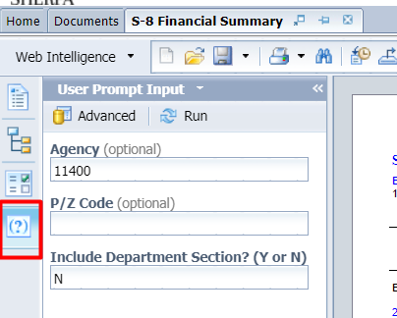

Type in the Organization or other values in the prompt areas. There are no values from which to choose, so you must type in a valid entry.
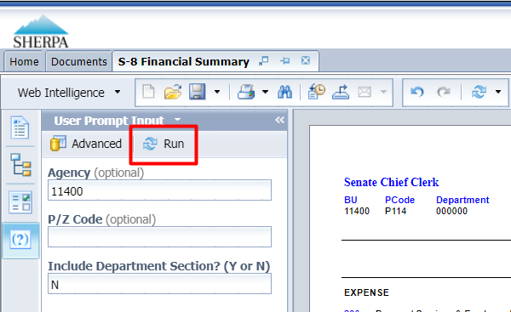

Click Run. The report will be refreshed with the data for the values you entered.

Drill Through on Personnel Report
Drilling displays the data at different levels of summarization. Drill Through is available on a Personnel Cost Forecasting (PCF) report.

From the Documents Folder, navigate to the 3.2 Personnel folder. Double click to open.
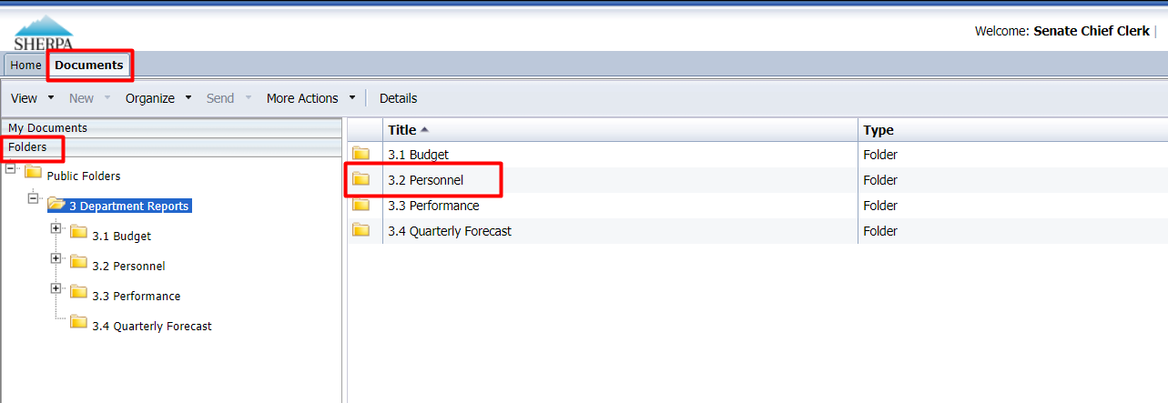

Locate the 302 – PCF Detail Agency/Individual report. Double click to open.
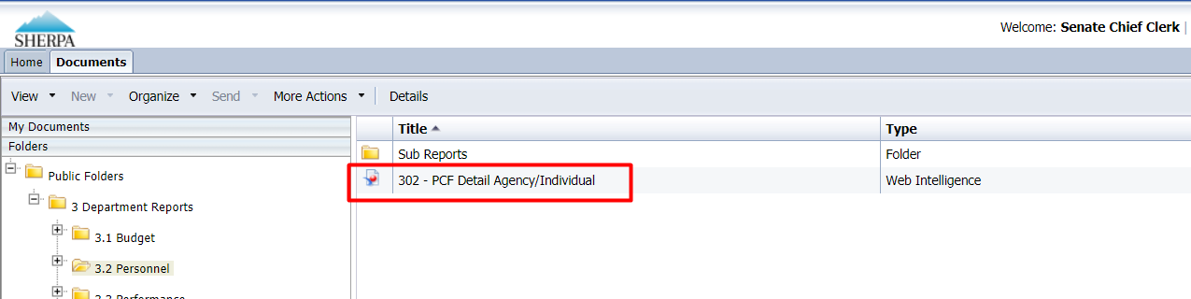

Complete the Prompt using the instructions in 21.3 Report Prompts, or leave blank and click OK.

The report will load. Click on the Drill icon to enable the drill functionality. The drill up icon appears in the report column header where drilling is available.

If the arrow points up, the report will allow drilling up to a higher level; if the arrow points down, the report will drill to a lower level of data. In this example, the data drills up to a higher level.

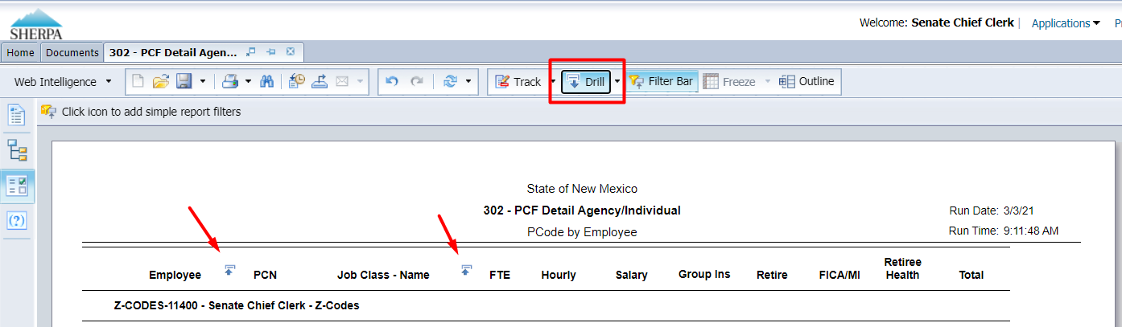

Option 1:

Left-click on any column header/field that has a drill icon. It will automatically drill to the next pre-defined level.
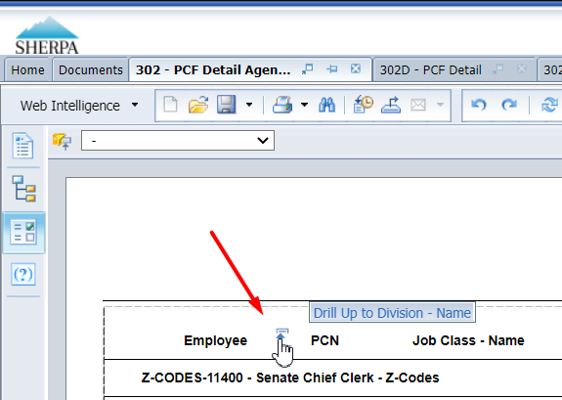

Option 2:

Right-click on the row you want to drill on and choose Drill By.
Note: The 302 Report shows employee listed by name, but in the screenshot below the employee names are redacted.

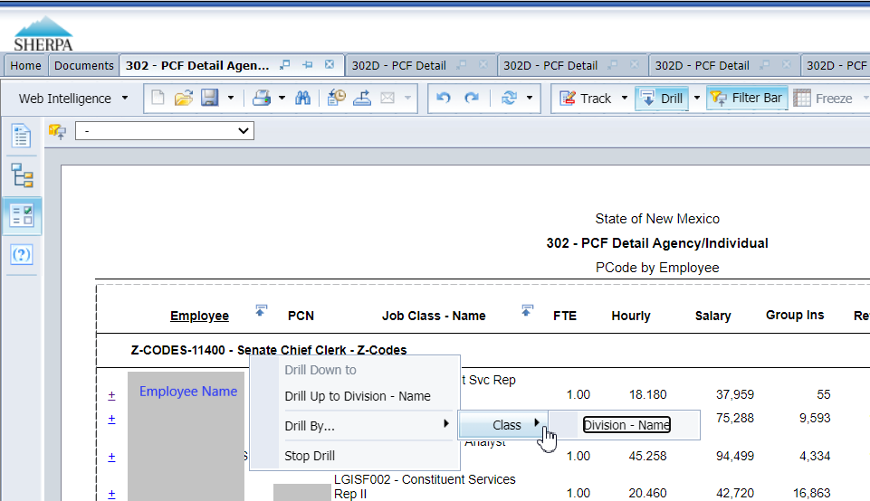

Select the drill dimension, the report will show the data at that level. The report at the new level will load.

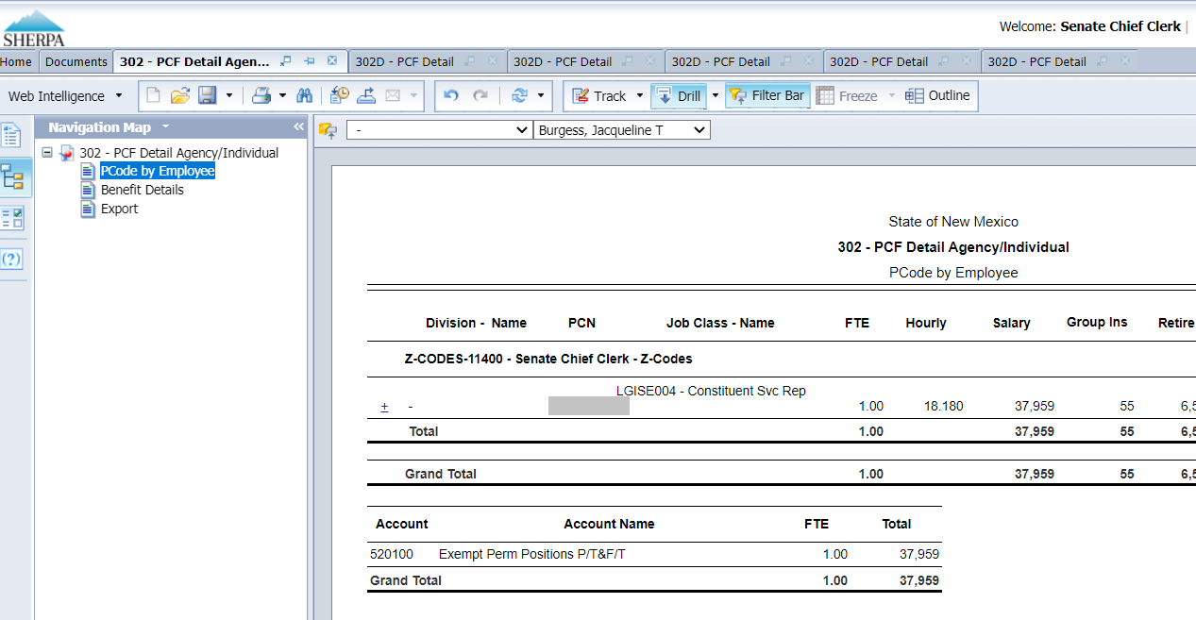

Linked Report
The 302 PCF Detail Report is also a linked report, meaning a separate report related to the same dataset can be opened by clicking a hyperlink available in the report.

Click the plus-sign hyperlink next to the employee name to open the PCF Detail for the employee.

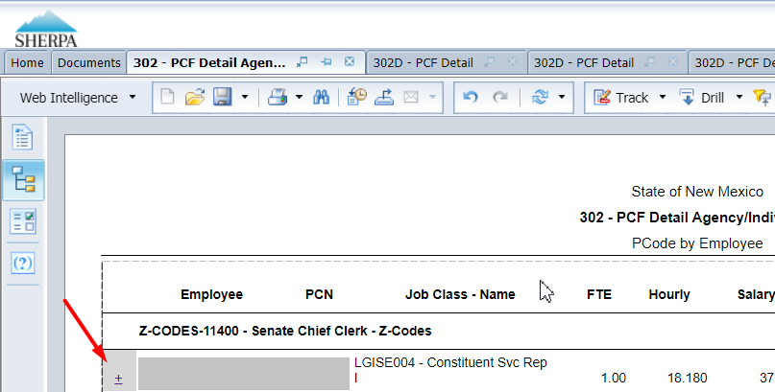

The detail report opens in a new tab.
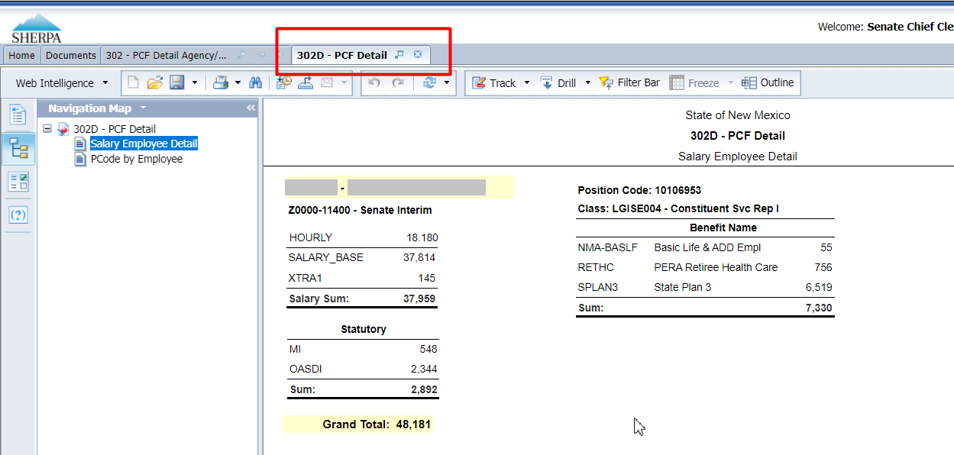

Limit Data Using Input Controls
Input Controls limit data displayed in the report after refreshing. Input Controls are available on the S-8 Financial Summary report.

Click on the Input Control icon to display the input control options.
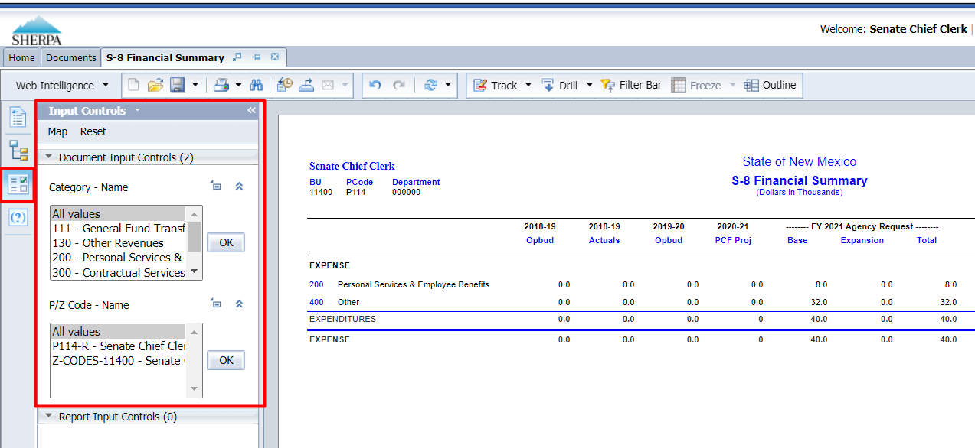

Select one or many values from the input control panel on the left-hand side of the screen. Hold down the Ctrl key to select multiple values with your cursor.

Click OK.
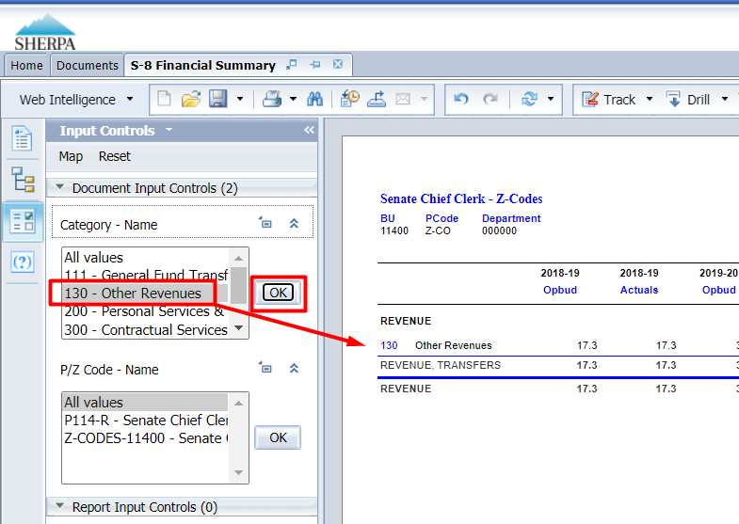

Select “All values” and click OK to return to the complete data set.
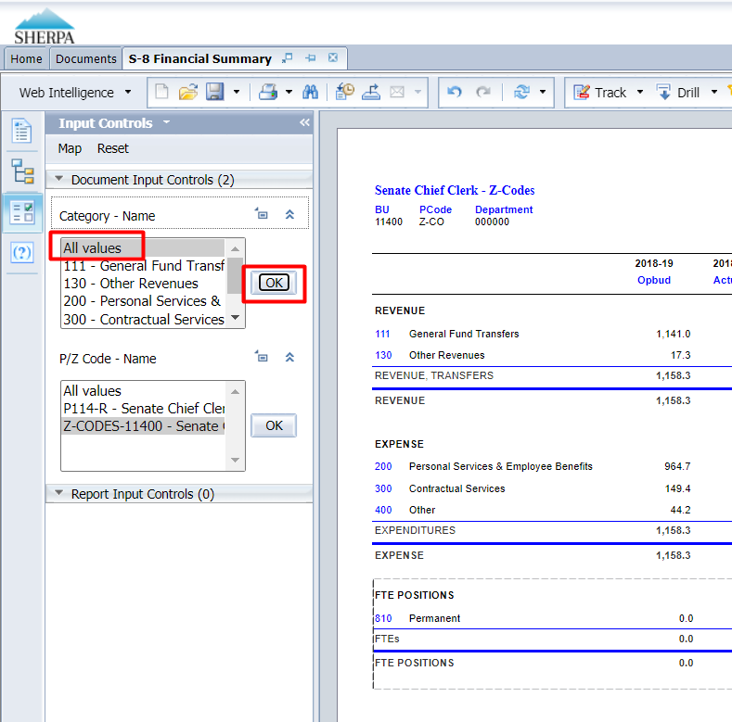

Export a Report
Options to export include all report tabs or data as PDF, Excel, CSV, or Text. The Export icon on the upper tool bar provides an Export popup.

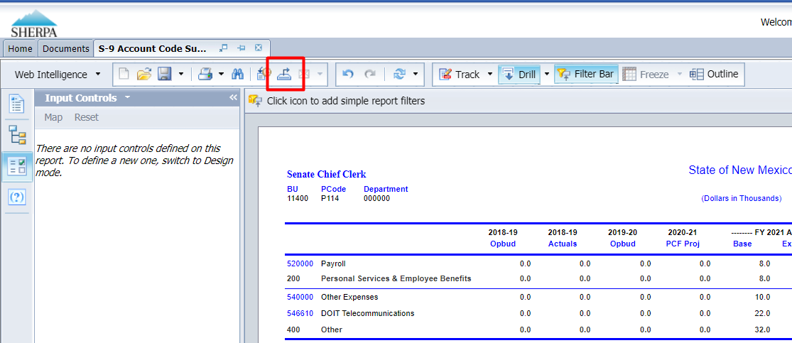

Select Report or Data. Report allows a selection of one, multiple, or all report tabs. Data allows a selection of queries defined for the report.
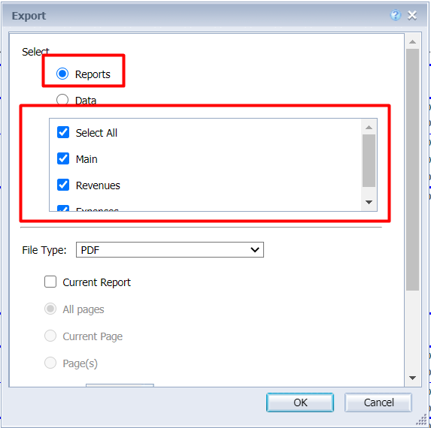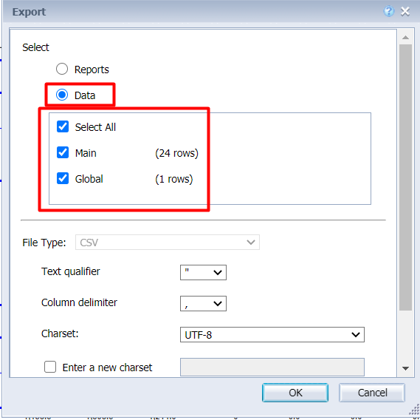

Select File Type. Each file type has additional export options.

Click OK.

Once the report downloads, click prompt to open.

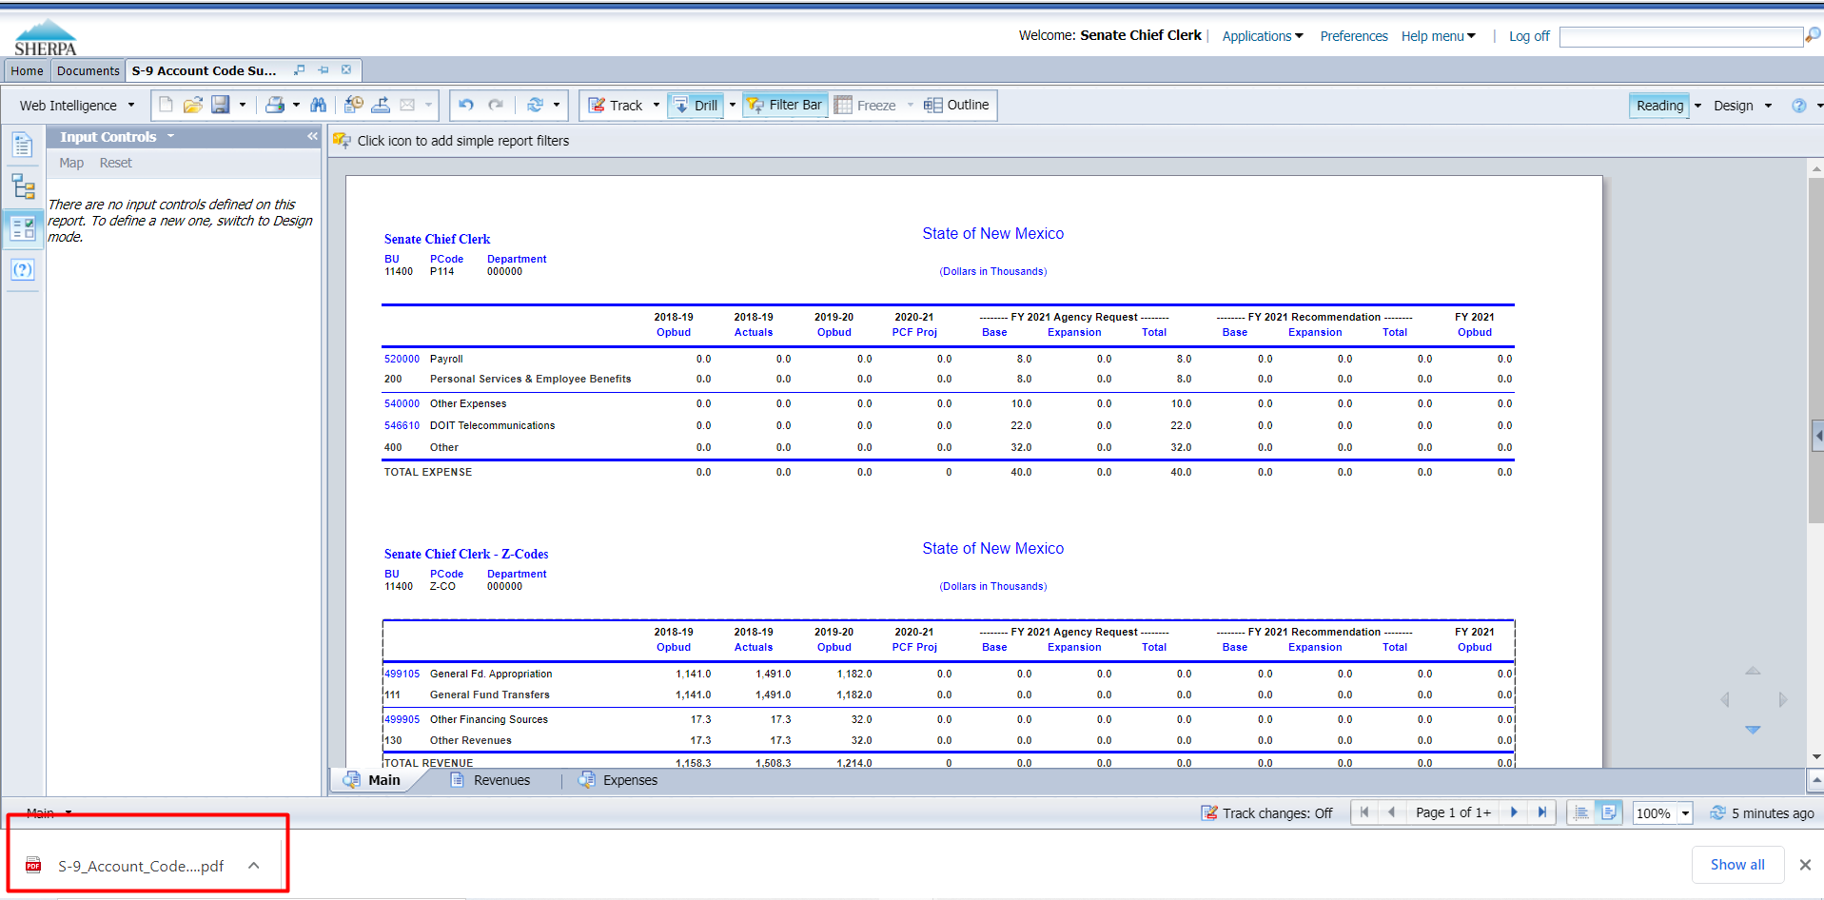

Saving as Excel
Double click the file in the bottom bar of the Browser window to Open. Click Enable Editing, then save the report as desired.
- The Excel files will not include the report headers.
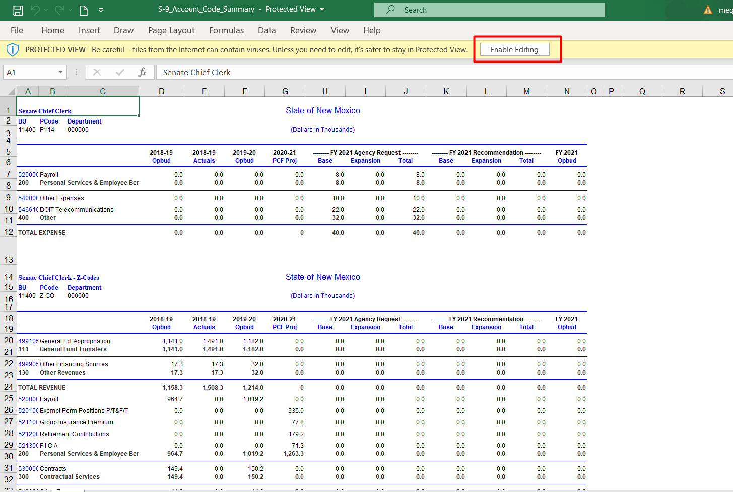

Saving as PDF
Click the arrow next to the downloaded file in the browser window.

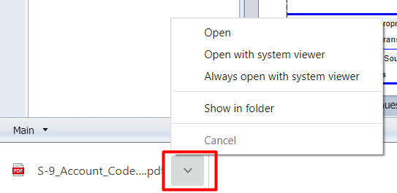

Click Open to open in a new browser window.
Click Open with System Browser to open in your computer’s default PDF viewer. Depending on your computer settings, this may be Adobe Reader or another PDF viewer.

The PDF will include the report header and provide navigation through the tabs on the left-hand side.
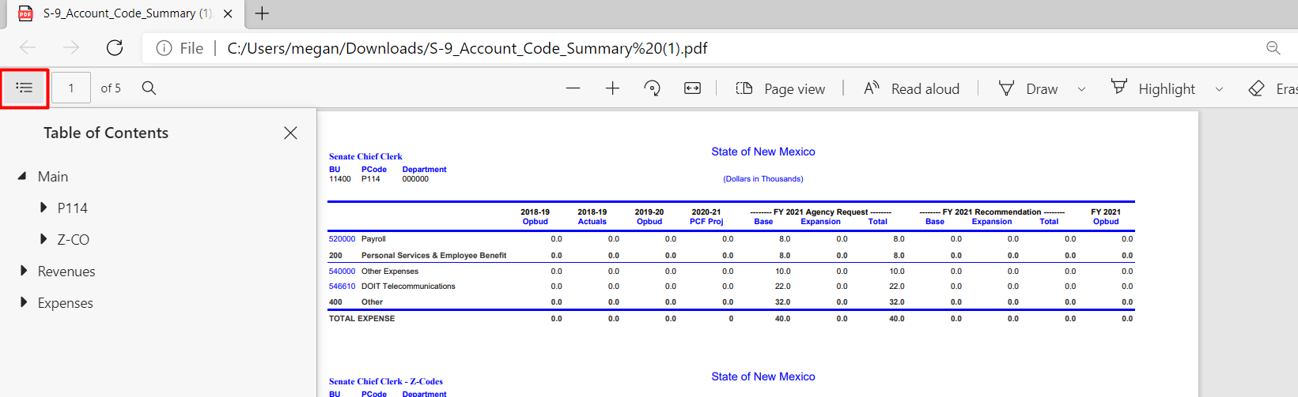

Print a Report
Clicking directly on the Print icon will download a PDF of the entire document (all tabs) that can be printed. Clicking on the arrow on the print button and selecting Print will provide additional options for what is to be generated into a PDF.

